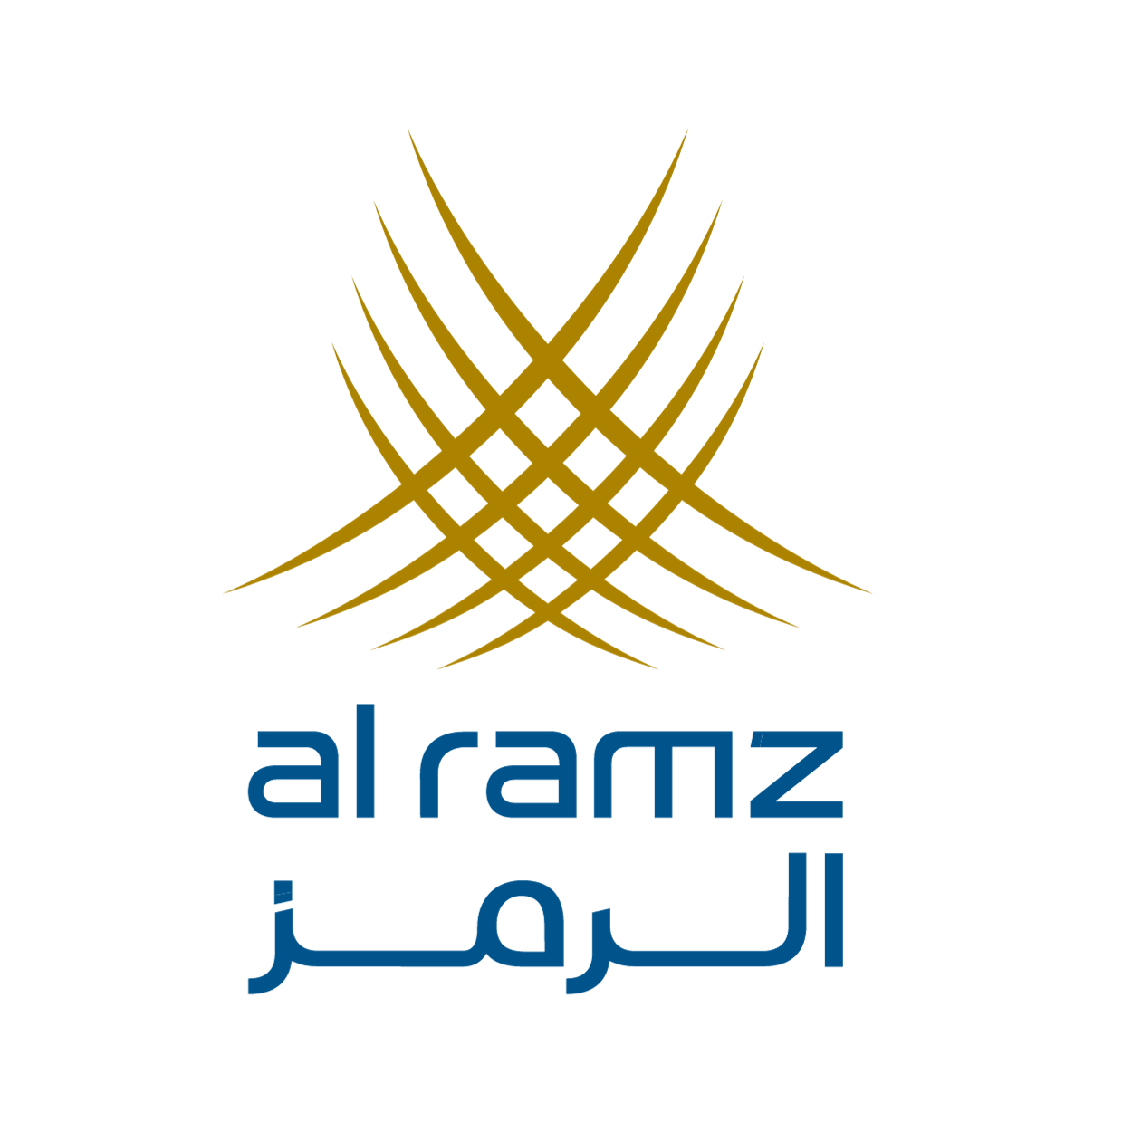 | 28 AUGUST 2026

Initiation of Coverage
Dubai Islamic Bank
Priced for fade, built for progress
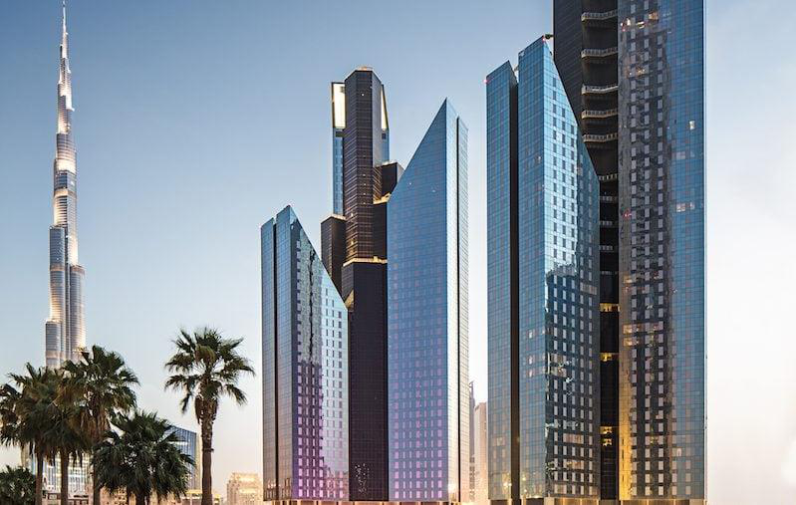  Last close, AED 7.31  Fair value, AED 7.98  Upside 9.2%  Stock rating Equal-Weight | Contents  Investment case 2  Islamic finance on a roll 4  DIB: fifty years of firsts 9  A bright financial outlook 17  The de-rating disconnect 27  An attractive entry-point 31  Key risks 37  Summary financials 39  Disclaimer and disclosures 41

Important Notice Al Ramz Capital may or may not provide financial services to Dubai Islamic Bank or any other related entities. This document is a Dreams AI Associate draft prepared for analyst review and has not been approved for distribution. Please see the disclaimer and disclosures at the back of this report.

Investment case
Fifty years on, priced like a laggard  We initiate coverage of Dubai Islamic Bank, the world's first full-service Islamic bank and the UAE's largest, with an Equal-Weight rating and a fair value of AED 7.98 per share, implying 9.2% upside to the last close of AED 7.31 and a total return of roughly 14% including the dividend. Our blended fair value averages four methods: justified price-to-tangible-book (AED 8.37), dividend discount (AED 6.40), trading comparables (AED 8.29) and DIB's own trading history (AED 8.87).  Islamic finance is on a roll, again. Global industry assets reached USD 5.98 trillion in 2024 and are projected toward USD 9.7 trillion by 2029. At home, the UAE has turned intent into policy: the national Islamic finance strategy approved in May 2025 targets AED 2.56 trillion of Islamic banking assets by 2031, more than 2.5 times today's pool. DIB, holding roughly two-fifths of the UAE's listed Islamic banking assets, is the single largest beneficiary of that tailwind.  The franchise delivered a record 2025. Total assets grew 21% to AED 416 billion, deposits rose 29%, AED 124 billion of new financing was originated, and pre-tax profit reached AED 9.0 billion, up 20% on a normalized basis. Asset quality is the best in a decade: the NPF ratio fell from 4.0% to 2.65% and reached 2.4% by June 2026.  But the earnings math has changed. UAE corporate tax plus the Pillar Two top-up turned 20% pre-tax growth into broadly flat net profit; the FY2025 dividend was cut to 35 fils from 45; and our base case sees margins compressing toward management's 2.3% guidance as the Fed cycle transmits through the dirham peg while cost of risk normalizes from an unsustainable 14bps toward 45bps. On our numbers EPS troughs near AED 0.89 in 2027-2028 before recovering to AED 1.02 by 2030.  The stock has de-rated far beyond that math. DIB is down 25.6% over twelve months against ADIB up 9.5%, and trades at 7.4x trailing earnings and roughly 1.0x book against ADIB's 13.1x and 2.66x. We think the discount now overstates the fade: the franchise, the state alignment, and the sector's policy tailwind are intact, and two levers, payout normalization and a visible margin floor, would each move fair value materially. At +9.2% upside we are constructive but not yet compelled; the sensitivity work in this report maps exactly which beliefs would change the rating. | Stock Rating  Source: Al Ramz Investment Research  Stock Statistics  Source: stockanalysis.com, 27 Aug 2026  Key Ratios  Source: Al Ramz Investment Research estimates
  Current Rating | Equal-Weight
  Fair Value | 7.98
  Former Rating | Not rated
  Target Upside | +9.2%
  Listing location | Dubai
  Sector | Banking
  Local Exchange | DIB
  Bloomberg | DIB UH
  Reuters | DISB.DU
  Last Close, AED | 7.31
  Market Cap (AED m) | 52,930
  Shares Out. (m) | 7,240.7
  Free Float | ~72%
  52w High (AED) | 10.20
  52w Low (AED) | 6.97
  YTD Change | -21.1%
  12m Change | -25.6%
  Indicator | 2026E
  P/E (x) | 7.9
  P/TBV (x) | 1.13
  Dividend Yield | 4.8%
  ROTE | 15.1%
  ROA | 1.7%

Islamic finance on a roll
Half a century after Dubai Islamic Bank invented the industry, Islamic finance is compounding at a pace conventional banking cannot match, and DIB's home regulator has now made expanding it official state policy. This chapter sizes the tide that lifts the company.

A six-trillion-dollar industry compounding at ten percent
Global Islamic finance assets reached USD 5.98 trillion in 2024, up 21% year on year, and ICD-LSEG projects the industry to reach USD 9.7 trillion by 2029, roughly 10% average annual growth. S&P, using a narrower methodology, still counts the industry above USD 5 trillion, estimates 10.2% growth in 2025, and projects 5-10% for 2026, with regional geopolitics the key swing factor. Islamic banking is the industry's core at about 72% of assets across 84 markets; sukuk, takaful and funds make up the balance.
The growth differential versus conventional finance is persistent, not episodic. Fitch reconfirmed in July 2026 that Islamic banks are growing financing faster than conventional peers across the Middle East, on broader adoption, product innovation, and demographics; Moody's reached the same conclusion for the GCC. The drivers are structural: young and growing Muslim populations, GCC diversification programs which fund themselves increasingly in Islamic format, and sovereign ecosystems, from Saudi Arabia's 76% Islamic banking penetration to Malaysia's capital markets, that keep deepening.
Chart 1: Global Islamic finance assets (USD tn)
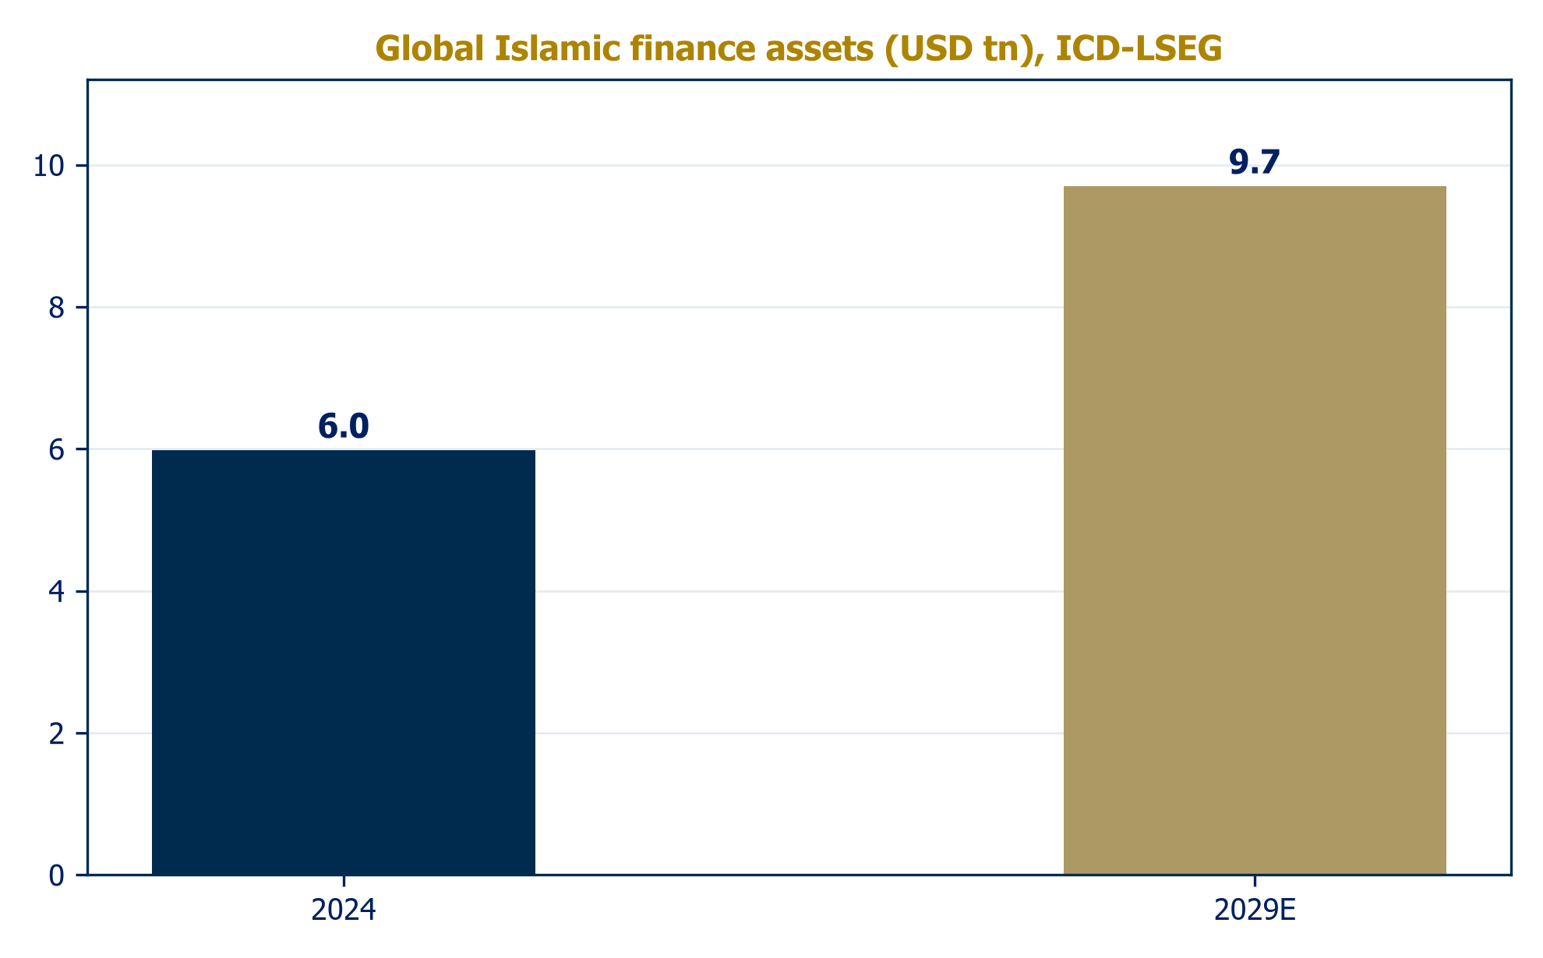
Source: ICD-LSEG Islamic Finance Development Indicator 2025

Sukuk: the trillion-dollar engine
Sukuk outstanding passed USD 1 trillion in 2024-2025. Issuance ran at USD 265-300 billion in 2025 depending on the counting convention, up sharply year on year, and S&P forecasts USD 270-280 billion for 2026, supported by Fed easing, GCC financing needs and refinancing walls. The market's composition is broadening in DIB's favor: the GCC accounted for 45% of global issuance in 2025 and sukuk now represent about 16% of all US-dollar debt issuance excluding China, while local-currency programs in Malaysia, Qatar, Saudi Arabia and Turkiye drove first-half 2026 growth of 20% year on year. Credit quality has been remarkable: 82.5% of Fitch-rated sukuk are investment grade, 90% of issuers carry stable outlooks, and the market has seen no defaults in four years.
For DIB this market is a double franchise. As an issuer, the bank has printed a decade of benchmarks culminating in its November 2025 sustainability-linked sukuk at Treasuries plus 90bps and its June 2026 AT1, both heavily oversubscribed, evidence that global Islamic liquidity prices DIB as a premier credit even while its equity de-rates. As an arranger and investor, DIB monetizes every leg of regional issuance growth through fees and its AED 85-91 billion treasury portfolio. The fastest-growing sub-segment, ESG sukuk, with record quarterly issuance through 2025, is one the bank effectively pioneered with the UAE's first Islamic Sustainable Finance Framework in 2022.

The UAE: 18% share, with state intent to change it
The UAE operates the largest banking system in the Middle East, with assets of AED 5.57 trillion as of April 2026 after 17% growth in 2025, sector-wide profitability at record levels, and the strongest credit growth in the GCC at roughly 14%. Within it, Islamic banks hold approximately AED 989 billion of assets, an 18% share that has been stable for five years, plus 22.8% of system credit.
That stability is precisely what the government intends to break. The UAE National Strategy for Islamic Finance, approved May 2025, targets AED 2.56 trillion of Islamic banking assets by 2031, more than 2.5 times the current pool, implying roughly 15% annual growth in the segment for the rest of the decade. The benchmark set is instructive: Islamic banking holds 76% of banking assets in Saudi Arabia and about half in Kuwait, against 18% in the UAE. There is nothing structural about the UAE's lower share; policy, product and distribution decide it, and all three are now pointed the same way.
Chart 2: UAE Islamic banking: current share and the 2031 target
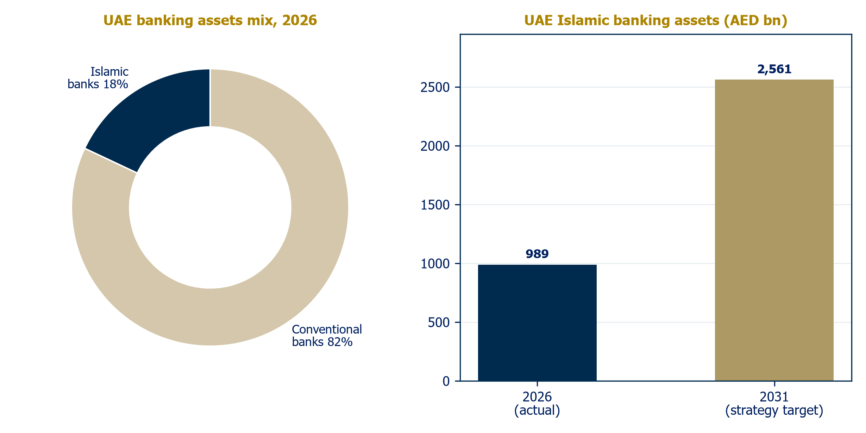
Source: S&P Global via Khaleej Times (Jul 2026); UAE national strategy via Gulf News

Rates: the margin variable
The dirham peg makes DIB's margin outlook a function of US policy. The Fed cut three times in 2025 to 3.50-3.75%, its December projections implied one further cut in 2026, and markets price roughly two; EIBOR has followed, and UAE top-10 bank net interest margins compressed 9bps in Q1 2026 to 2.37%. The offset is volume: system credit is growing at the fastest pace in the Gulf. For Islamic banks the transmission is identical in economics even if different in form, and DIB's own guidance, a 2.3% net profit margin for 2026 versus 3.0% in 2024, quantifies the squeeze honestly.

Market opportunity: three concentric rings
DIB's addressable market is best sized in three rings. Ring one is UAE Islamic banking: an AED 989 billion pool inside a AED 5.57 trillion system, with a state target of AED 2.56 trillion by 2031. If that target is even approximately achieved, the domestic Islamic pool grows at roughly 15% annually for the rest of the decade, and DIB, at around two-fifths of the listed Islamic-bank pool, is its single largest beneficiary. Simply holding share implies a balance sheet approaching AED 700-800 billion by 2031, before any share gains.
Ring two is regional capital markets: the trillion-dollar sukuk stock and its USD 270-280 billion annual issuance, which DIB monetizes twice, as the GCC's most prolific Islamic bank issuer and as arranger and investor, with leadership in the fastest-growing ESG sub-segment. Ring three is international Islamic finance: through Pakistan (a market legally transitioning toward Islamic banking), Indonesia (the world's largest Muslim population at single-digit Islamic penetration), Turkey (participation banking share still around 8%, plus the T.O.M. digital play) and East Africa, DIB holds options on markets growing from low bases toward the industry's projected USD 9.7 trillion. These stakes contribute modestly today and carry commensurate risk, but no other UAE Islamic bank owns a comparable set. Realistically, ring one dominates the investment case: the strategic question is not market size but the margin and capital intensity at which growth is delivered.

Macro and property: strong, with a cooling roof
Consensus puts UAE GDP growth at 4.8-5.0% for 2026, driven by a non-oil economy now 79% of output; Q1 2026 printed 3.0% with non-oil up 4.8%. The one soft patch matters to DIB specifically: Dubai residential transactions cooled roughly 16% by value in H1 2026 and price growth is forecast to moderate to 5-8% after two extraordinary years. That is a normalization, not a correction, but DIB's collateral base and property adjacencies make the trajectory worth watching, and it features in our risk table. The geopolitical scenario, S&P's stated downside for the whole industry, is the tail risk no UAE bank escapes.

DIB: fifty years of firsts

What DIB is
Dubai Islamic Bank is the world's first full-service Islamic bank, founded in 1975, today the largest Islamic bank in the UAE and the third largest globally by assets. It is a universal bank operating entirely under Sharia principles: deposits are structured as profit-sharing and wakala arrangements, financing through murabaha, ijara and similar asset-backed contracts. The group spans consumer banking, corporate banking, treasury and real estate, with operations in seven countries across three continents, more than 500 branches group-wide, over 12,000 employees, and at least five million customers.
Scale, at end-June 2026: total assets of AED 423 billion, net financing of AED 281 billion, customer deposits of AED 327 billion, and a capital stack refreshed by a USD 1 billion AT1 sukuk printed in June 2026 against a USD 2.3 billion order book. Fitch estimates DIB holds about 8% of UAE banking system assets, making it the country's fourth-largest bank overall and the anchor of its Islamic segment. Credit ratings reflect the sovereign relationship: A3 stable (Moody's), A stable (Fitch), the latter resting explicitly on expected Government of Dubai support.
Chart 3: Largest Islamic banks by assets (USD bn, FY2024)
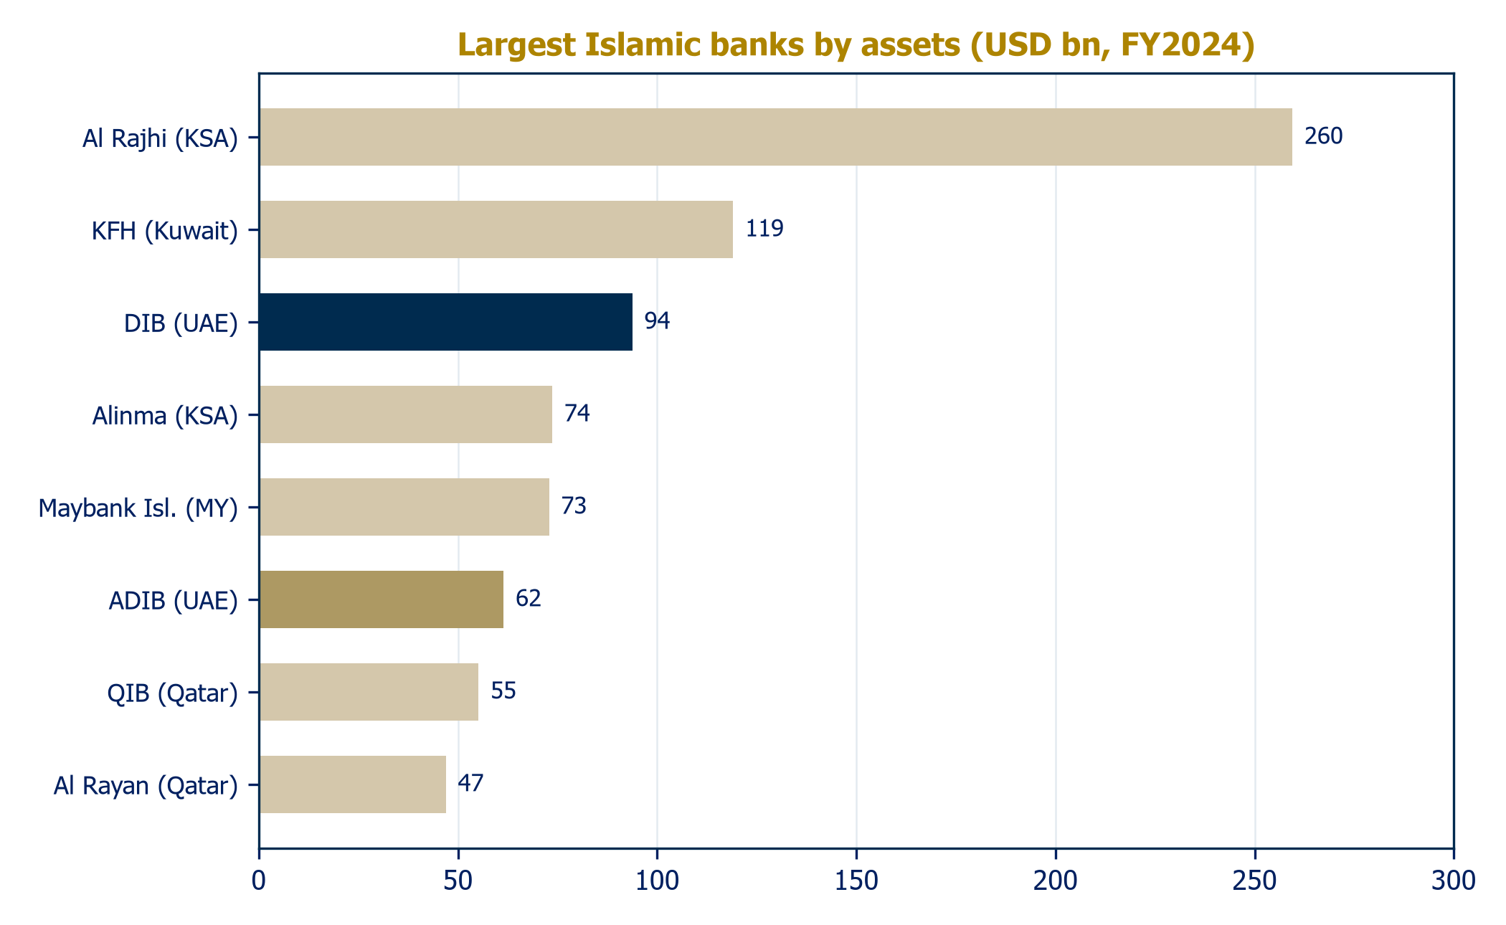
Source: TAB Insights AB100, 2025
Chart 4: UAE Islamic banks by total assets, FY2025 (AED bn)
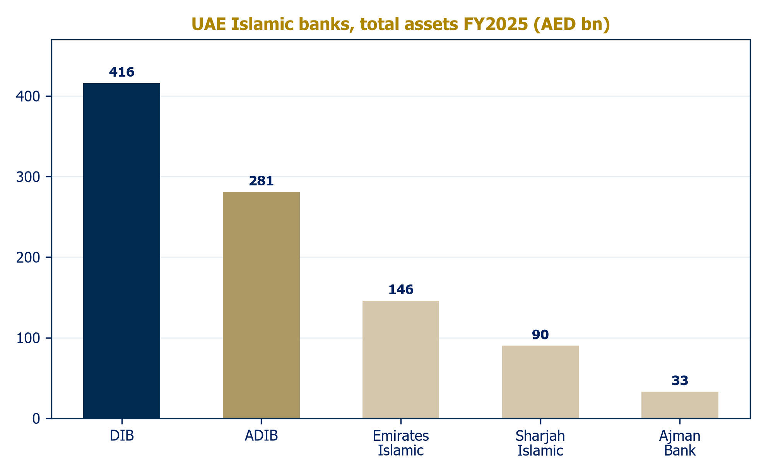
Source: Company disclosures, FY2025

Five decades of firsts
DIB's founding is a landmark in financial history. A decree issued by H.H. Sheikh Rashid bin Saeed Al Maktoum in March 1975 authorized the establishment of the bank, founded by Saeed bin Ahmed Lootah, and it opened that September as the first institution anywhere to deliver complete commercial banking in full Sharia compliance. The modern USD 6 trillion industry traces its commercial origins substantially to this institution.
The subsequent arc: Sharia Supervisory Board formalized in 1989; conversion to a public joint stock company in 1992; DFM listing in 2000; the seeding of real estate adjacencies Tamweel and Deyaar in the early 2000s; international expansion to Pakistan (2006), Jordan (2010), Indonesia (2014, now ~38% of Panin Dubai Syariah), and Kenya (2017); Dar Al Sharia established as the industry's reference consultancy; entry to the billion-dollar profit club in 2015 and D-SIB designation in 2018.
The transformational modern event was the acquisition of Noor Bank, completed January 2020 and integrated in a record 283 days, which consolidated DIB's domestic dominance. The 2020s added three threads: sustainable finance leadership (the UAE's first Islamic Sustainable Finance Framework in 2022, a USD 1 billion sustainable sukuk in 2024, and a debut USD 1 billion sustainability-linked sukuk in November 2025 priced at the bank's tightest-ever spread of Treasuries plus 90bps); digital and international optionality (the rabbit youth app in 2021, the DIB 'alt' digital umbrella in 2023, and a 25% stake in Turkey's T.O.M. digital banking group); and balance-sheet acceleration, with 2025 the strongest growth year in the bank's history. The bank marked its Golden Jubilee in May 2025 with a rebrand under the banner 'Progress Never Stops'.
Chart 5: Five decades of firsts
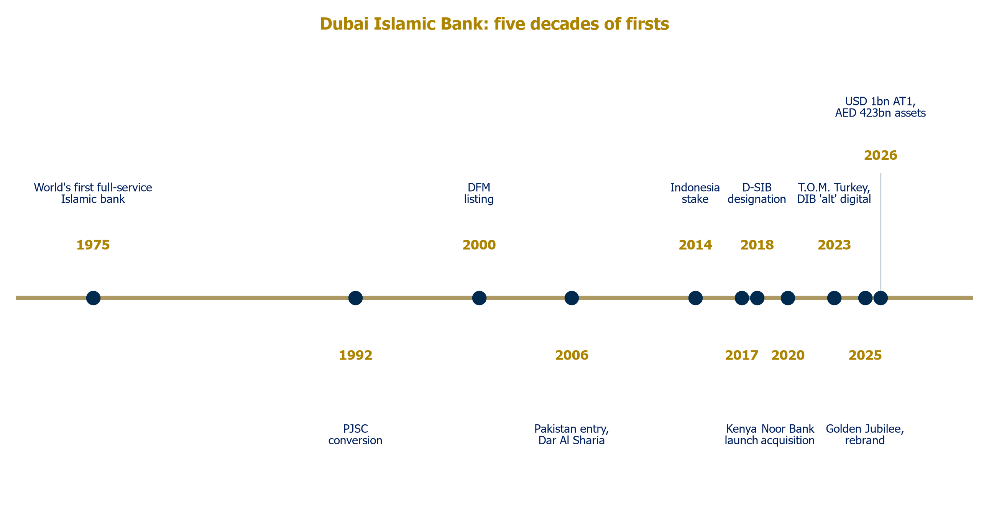
Source: Company disclosures; Al Ramz Investment Research

The franchise: consumer engine, corporate scale, sukuk house
Consumer banking anchors the funding base: accounts, cards, personal, auto and home finance, the XTRA proposition, and tiered wealth offerings led by Wajaha. Consumer deposits drive the bank's low-cost funding; CASA stood at 38.1% of deposits at end-2024 and 34% by mid-2026, the decline itself a symptom of the rate cycle that should partially reverse as rates fall. Corporate and institutional banking spans contracting and real estate finance, trade, cash management and syndications, and originated the bulk of 2025's AED 124 billion of new financing. Treasury manages a sukuk portfolio of AED 85-91 billion. Real estate runs through both the financing book and equity positions, notably developer Deyaar.
The product set is a full universal-bank offering delivered through Islamic contracts. In consumer banking: current and savings accounts structured as qard and mudaraba, personal, auto and home finance, a full cards suite, takaful distribution, and the Wajaha wealth proposition for high-net-worth clients dating to 2009. In corporate banking: contracting and real estate finance, working capital and trade instruments, cash management, syndications and project finance. Investment banking spans sukuk origination, structuring through Dar Al Sharia's advisory capability, and equity capital markets participation. Pricing across the book is benchmarked to prevailing dirham profit rates, so revenue sensitivity to the rate cycle mirrors conventional peers even though contract forms differ.
Digitally, DIB is among the region's leaders: 97% of transactions are processed digitally, digital users grew 33% in 2025, the 'alt' umbrella carries more than 135 services across mobile, online, WhatsApp and ATM channels, and an AI partnership with HCLTech was signed at GITEX in October 2025 to industrialize AI across advisory, operations and risk. The international footprint, wholly-owned DIB Pakistan (est. 2006), DIB Bank Kenya (2017), the ~38% Indonesian stake in Panin Dubai Syariah, the 25% Turkish stake in T.O.M. Group, Bank of Khartoum and Bosna Bank International (Europe's first Sharia-compliant bank), contributes modestly today but represents the only genuinely global network among UAE Islamic banks.
Chart 6: Deposit mix: CASA vs term
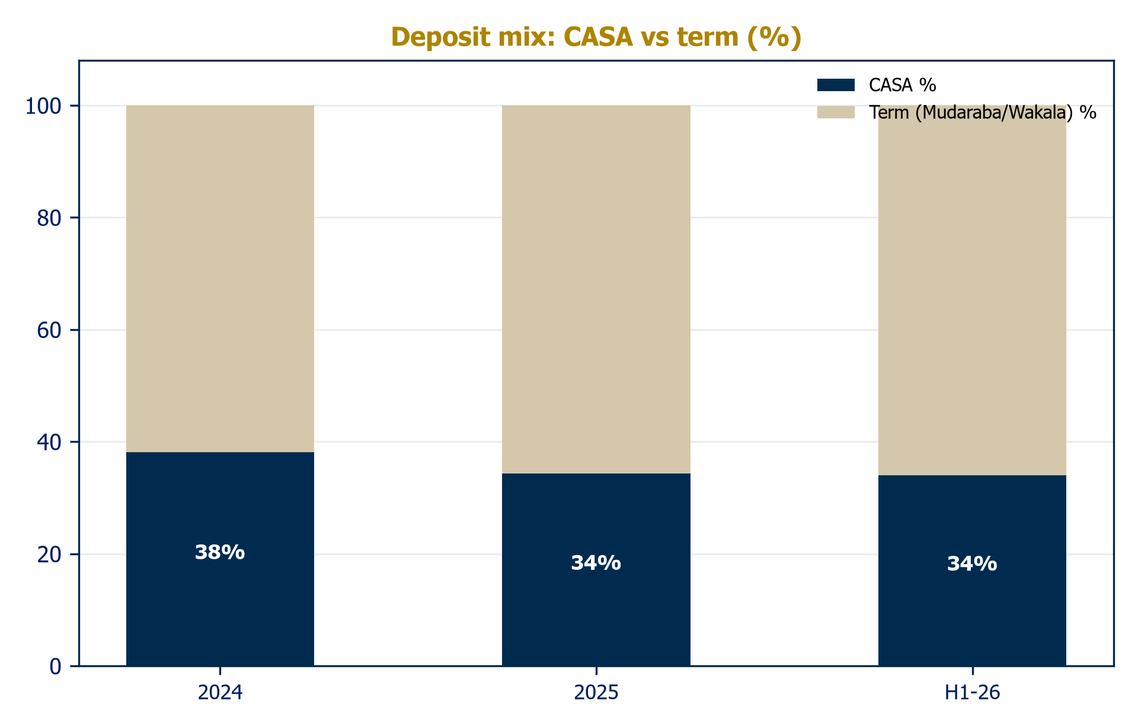
Source: Company disclosures

Customers and go-to-market
DIB serves at least five million customers (group communications cite up to 11 million across all markets; the figures differ in scope) spanning retail, SME, corporate, institutional and sovereign clients. Its natural base is the national and resident population preferring Sharia-compliant banking, but scale, pricing and digital experience make it a mainstream competitor for every customer: Islamic banking in the UAE is a competitive alternative, not a niche. Distribution runs through more than 540 branches group-wide, the DIB 'alt' digital stack, and relationship coverage for corporate and wealth segments.
Government and government-related entities are a structural client vertical the conventional competition cannot easily replicate: the ICD relationship, the chairman's position at the Ruler's Court, and mandates such as the 2026 strategic partnership with the Mohammed Bin Rashid Housing Establishment for national housing finance illustrate a pipeline of quasi-official business. Two go-to-market motions deserve attention. First, deposit gathering: 2025's 29% growth materially outpaced the sector as management deliberately mobilized funding ahead of demand, trading margin for liquidity. Second, origination scale: AED 124 billion of gross new financing in one year evidences a corporate franchise winning a disproportionate share of the UAE's credit expansion.

Competitive landscape
DIB competes on three fronts. Against UAE Islamic banks for the Sharia-preferring customer: ADIB (assets AED 281 billion, net profit AED 7.1 billion, an industry-leading ~28% ROE) is the reference peer, two-thirds DIB's size but meaningfully more profitable and rewarded for it at 2.66x book; Emirates Islamic was 2025's fastest grower (assets +31%, record AED 3.3 billion profit) and combines ENBD's technology with an Islamic wrapper aimed at DIB's home market; Sharjah Islamic and Ajman Bank are sub-scale but compounding quickly. Against the UAE conventional giants for the mainstream customer and every large corporate mandate: Emirates NBD (assets above AED 1 trillion, and a landmark USD 2.75 billion acquisition of 60% of India's RBL Bank in June 2026) and FAB (assets AED 1.4 trillion, ROTE 19.2%) define the scale frontier. Against the regional Islamic champions for capital-markets flow and the global-champion narrative: Al Rajhi (USD 278 billion of assets, 23.4% ROE, 16.4x earnings) and KFH (USD 139 billion).
A newer front is digital: ruya, the Ajman-based Islamic digital bank, onboarded roughly 60,000 customers in its first year and became the world's first Islamic bank to offer virtual-asset investments; Wio reached AED 61 billion of assets and profitability; Zand targets corporate and digital assets. None threatens DIB's balance sheet today, but they compress retail economics and raise the customer-experience bar, and ruya competes for exactly the young Islamic-first customer DIB's rabbit app targets. DIB's advantages remain scale leadership in its segment, the sovereign relationship, the region's premier sukuk franchise, the strongest brand in Islamic banking history and an advanced digital stack; its vulnerabilities are a returns gap to ADIB, thinner capital than its growth rate comfortably supports, and heavier legacy real estate DNA.

Governance: Dubai Inc. at the table
The Government of Dubai anchors the register through the Investment Corporation of Dubai, holding approximately 27.9%, and the linkage runs deeper than ownership: DIB's chairman, H.E. Mohammed Ibrahim Al Shaibani, is simultaneously Director General of the Dubai Ruler's Court and Managing Director of ICD, embedding the emirate's fiscal apparatus at the top of the governance structure. The board comprises nine members serving a 2023-2026 term, with Eng. Yahya Saeed Lootah as vice chairman, continuity to the founding family, and members drawn from Dubai's commercial establishment. The foreign ownership limit was raised to 40% in 2020, leaving headroom for international institutional ownership.
Sharia oversight rests with an Internal Sharia Supervision Committee of internationally recognized scholars: Prof. Dr. Mohammad Abdul Rahim Sultan Al Olama (chairman, member of Dubai's Grand Islamic Scholars Body), Prof. Dr. Mohamed Ali Elgari (vice chairman, Professor of Islamic Economics at King Abdul Aziz University and IDB Prize laureate), Prof. Dr. Muhammad Qaseem and Prof. Dr. Mohamad Akram Laldin. The committee operates under the Central Bank's Higher Sharia Authority framework, which since 2020 has required every Islamic bank to maintain a qualified ISSC, internal Sharia control and audit functions, and published resolutions. DIB's own Sharia infrastructure predates the regulation by three decades, its board was formalized in 1989, and its Dar Al Sharia subsidiary advises much of the industry, a quiet moat: the bank sets standards its competitors then follow.
Chart 7: Ownership structure
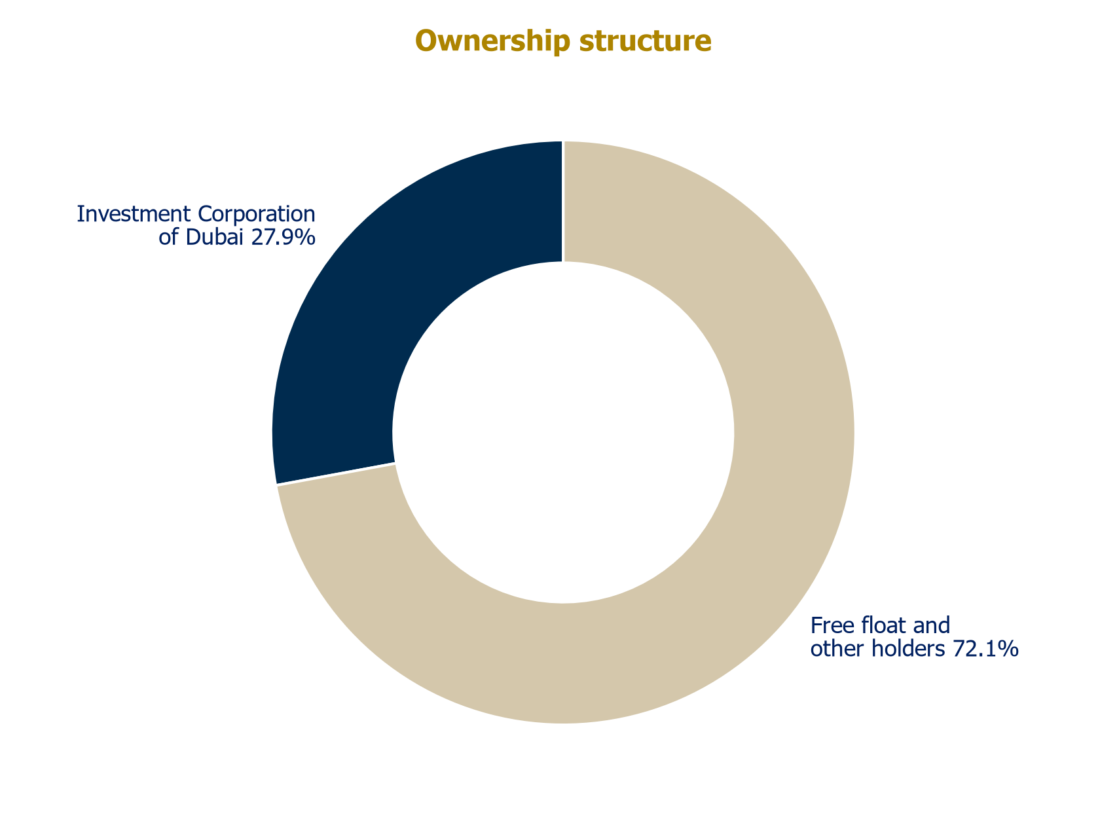
Source: DIB Annual Report 2025

Dr. Adnan Chilwan, Group Chief Executive Officer
Dr. Chilwan has led DIB since July 2013 and ranks among the longest-serving and most consequential bank CEOs in the Gulf. He joined DIB in 2008 as Chief of Retail Banking after senior roles across both conventional and Islamic institutions, including HSBC, Dubai Bank, Abu Dhabi Islamic Bank and Mashreq, giving him nearly three decades of experience across both models. His impact was immediate: in his first nine months as CEO net profit rose 33.5%, and by 2014 the bank served 1.4 million customers through 86 UAE branches. Under his thirteen-year leadership DIB has grown into a group with assets exceeding USD 115 billion, absorbed Noor Bank in a record-time integration, entered Turkey, Kenya and Indonesia, and established itself as the most active bank in sustainable sukuk globally. He holds a PhD and an MBA in Marketing and is a Certified Islamic Banker. Beyond DIB he chairs the board of DIB Bank Kenya and holds board roles at Deyaar, the Liquidity Management Centre and the International Islamic Financial Market. External recognition includes Forbes Middle East Top 100 CEOs (2023 and 2024) and Banker of the Year at the MEA Finance Awards 2022. For investors, Chilwan personifies both strategic continuity and a concentration: the bank's modern identity is to a large degree his construction.

John Macedo, Chief Financial Officer
Macedo has been DIB's CFO since 2016, a decade of tenure spanning the Noor integration, the COVID cycle, the introduction of UAE corporate tax and the record 2025 growth year. He came to DIB from Saudi Hollandi Bank (later Alawwal Bank) in Riyadh, where he served as CFO through a period of regulatory transformation, and before that was CFO of the Africa Division at Liberty Life, the South African insurance group. He holds an Accounting Science degree from the University of South Africa. Macedo's fingerprints are on the funding strategy that defines the current balance sheet: the laddered sukuk program, the sustainable and sustainability-linked issuances at progressively tighter spreads, and the June 2026 USD 1 billion AT1 that rebuilt capital headroom after a year of 21% asset growth. His discipline shows in a cost-to-income ratio held in the 26-29% range through the growth surge, among the better prints in the regional sector.

Sanjay Malhotra, Chief Consumer Banking Officer
Malhotra has run DIB's consumer bank since February 2015, making him the architect of the retail franchise that anchors the group's low-cost deposits. His career spans three decades of consumer banking across the region: Head of Consumer Banking MENA at National Bank of Kuwait from 2007, Regional Head of Retail Banking at Arab Bank from 2004 to 2007, and earlier roles at ANZ Grindlays and Citibank India; he graduated from BITS Pilani in 1987. At DIB he has overseen the XTRA proposition, the rabbit digital app aimed at younger customers, and the consolidation of digital channels under DIB 'alt', through which 97% of the bank's transactions now flow. In an environment where UAE deposit competition is intensifying and digital challengers target exactly DIB's retail base, Malhotra's franchise is where that battle will be fought.
The wider bench includes Obaid Al Shamsi (COO), Naveed Ali (Corporate Banking), Musabbah Al Qaizi (Chief Digital Officer), Chandra Mohan Ganapathy (Group CRO) and Varun Sood (Chief Transformation Officer). Succession planning around the long-tenured Group CEO is the governance question we would press management on.

A bright financial outlook

The arc into 2025: from cleanup to compounding
The starting point matters for what follows. DIB entered this decade digesting the Noor Bank acquisition and a pandemic credit cycle: 2021 carried AED 2.4 billion of impairments at a 99bps cost of risk against an NPF ratio of 6.8%. The subsequent four years were a textbook workout. Impairments fell every single year, to AED 2.1 billion (2022), AED 1.4 billion (2023) and roughly AED 0.4-0.5 billion (2024-2025); the NPF ratio was cut by two-thirds; cash coverage rose from 72% to 120%; and pre-tax profit doubled from AED 4.4 billion to AED 9.0 billion. Revenue, meanwhile, re-based upward as the 2022-2023 rate surge lifted funded income by three-quarters. By the time the growth year arrived, the balance sheet had been scrubbed, which is why 2025's 21% expansion did not cost the bank a basis point of asset quality.

2025: the growth year
FY2025 was the strongest balance-sheet year in DIB's history: total assets up 21% to AED 416 billion, customer deposits up 29% to AED 320 billion, net financing up 23% to AED 262 billion, and AED 124 billion of gross new financing and sukuk originated, up 80% year on year. Operating revenue rose 3% to AED 13.3 billion and pre-tax profit reached AED 9.0 billion, up 20% against a normalized 2024. Asset quality reached decade bests: NPF at 2.65% (from 4.0%), total coverage 160%, cost of risk just 14bps. The growth was deliberately deposit-led, with term inflows parked at the central bank ahead of deployment, a strategy that trades near-term margin for balance-sheet optionality.
Chart 8: Total assets (AED bn)
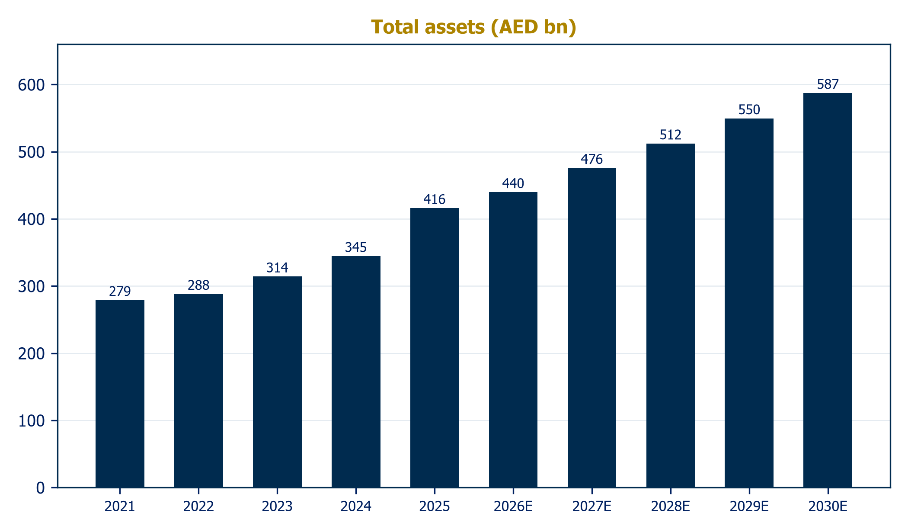
Source: Audited financial statements; Al Ramz Investment Research estimates
Chart 9: Financing vs deposits and the financing-to-deposit ratio
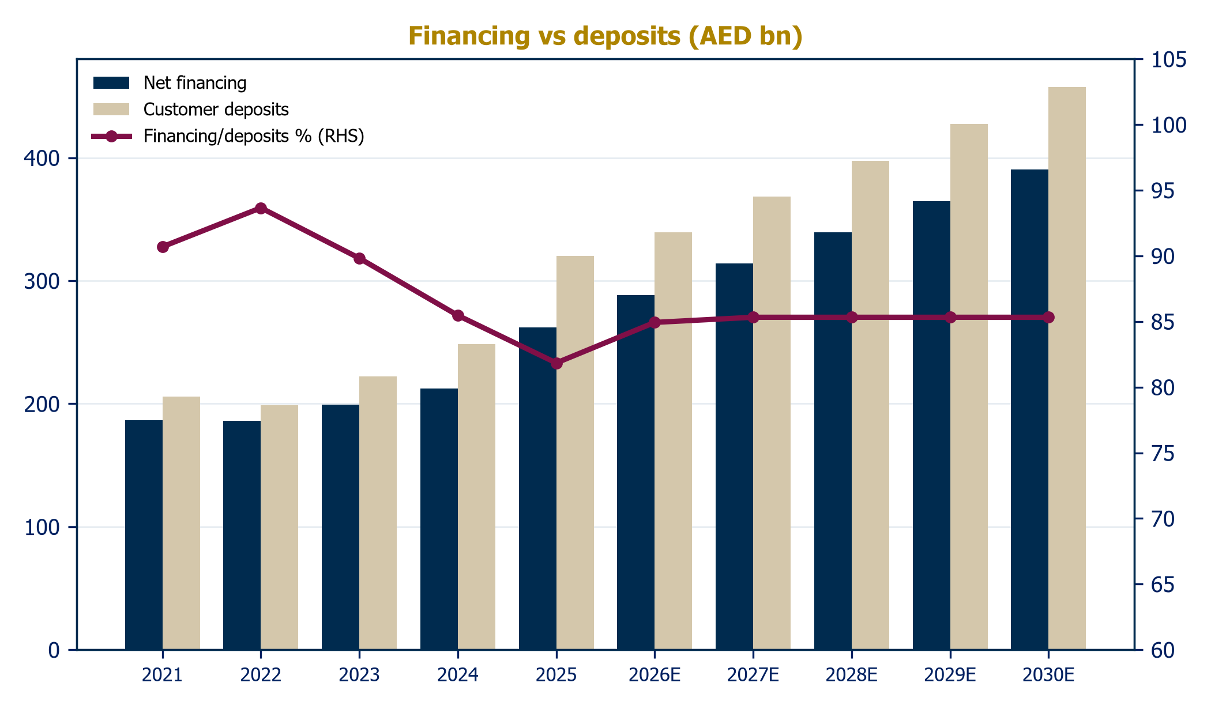
Source: Audited financial statements; Al Ramz Investment Research estimates

H1 2026: revenue up ten, profit flat, and why
The first half of 2026 showed the new earnings arithmetic. Gross revenue rose 10% to AED 12.4 billion and operating profit 6% to AED 4.8 billion, yet net profit held flat at AED 3.74 billion. Three forces: the net profit margin compressed to 2.4% as 2025's deposit mobilization repriced faster than assets; impairments normalized to AED 489 million (cost of risk 28bps versus an unrepeatable 14bps); and the tax line took 13.8% of pre-tax profit as the UAE's 9% corporate tax plus the Pillar Two 15% top-up fully landed. Management maintained full-year guidance: financing growth ~10%, NPM 2.3%, cost-to-income 28%, pre-tax ROTE 21%.
Table 1: 2026 progression vs guidance
Metric | Q1 2026 | H1 2026 | FY2026 guidance
Revenue growth, YoY | +13% | +10% | n.a.
Net profit margin | 2.5% | 2.4% | 2.3%
Cost-to-income | 28.2% | 29.0% | 28%
NPF ratio | 2.5% | 2.4% | 2.5%
Cost of risk (bps) | n.a. | 28 | n.a.
CET1 | 12.6% | 13.0% | n.a.
Pre-tax ROTE | 21.0% | 20% | 21%
Source: Company disclosures; H1 2026 investor presentation
Chart 10: Net operating revenue and growth
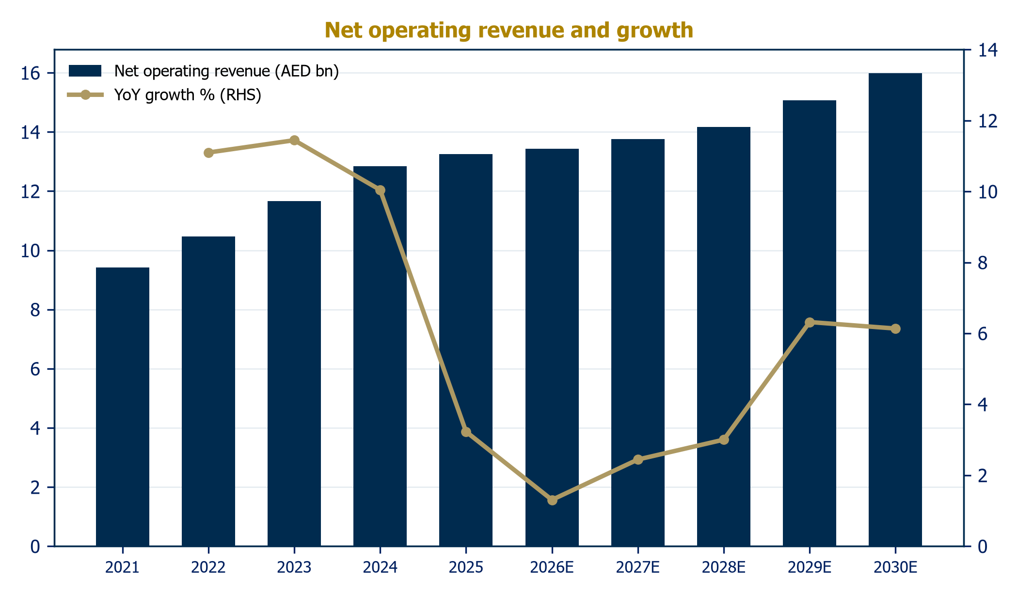
Source: Audited financial statements; Al Ramz Investment Research estimates
Chart 11: Pre-tax vs net profit: the tax wedge (AED bn)
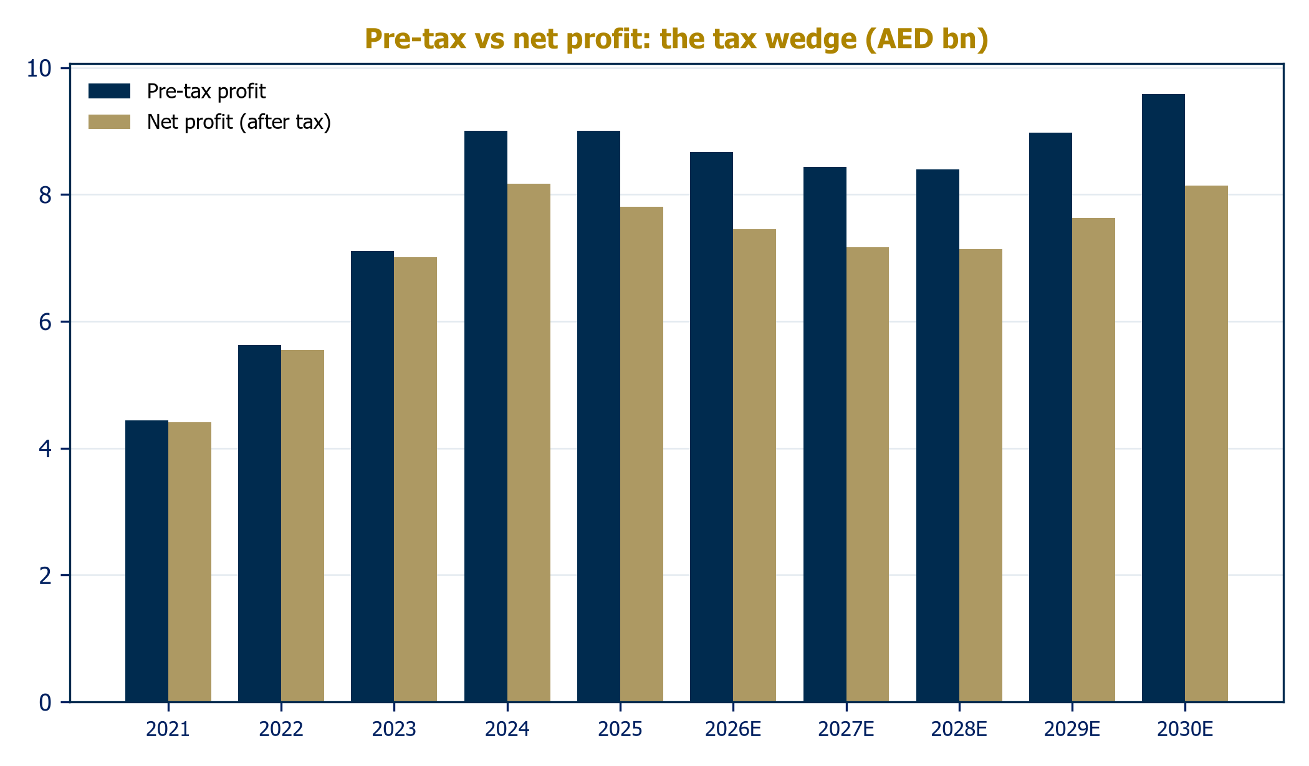
Source: Audited financial statements; Al Ramz Investment Research estimates

Our base case: guidance-anchored, honestly conservative
Our model is calibrated so that 2026 estimates land on the actual H1 run-rate, and follows management guidance where it exists. The pillars: financing growth of 10% in 2026 tapering to 7% by 2030; deposits growing broadly in line, keeping the financing-to-deposit ratio in the mid-80s; gross yields declining with the expected Fed path while funding costs reprice down more slowly; fee income compounding at 6%; operating cost growth of 4-5%; cost of risk stepping from 30bps to a mid-cycle 45bps; and a 15% effective tax rate from 2027.
Table 2: 2026 guidance vs our base case
Metric | Guidance | Our 2026E
Net financing & sukuk growth | ~10% | 10.0% (financing)
Net profit margin | 2.3% | 2.4% (model basis)
Cost-to-income | 28% | 29.3%
Cost of risk | ~ | 30bps
Pre-tax ROTE | 21% | ~19% (model basis)
NPF ratio | 2.5% | 2.4% (H1 actual)
Source: Company guidance (H1 2026 earnings call); Al Ramz Investment Research estimates
Chart 12: Net operating revenue by stream (AED bn)
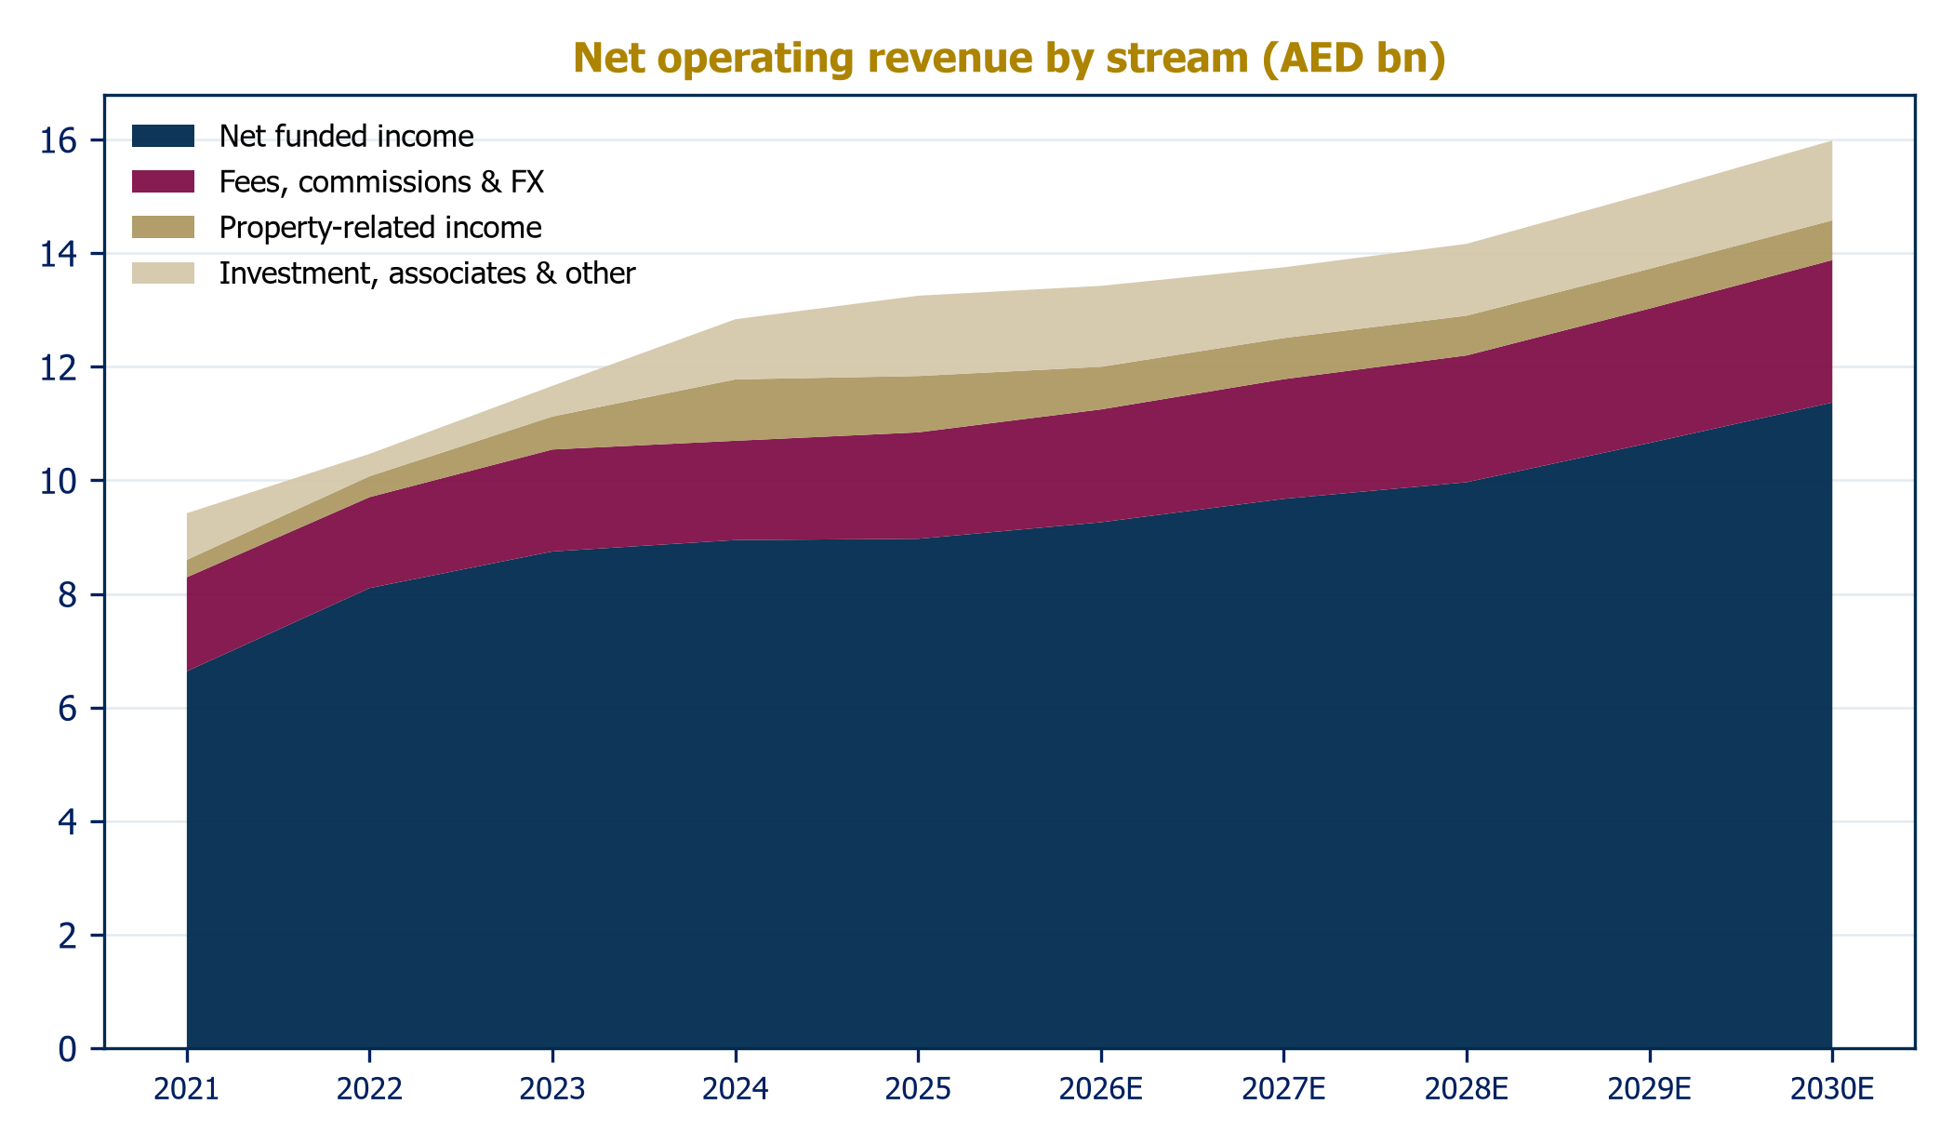
Source: Audited financial statements; Al Ramz Investment Research estimates
Chart 13: Earning asset mix (AED bn)
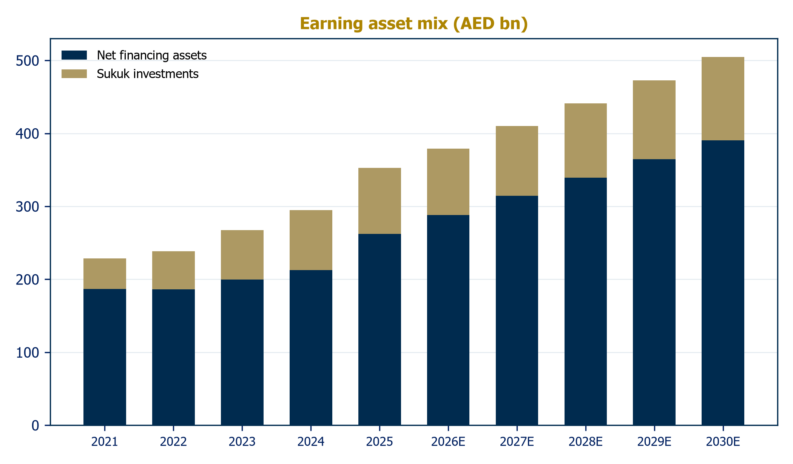
Source: Audited financial statements; Al Ramz Investment Research estimates
Chart 14: Margin dynamics: yield, cost of funds, net margin
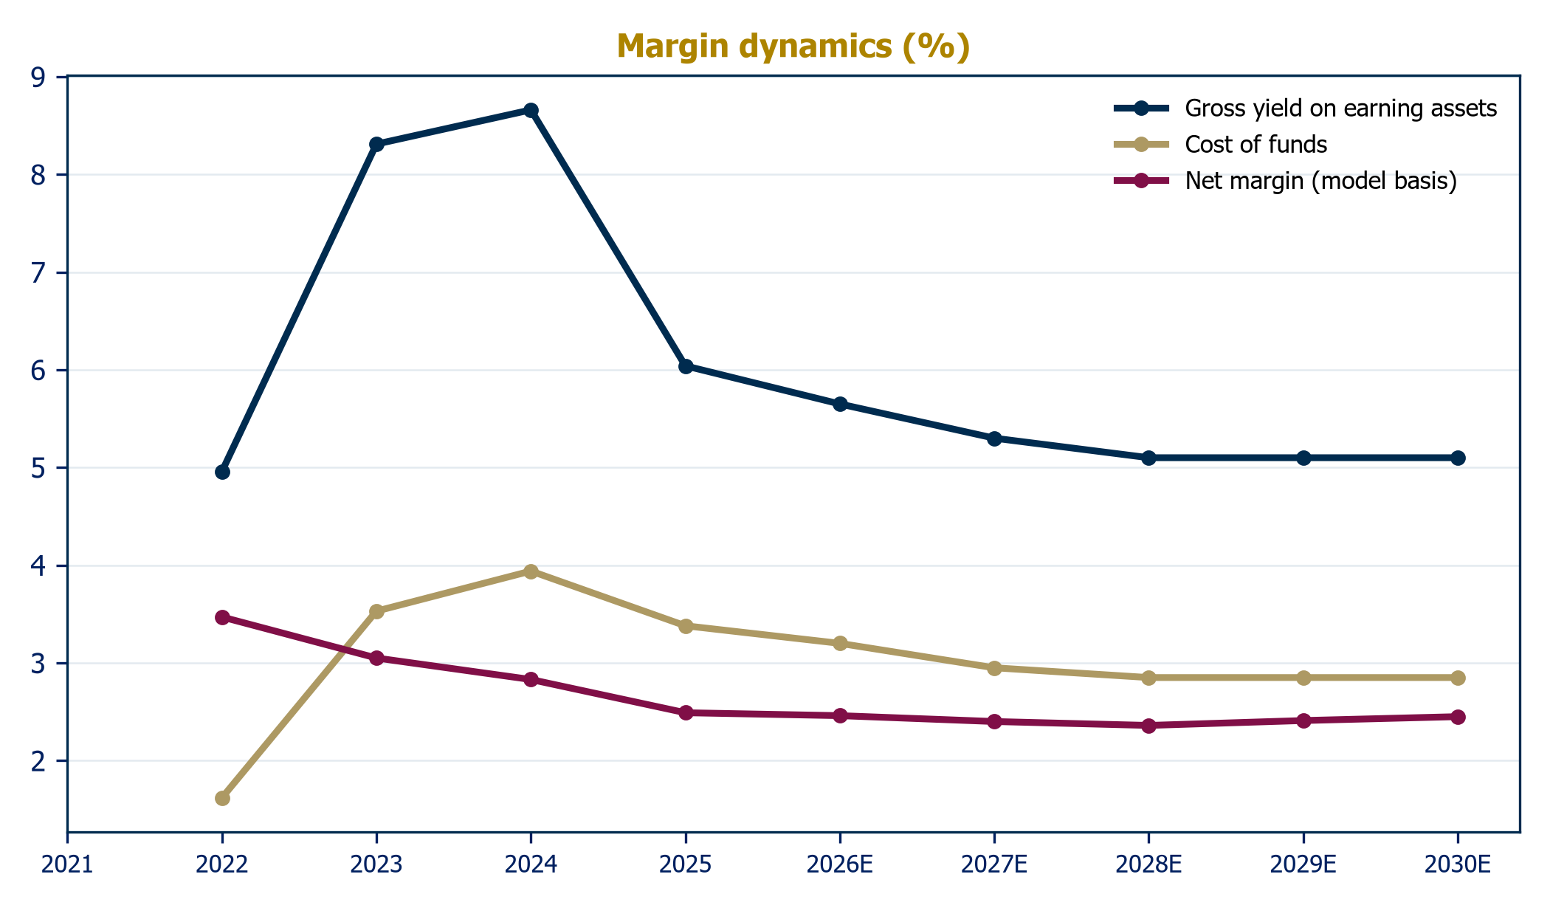
Source: Al Ramz Investment Research estimates on audited data

Efficiency and credit: normalization, not deterioration
The cost-to-income ratio, 26-27% through 2022-2024, has drifted to 28-29% as revenue growth slowed against continued investment in people and technology; our base case holds it near 29-30% before efficiency gains resume. The credit line is the bigger swing factor for estimates: 14bps of cost of risk in 2024-2025 was a gift of recoveries and the NPF cleanup, and we model a step to 45bps by 2028, in line with a mid-cycle UAE book. Even then, coverage at 158% and an NPF ratio near 2.4% leave DIB's balance sheet in its best shape since before the global financial crisis. Capital is the constraint to watch: CET1 of 13.0% at H1 2026 is adequate but not lavish against double-digit growth ambitions, which is exactly why the bank has twice tapped AT1 markets since late 2024.
Chart 15: Cost-to-income ratio (%)
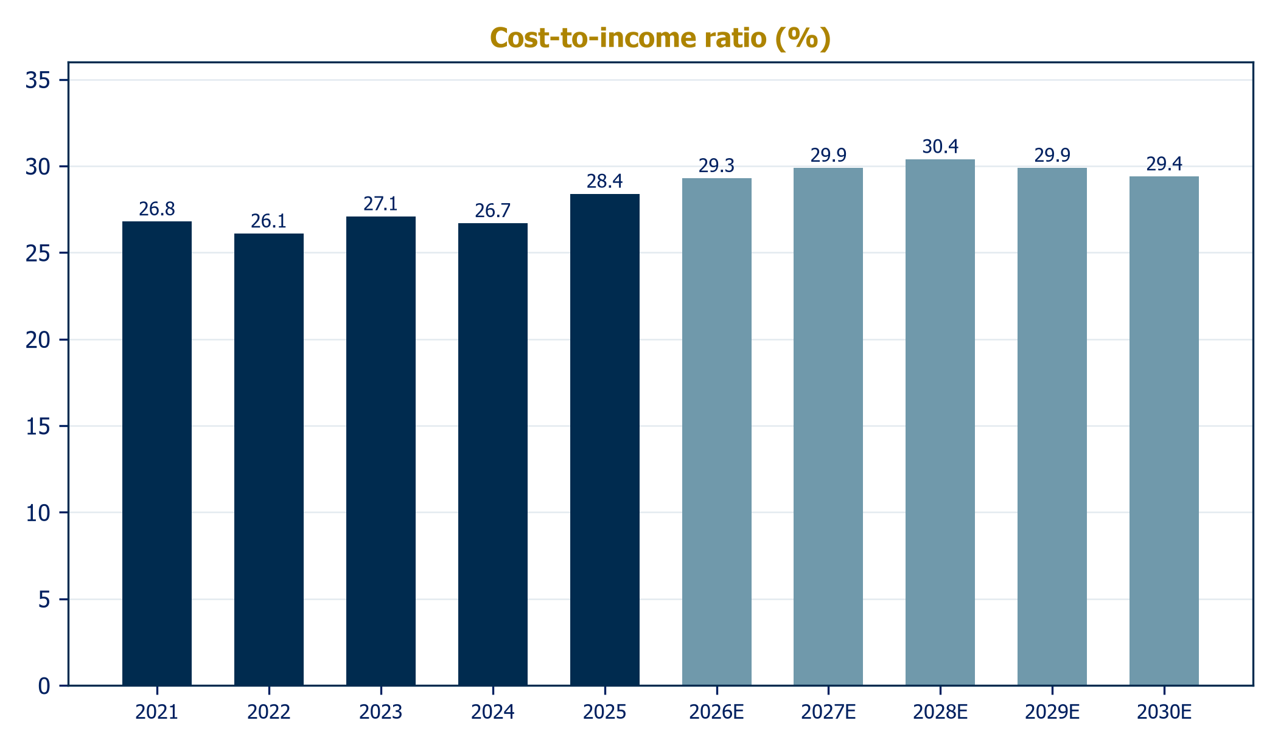
Source: Company disclosures; Al Ramz Investment Research estimates
Chart 16: Pre-impairment profit vs impairments (AED bn)
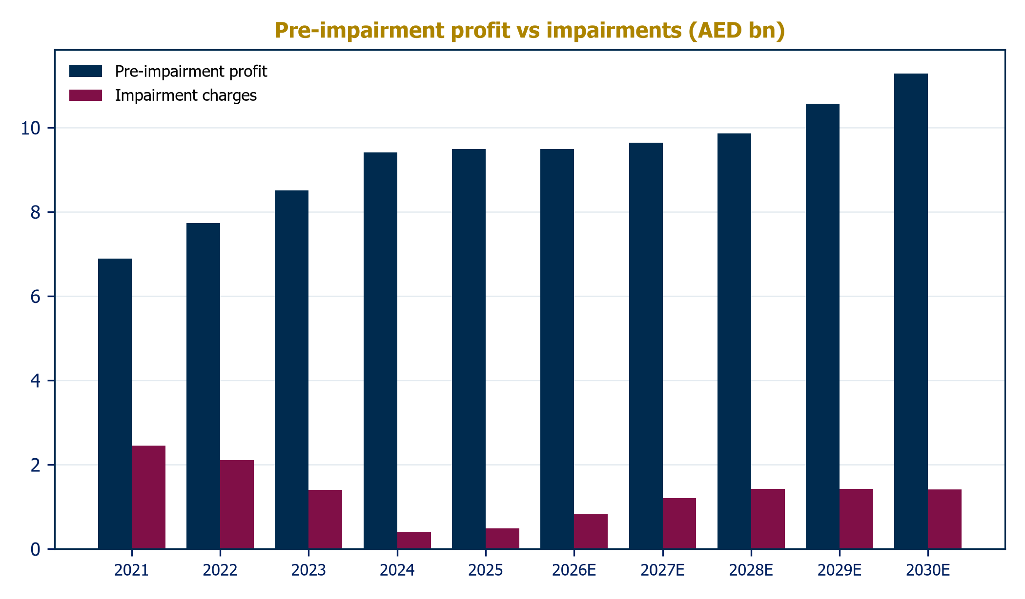
Source: Audited financial statements; Al Ramz Investment Research estimates
Chart 17: Cost of risk (bps)
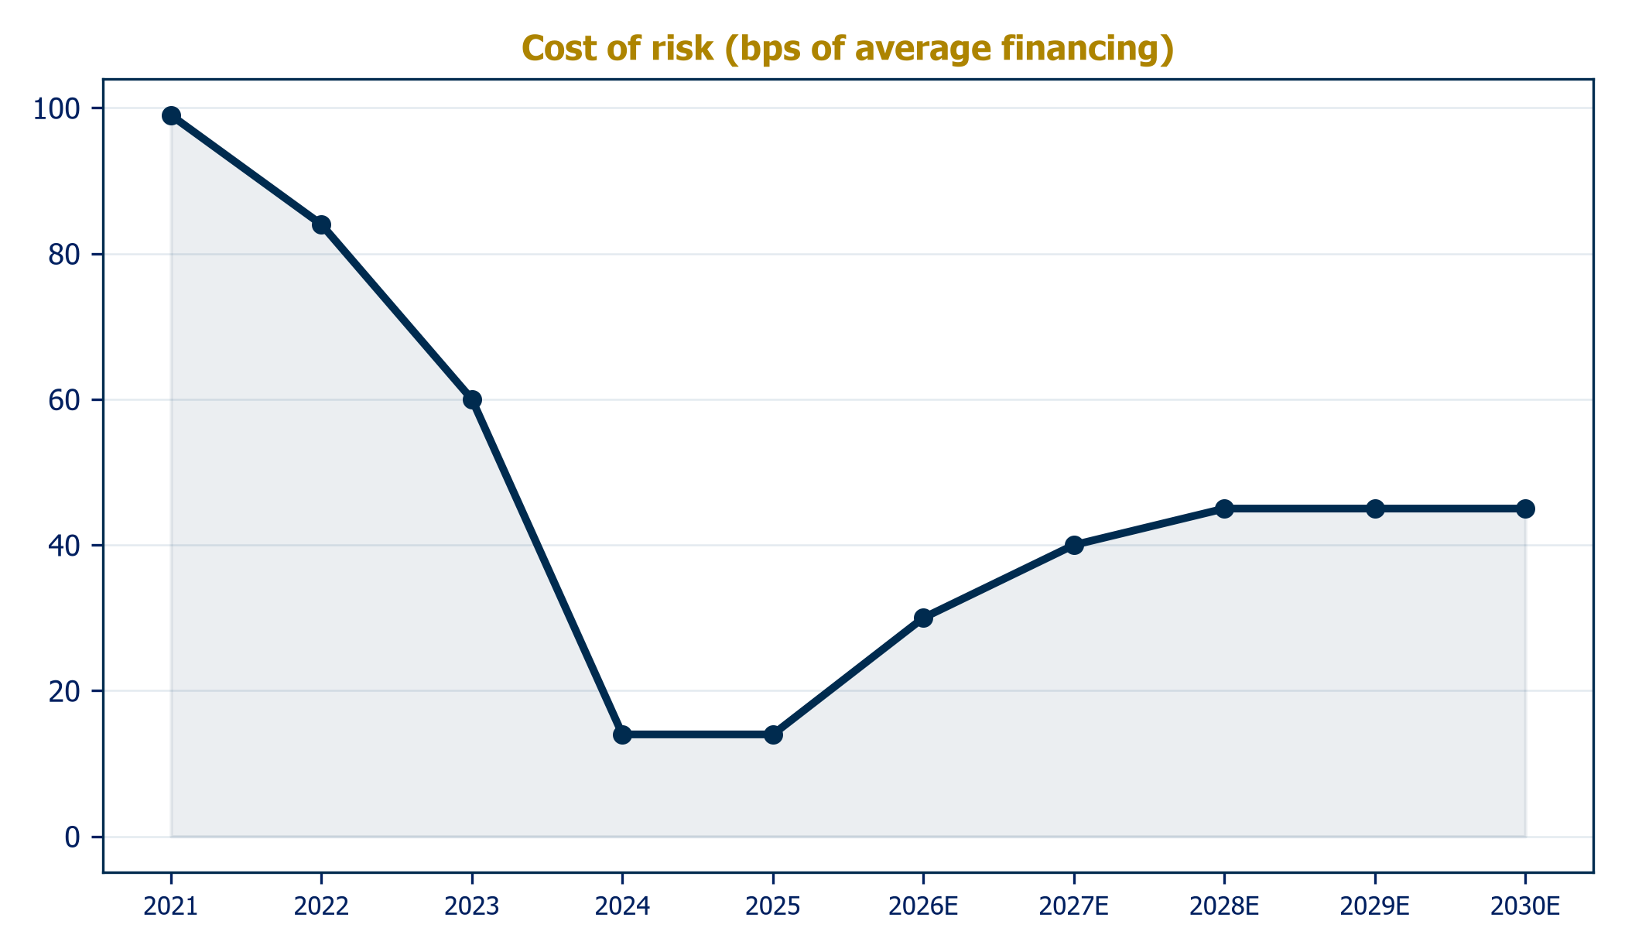
Source: Company disclosures; Al Ramz Investment Research estimates
Chart 18: Asset quality: NPF and coverage
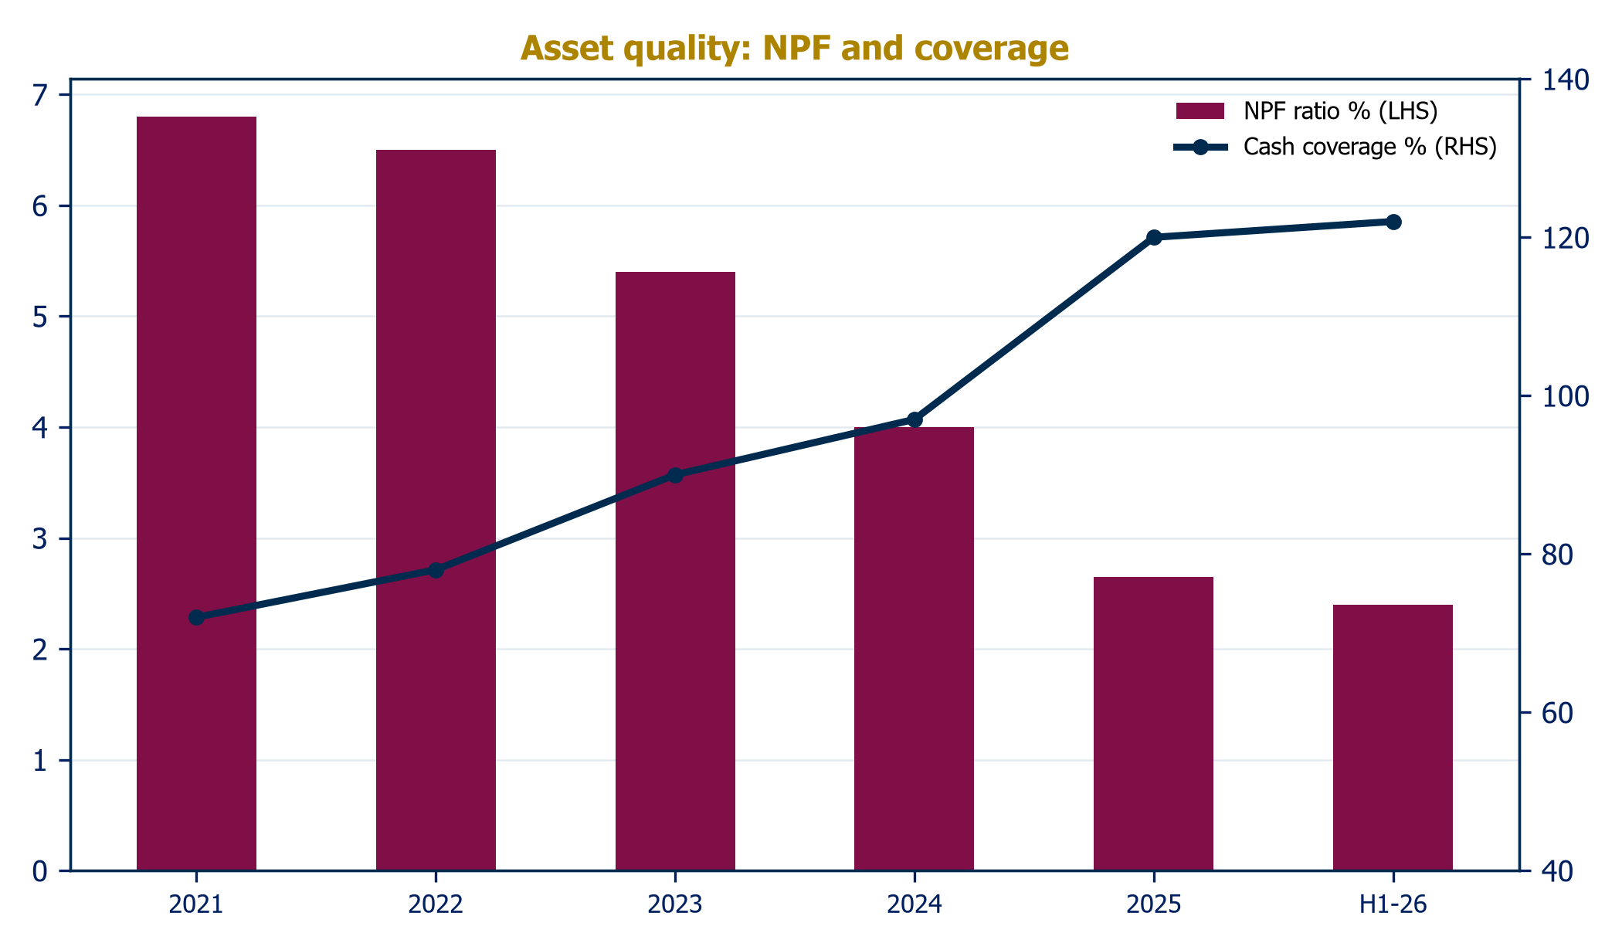
Source: Company disclosures
Chart 19: Capital adequacy (%)
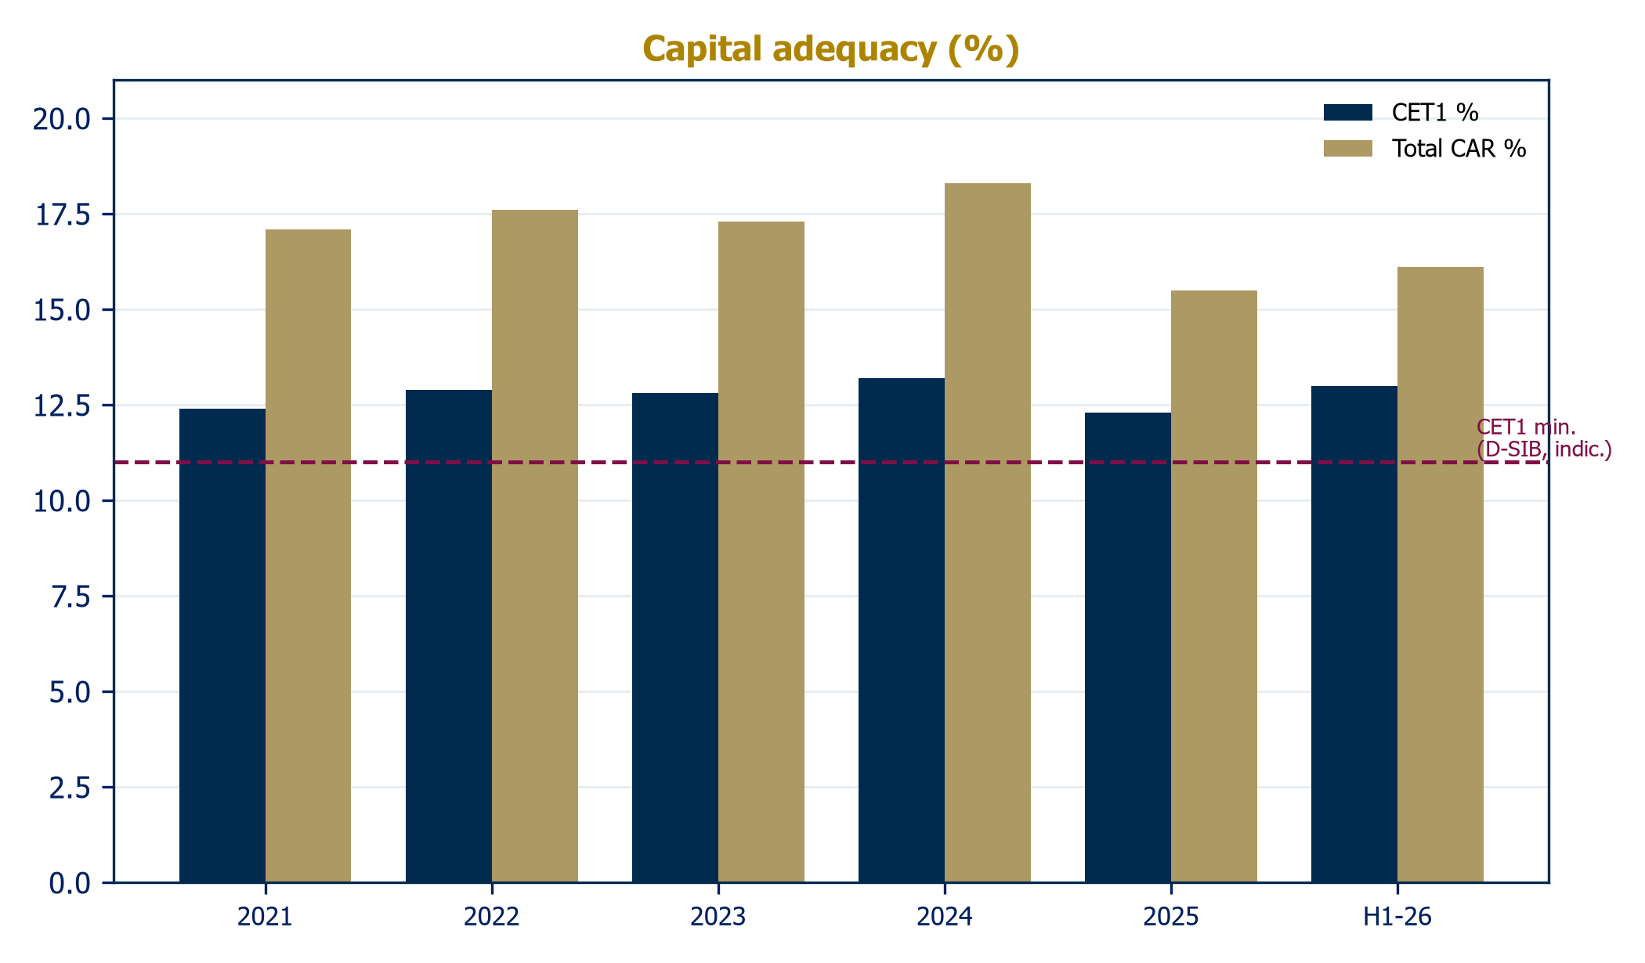
Source: Company disclosures

Funding and liquidity: the sukuk house funds itself well
DIB's liability franchise is a strategic asset in its own right. Customer deposits fund 77% of the balance sheet; the senior sukuk program (AED 25 billion outstanding at end-2025) provides duration; and the bank's capital-markets access was demonstrated twice in eight months at progressively better terms: a debut USD 1 billion sustainability-linked sukuk in November 2025 priced at Treasuries plus 90bps, the tightest public spread in the bank's history against a twice-oversubscribed book, and a USD 1 billion perpetual AT1 in June 2026 at a 6.250% profit rate against a USD 2.3 billion order book, the largest GCC AT1 of the recent period. Liquidity metrics remain comfortable, with LCR at 140% and NSFR at 105% at H1 2026. Q1 2026 confirmed the operating trajectory: revenue up 13% year on year, operating profit up 12%, NPF down to 2.5%, and CET1 rebuilding to 12.6% even before the AT1 print.

The earnings path: trough, then compound
Put together, our base case shows net profit of AED 7.45 billion in 2026, a trough near AED 7.14-7.17 billion in 2027-2028 as margin compression and credit normalization overlap with the full tax rate, then recovery to AED 8.15 billion by 2030. EPS follows from AED 0.93 to a 2027-28 trough of AED 0.89 and back to AED 1.02, above the 2024 peak. Dividends step from 35 fils toward 45 fils by 2030 on our assumptions. The uncomfortable output is returns: with a roughly 40% payout, equity compounds faster than earnings, and post-tax ROTE settles near 12-13% from 17% in 2025. That single ratio is the pivot of the valuation debate in the next chapter, and lifting it, through payout, mix, or growth, is the clearest management lever we can identify.
Chart 20: Returns: ROTE and ROA
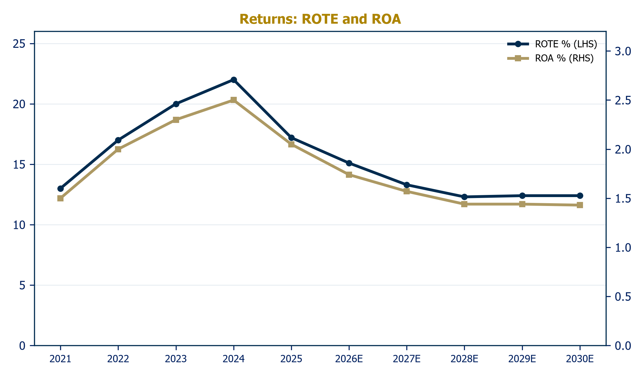
Source: Al Ramz Investment Research estimates on audited data
Chart 21: EPS and DPS (AED)
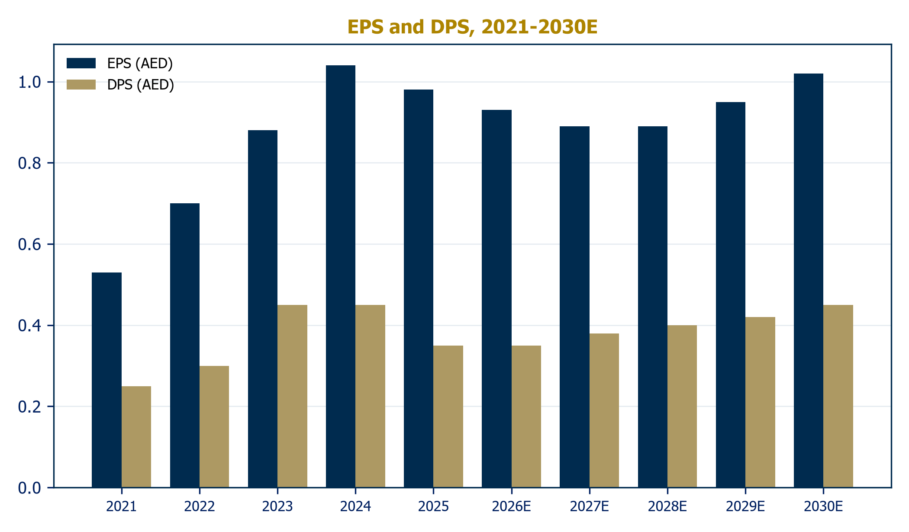
Source: Company disclosures; Al Ramz Investment Research estimates
Table 3: Scenario outcomes, 2030E
 | Bull | Base | Bear
Earning asset growth (CAGR) | 11.0% | 8.0% | 5.0%
Net profit margin | 2.45% | 2.30% | 2.10%
Cost-to-income | 27.0% | 29.5% | 31.5%
Cost of risk (bps) | 30 | 42 | 65
2030E net profit (AED bn) | 10.6 | 8.2 | 5.5
2030E EPS (AED) | 1.34 | 1.02 | 0.67
Source: Al Ramz Investment Research estimates
Chart 22: 2030E net profit by scenario (AED bn)
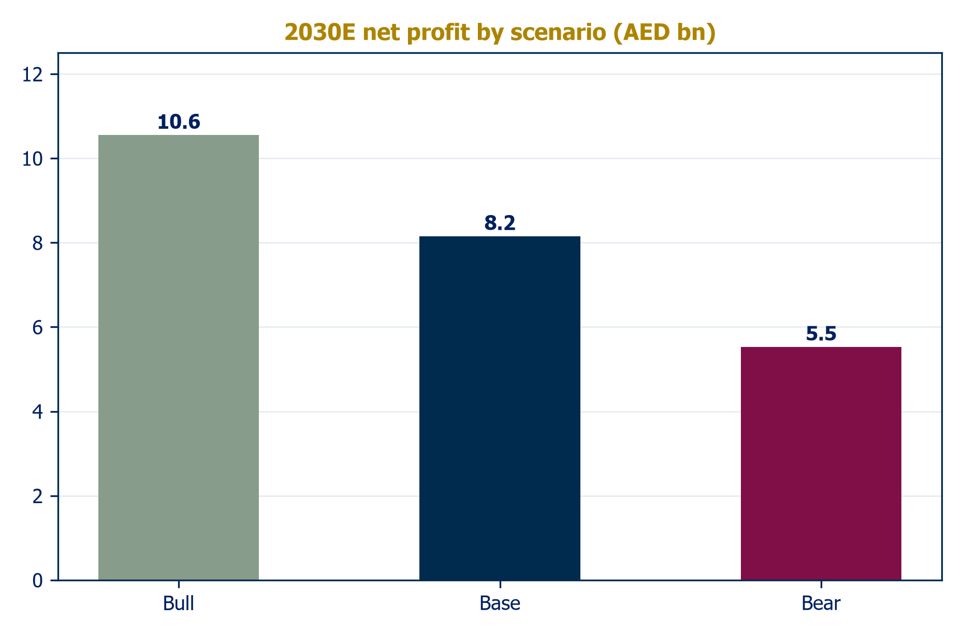
Source: Al Ramz Investment Research estimates

The de-rating disconnect
Every initiation needs to answer one question above all others. For DIB in 2026 the question is not whether the franchise is good, fifty years of evidence answers that, but why the market stopped paying for it, and what would make it start again.

What happened to the stock
DIB closed at an all-time high on 9 February 2026, the session before FY2025 results. It has since fallen roughly 28%, is down 25.6% over twelve months and 21% year to date, against a DFM index down mid-single digits from its peak and ADIB up 9.5% over the same window. The de-rating happened while the company was reporting record assets, decade-best asset quality, and maintained guidance. Street consensus sits at Hold with an AED 8.21 target; nobody downgraded the franchise. The stock simply stopped being paid for.
Chart 23: Trailing P/E across the peer group (x)
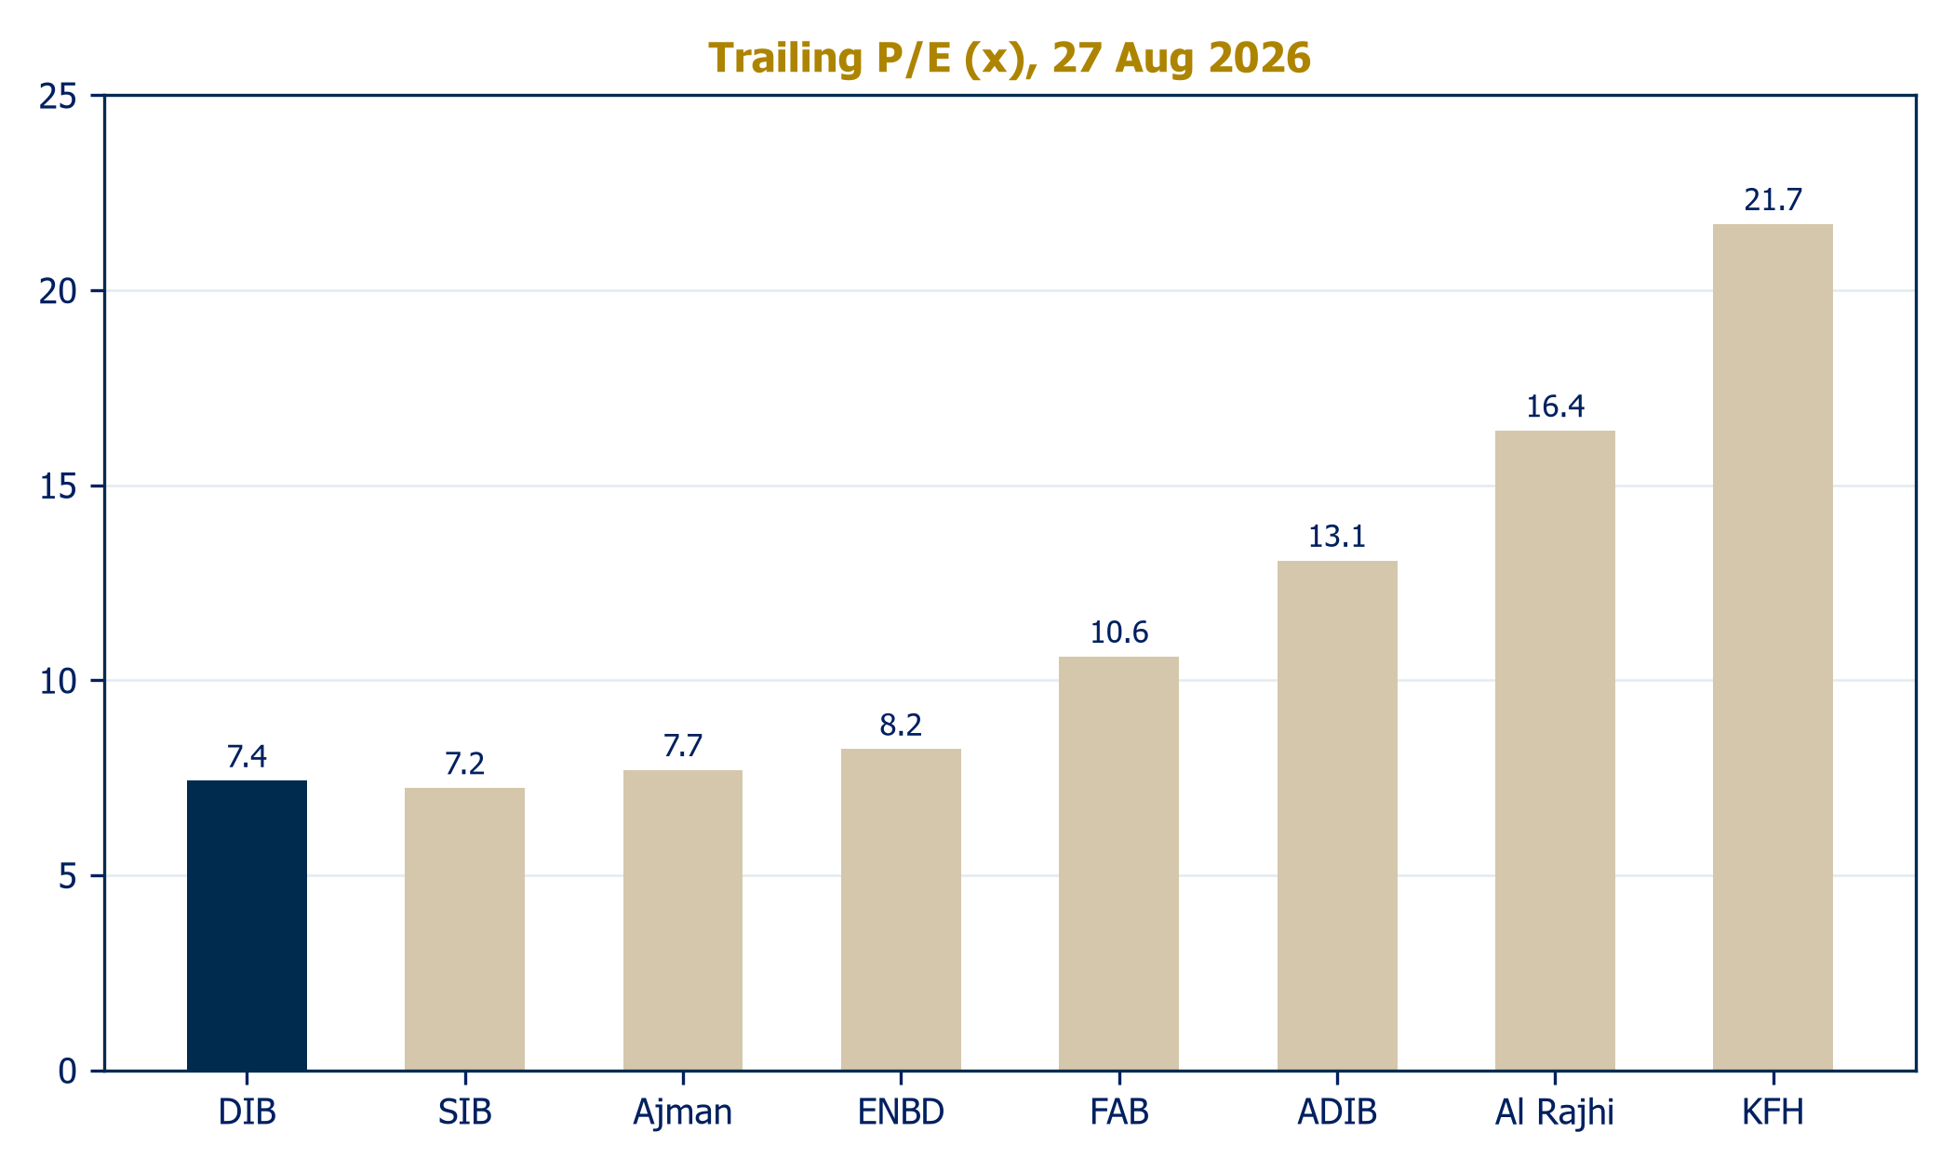
Source: stockanalysis.com, 27 Aug 2026
Table 4: Peer comparison
Bank | Assets (bn) | FY25 net profit | ROE | P/E (x) | P/B (x)
DIB (UAE) | AED 416 | AED 7.8bn | 17.2% | 7.4 | 1.24
ADIB (UAE) | AED 281 | AED 7.1bn | ~28% | 13.1 | 2.66
Emirates Islamic (UAE) | AED 146 | AED 3.3bn | n.a. | n.m. | n.m.
Sharjah Islamic (UAE) | AED 90 | AED 1.3bn | 16.3% | 7.2 | n.a.
Ajman Bank (UAE) | AED 33 | AED 0.5bn | 15.6% | 7.7 | n.a.
Al Rajhi (KSA) | SAR 1,043 | SAR 24.8bn | 23.4% | 16.4 | ~3.7
KFH (Kuwait) | KD 42.8 | KD 0.63bn | ~11% | ~21.7 | n.a.
Emirates NBD (UAE) | AED 1,000+ | AED 24.0bn | 18.8% | 8.2 | 1.23
FAB (UAE) | AED 1,400 | AED 21.1bn | 19.2% | 10.6 | 1.51
Source: Company disclosures; stockanalysis.com, 27 Aug 2026. Emirates Islamic multiples not meaningful (~0.1% free float); some figures computed.

Three mechanical explanations, all partial
First, the tax wedge made pre-tax delivery invisible. DIB's headline communication celebrates pre-tax records, but shareholders eat after-tax earnings, and those have been flat for three halves: the 9% federal tax plus the 15% Pillar Two top-up consumed the entire operating improvement. A market trained on DIB's pre-2024 net profit trajectory saw stagnation where management saw growth.
Second, the dividend cut broke the signal. Cutting the FY2025 dividend to 35 fils from 45, despite record pre-tax profit, was prudent capital management ahead of 21% balance-sheet growth, but it read as a downgrade of shareholder priority, and in a market where ADIB pays out 50%-plus, income investors rotated.
Third, the returns math genuinely softened. As this report's model shows, heavy retention plus margin compression plus full taxation grinds post-tax ROTE from 17% toward 12-13%. The market's P/B machine is brutal about that: our peer scatter shows UAE and Saudi banks priced almost exactly on the justified-P/B line, and DIB's position on that line at 1.0-1.2x book is not an anomaly, it is arithmetic.
Chart 24: The market pays for returns: ROE vs P/B
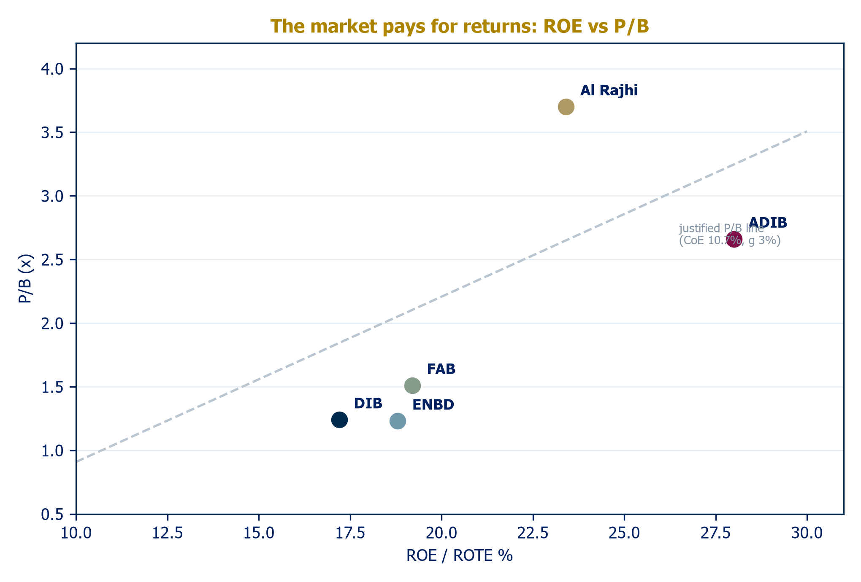
Source: Company disclosures; stockanalysis.com; Al Ramz Investment Research

What the arithmetic misses
Three things, in our view. The franchise premium is being priced at zero. DIB is the largest bank in its segment in the market with the strongest policy tailwind in global Islamic finance, holds an irreplaceable sukuk franchise, and carries explicit sovereign alignment; none of that appears in a multiple that matches Sharjah Islamic Bank's. The capital rebuild is done. The June 2026 AT1 took CET1 back to 13.0% and RWAs are funded for the growth plan, which removes the equity-raise tail risk that hung over the story. The payout lever is live. Management cut the dividend into a growth year; the corollary is that as growth moderates toward our 7-8% forecast, the same logic argues for payout normalization, and our DDM shows each ten points of payout is worth roughly half a dirham of fair value.
Chart 25: FY2025 net profit across the peer group (AED bn)
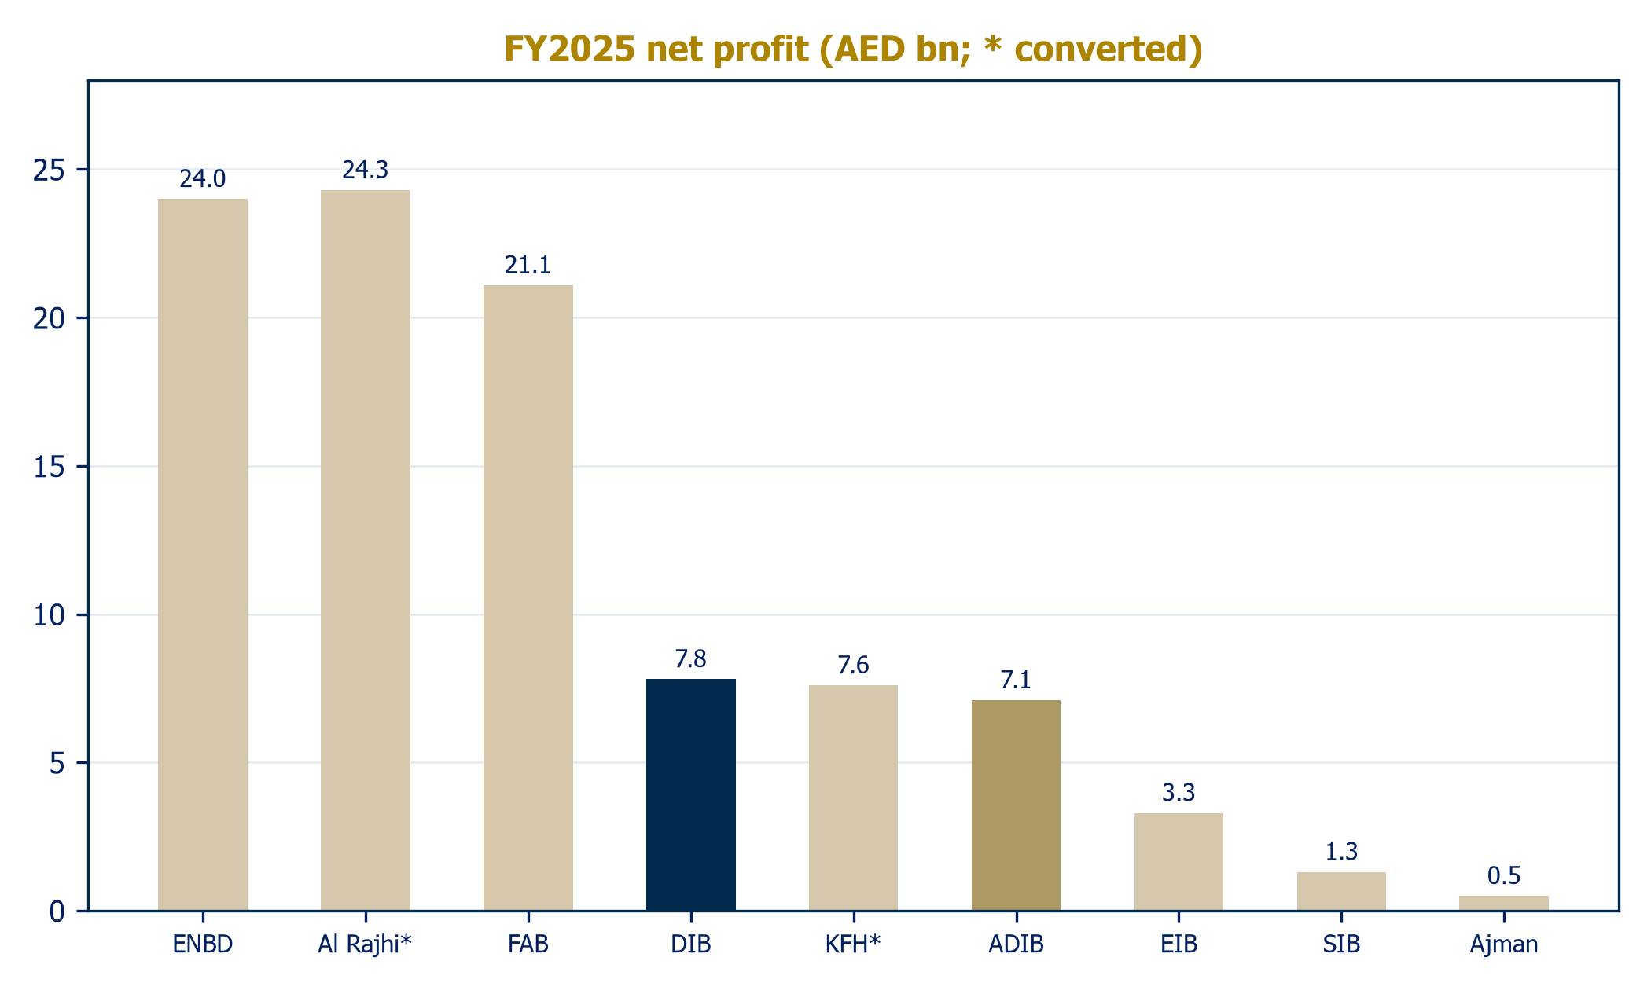
Source: Company disclosures; conversions at spot rates

What would re-rate the stock
We would upgrade on evidence of any of: a stated payout policy or a return toward 45 fils; two consecutive quarters of NPM at or above the 2.3% floor, proving the margin trough; ROTE stabilization in disclosure and delivery; or balance-sheet growth converting into fee franchises (sukuk league tables, international associates) that lift returns without capital. Symmetrically, the bear path is margin overshoot below 2.1% or a Dubai property correction. Our sensitivity tables in the next chapter price each of these beliefs explicitly. At 1.0x book, we think the market has already paid for the bear case; it has not yet paid for management pulling any lever at all.
Chart 26: Valuation multiples: current vs history vs target
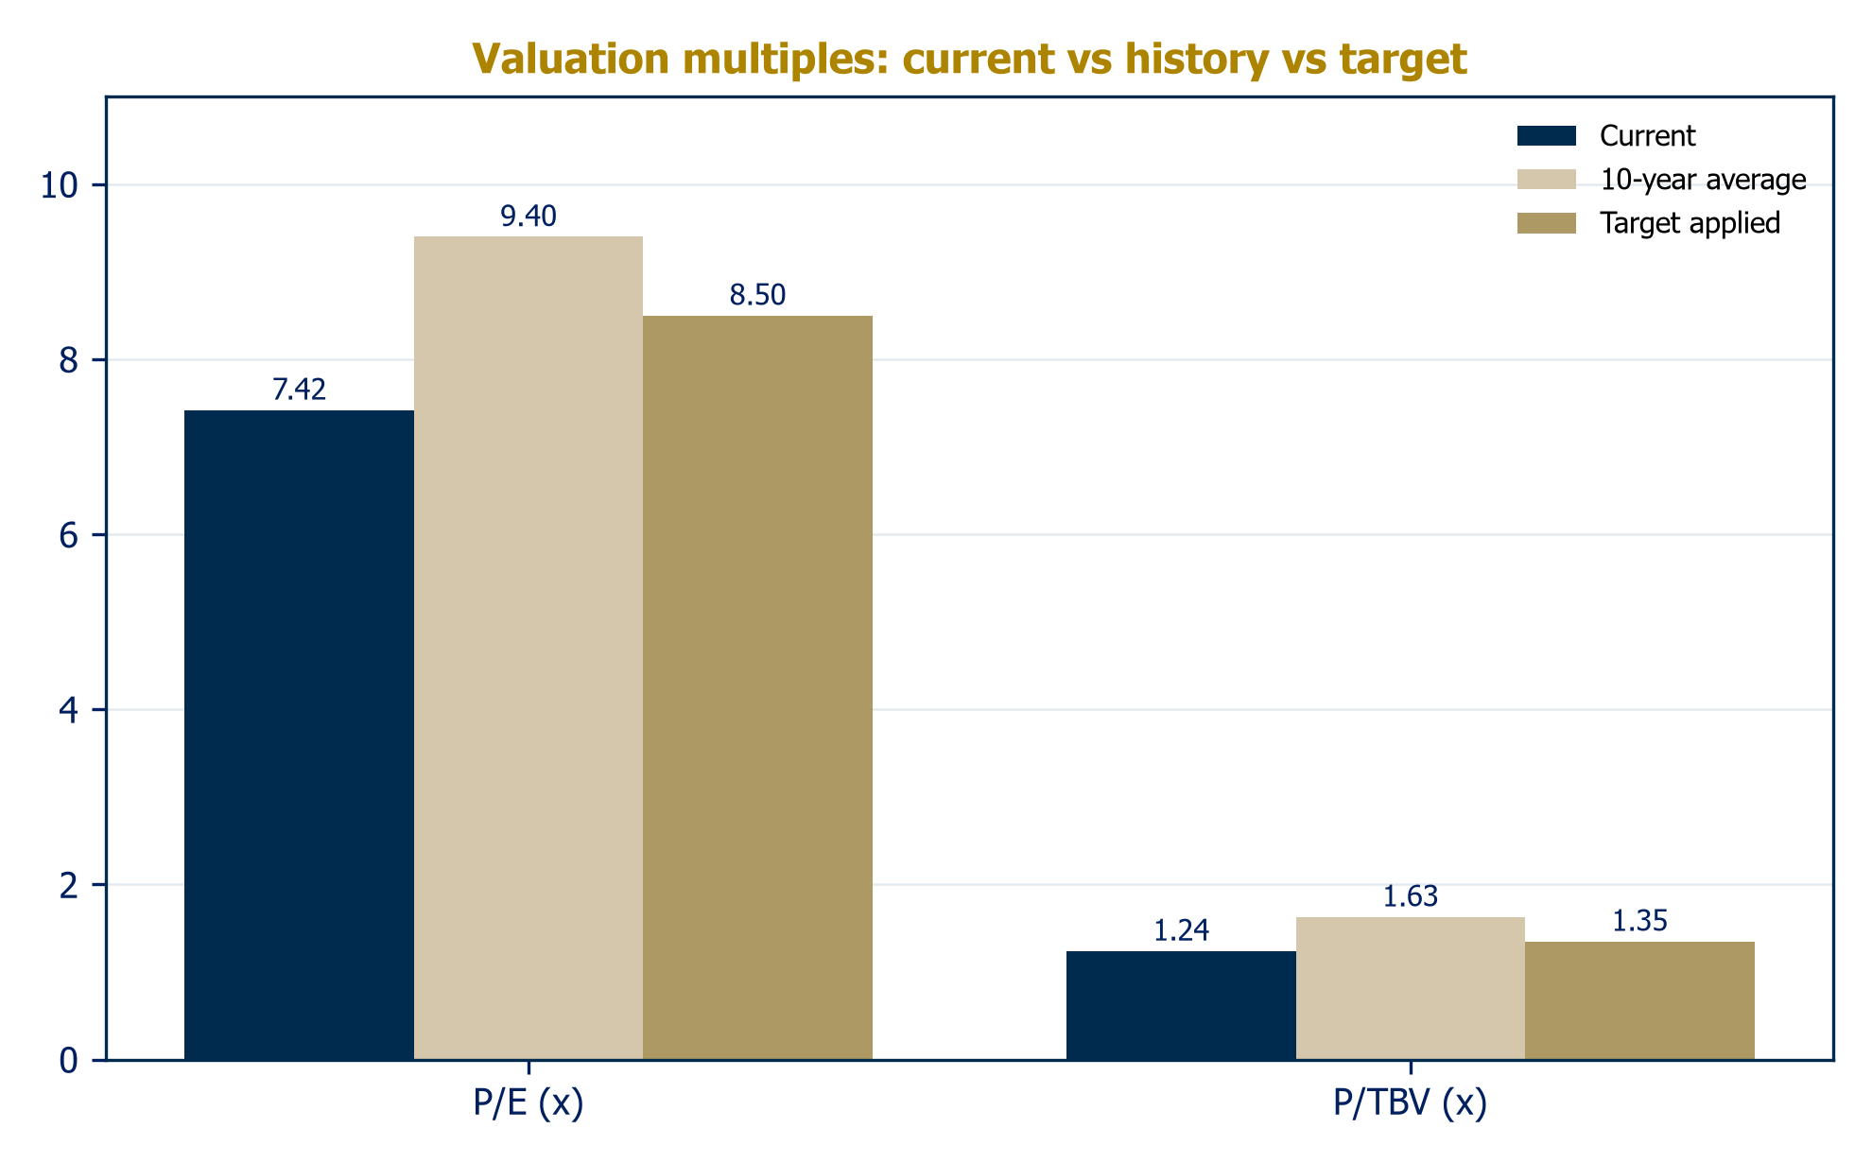
Source: stockanalysis.com; Al Ramz Investment Research (2023) historical anchors

An attractive entry-point, in time
We value DIB with four equity-side methods, equally weighted. Enterprise-value approaches built on unlevered free cash flow do not apply to a deposit-funded bank, so the toolkit is the classic bank set: what returns justify against book, what the dividends are worth, what peers imply, and what DIB's own history says. The blend gives a fair value of AED 7.98, 9.2% above the last close, and an Equal-Weight initiation under the house rule of plus-or-minus 15%.
Table 5: Fair value build
Method | Implied value (AED) | Weight | Contribution
Justified P/TBV (Gordon on ROTE) | 8.37 | 25% | 2.09
Dividend discount model | 6.40 | 25% | 1.60
Trading comparables | 8.29 | 25% | 2.07
Historical multiples | 8.87 | 25% | 2.22
Blended fair value | 7.98 | 100% | 7.98
Source: Al Ramz Investment Research estimates

Cost of equity: 10.7%
Risk-free rate 4.0% (10-year US Treasury, the relevant anchor under the peg), equity risk premium 6.0%, beta 1.05, plus 40bps for regional and concentration factors: a 10.7% cost of equity, with terminal growth of 3.0%. Both are live inputs in the model.

Justified P/TBV: AED 8.37
The Gordon formulation ties the warranted book multiple to sustainable returns: (ROTE minus g) over (CoE minus g). The judgment is sustainable ROTE. DIB earned about 17% in FY2025; our base case fades to 12-13% on heavy retention. We adopt 13.0%, between the two, implicitly assuming payout normalization restrains the equity build. That warrants 1.30x tangible book against 2026E TBVPS of AED 6.44: AED 8.37. The grid below is the debate in numbers: defend 15% ROTE and the stock is worth ten dirhams; accept the fade and today's price is roughly fair.
Table 6: Justified P/TBV sensitivity (AED/share)
CoE \ ROTE | 11% | 12% | 13% | 14% | 15%
9.7% | 7.69 | 8.65 | 9.61 | 10.57 | 11.53
10.2% | 7.16 | 8.05 | 8.94 | 9.84 | 10.73
10.7% | 6.69 | 7.53 | 8.37 | 9.20 | 10.04
11.2% | 6.28 | 7.07 | 7.85 | 8.64 | 9.42
11.7% | 5.92 | 6.66 | 7.40 | 8.14 | 8.88
Source: Al Ramz Investment Research estimates
Chart 27: Justified P/TBV fair value sensitivity (AED/share)
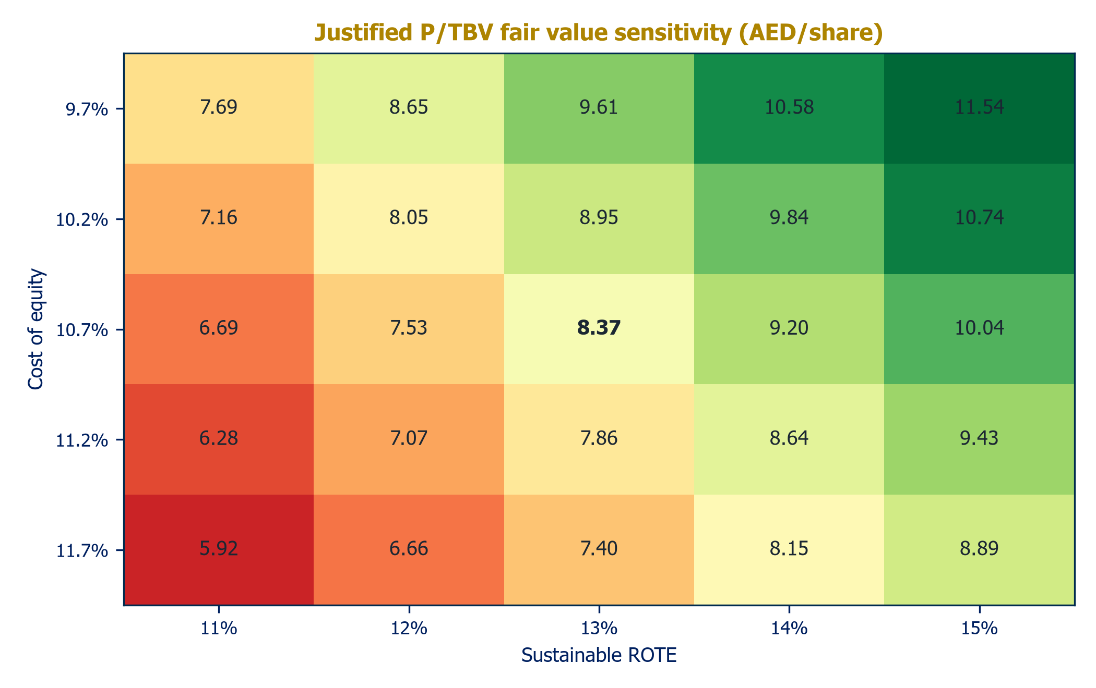
Source: Al Ramz Investment Research estimates

Dividend discount: AED 6.40, and deliberately so
Discounting the base-case dividend path (35 to 45 fils, 2026-2030) at 10.7% gives AED 1.47 of present value; a terminal value on a normalized 60% payout of 2031 earnings adds AED 4.92. Total: AED 6.40. The DDM prices only the cash the base case actually pays, and its gap to the other methods is precisely the market's current complaint. It is also the cleanest statement of the upside lever: payout normalization from 2027 rather than the terminal year would lift this leg toward AED 7.5-8.0 on its own.
Chart 28: Dividend discount model build (AED/share)
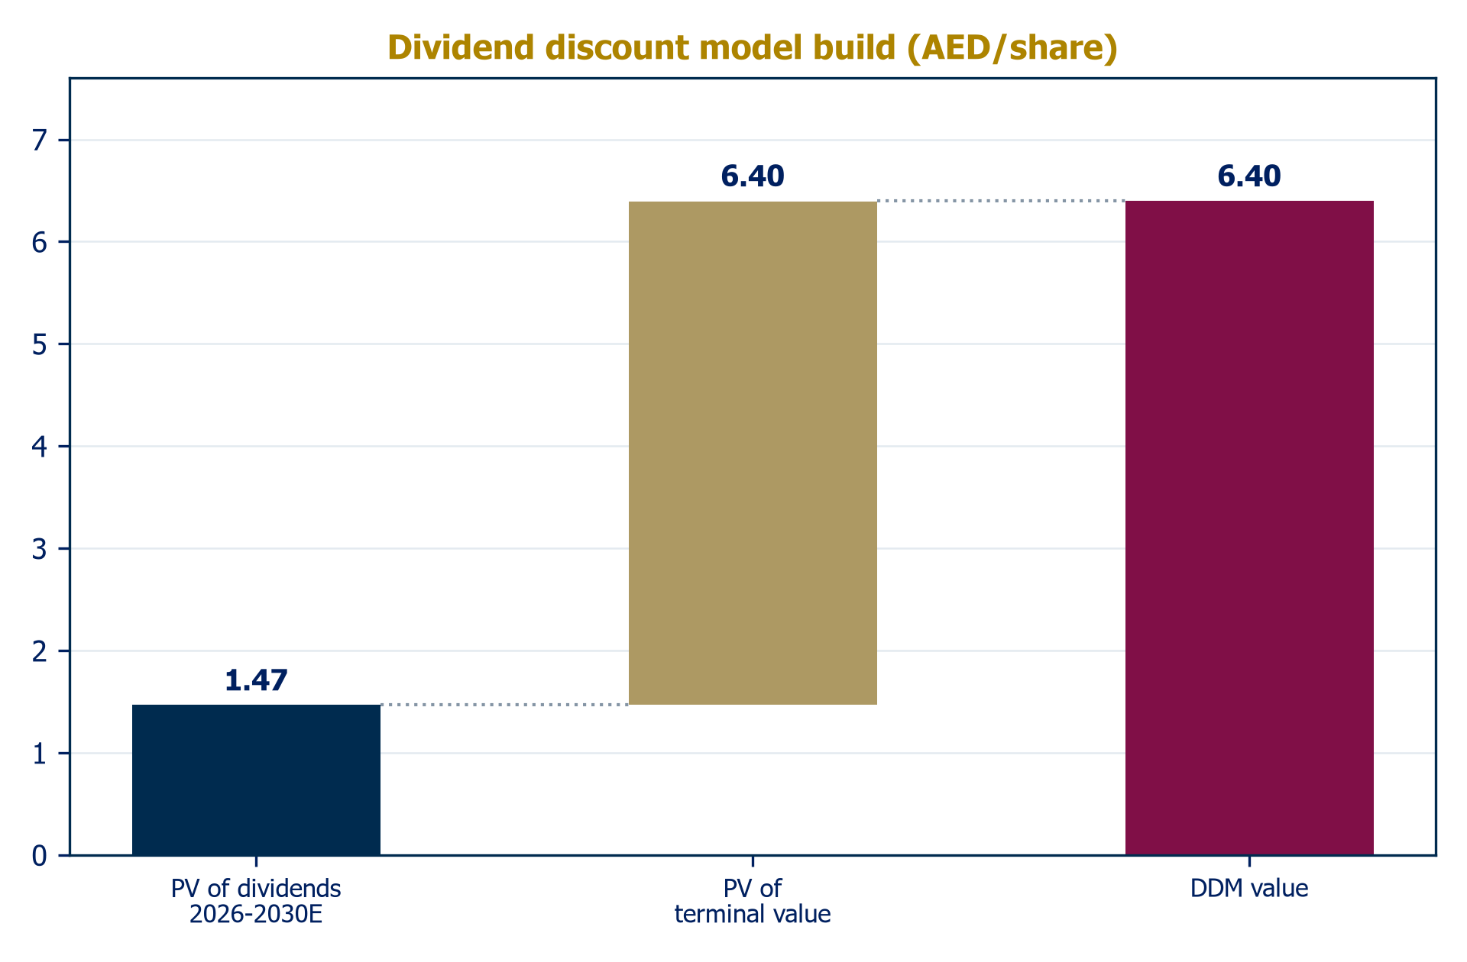
Source: Al Ramz Investment Research estimates

Comparables: AED 8.29
DIB trades at 7.4x trailing earnings, the cheapest of any large GCC Islamic or UAE conventional bank, against ADIB at 13.1x, FAB at 10.6x, ENBD at 8.2x, Al Rajhi at 16.4x. On book, 1.24x tangible versus ADIB's 2.66x. The regional pattern is coldly rational, multiples track ROE, so we set targets rather than import peers wholesale: 8.5x 2026E EPS (premium to SIB and Ajman for scale, deep discount to ADIB for the returns gap) gives AED 7.89; 1.35x 2026E tangible book gives AED 8.69; averaged, AED 8.29.

History: AED 8.87
The house's 2023 initiation documented DIB's 10-year averages of 9.4x earnings and 1.63x book. We keep the P/E anchor and haircut the book anchor to 1.40x for the post-tax era, since a 9%-plus-top-up tax regime structurally lowers ROE against the untaxed history. Applied to 2026 estimates: AED 8.72 and AED 9.02, average AED 8.87. The market paid these levels as recently as February 2026.
Chart 29: Fair value by method (AED/share)
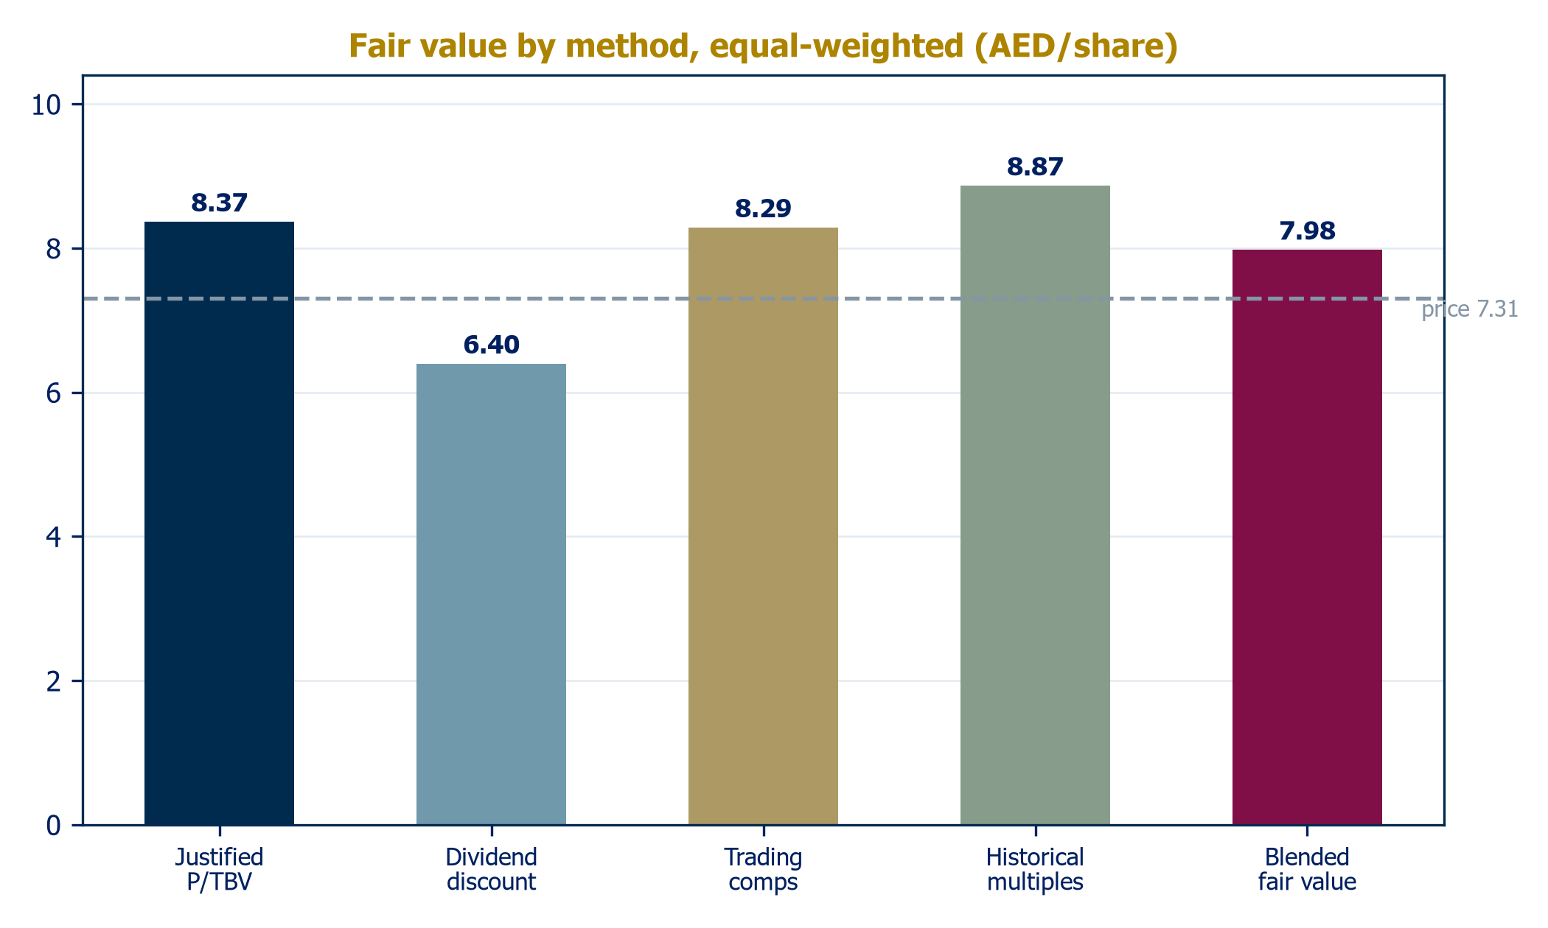
Source: Al Ramz Investment Research estimates
Chart 30: Valuation football field (AED/share)
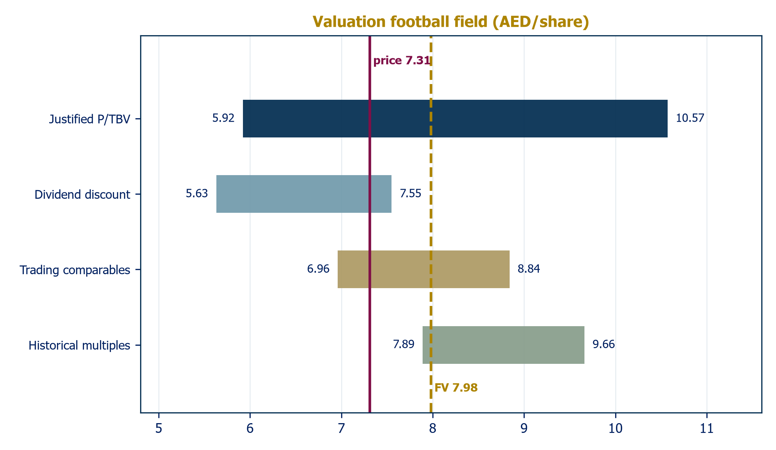
Source: Al Ramz Investment Research estimates

Cross-check: what the market is already pricing
It is worth inverting the exercise. At AED 7.31 the stock trades at 1.13x 2026E tangible book; solving the Gordon relation backwards at our 10.7% cost of equity and 3.0% terminal growth, the market is pricing a sustainable ROTE of about 11.7%, below even our deliberately conservative model trough of 12.3%. In other words, the current price embeds a returns fade slightly worse than a base case which itself assumes management pulls no lever at all: no payout normalization, no efficiency recovery, no mix improvement, and a full credit-cost cycle. That is what gives the risk-reward its asymmetry despite a headline upside of only 9%: the bear case is largely in the price, while none of the identifiable levers are. The symmetrical honesty is that value alone is not a catalyst, which is why the rating waits on evidence rather than anticipating it.

Verdict and catalysts
The blended AED 7.98 sits within a football field whose every range except the DDM's straddles the current price from above. With +9.2% price upside and a 4.8% dividend yield, the total return case is respectable but short of our Over-Weight threshold, hence Equal-Weight, with a clear map of what changes the answer. For the record, street consensus (Hold, AED 8.21) sits within pennies of our independent result.
Catalysts we are watching: (1) H2 2026 results proving the 2.3% NPM floor; (2) any payout normalization signal, the single most powerful lever; (3) the end of the Fed cutting cycle giving 2027 margin visibility; (4) execution milestones under the UAE's 2031 Islamic finance strategy; (5) continued record-tight sukuk pricing supporting both funding costs and the arrangement franchise.

Key risks to our investment theme
We believe the operating environment for UAE banking remains fundamentally supportive: healthy macro drivers, a diversifying non-oil economy, strong sector balance sheets and a regulator committed to expanding exactly DIB's segment. But this encouraging picture could swing on global rates and regional geopolitics, and DIB carries specific exposures of its own. We flag thirteen risks across four categories.

Company-specific
Margin compression is the dominant near-term earnings risk: management itself guides the 2026 net profit margin to 2.3% from 3.0% in 2024, and a faster Fed would take it lower, with each 10bps worth roughly AED 400 million of revenue. Real estate concentration ties the franchise, collateral base and equity stakes to a Dubai cycle that is cooling from exceptional levels. Capital headroom is adequate rather than lavish: CET1 of 13.0% against 21% asset growth explains two AT1 taps in eight months, and sustained hyper-growth would force a choice between slower expansion, costlier hybrids or equity. Key-person risk attaches to a thirteen-year CEO tenure with untested succession, and the international portfolio (Pakistan, Sudan, Turkey, Kenya) carries recurring sovereign and currency write-down potential against modest earnings contribution.

Industry, financial and macro
Competitive intensity is rising on three fronts at once: ADIB compounding at 28% ROE, Emirates Islamic growing above 30%, and digital challengers resetting retail economics. Credit-cost normalization from an unrepeatable 14bps is modeled at 45bps, but a property-led overshoot toward the bear case's 65bps would take roughly 8% off 2030 earnings. Tax and payout dynamics remain the equity story's headwind until management sets a clear distribution policy. On the macro side, geopolitical escalation is the industry's stated downside scenario, hitting credit growth, property and multiples simultaneously, while US rate-path tails hurt in either direction: faster cuts squeeze margins, no cuts prolong deposit-cost pressure. Finally, Sharia standardization shocks to sukuk documentation remain a low-probability, high-impact industry event.
Table 7: Key risks
Risk | Category | Assessment
Margin compression beyond the 2.3% guided floor as Fed easing transmits through the peg | Company | Each 10bps of NPM is roughly AED 400m of revenue; the bear case prices NPM at 2.10%
Dubai real estate cycle: cooling volumes, moderating prices, collateral and Deyaar linkage | Company | H1 2026 transaction values -16% YoY; NPF 2.4% and 158% coverage provide the cushion
Capital headroom vs growth: CET1 13.0% against double-digit ambitions | Company | Two AT1 taps since 2024; sustained hyper-growth would force issuance or slower growth
Credit cost normalization from 14bps toward mid-cycle 45bps | Financial | Modeled; consensus assuming 2025 credit costs persist would be too high
Tax and payout: Pillar Two top-up plus dividend restraint suppress the equity story | Financial | The de-rating driver; payout normalization is equally the upside lever
Key person: a thirteen-year CEO tenure with untested succession | Company | Any transition would be a genuine event for the equity
Competitive intensity: ADIB at 28% ROE, Emirates Islamic growing 30%+, digital challengers (ruya, Wio) | Industry | Retail margin and deposit-cost pressure is structural
Sharia standardization shocks to sukuk documentation | Industry | Low probability, high industry impact
Geopolitical escalation: S&P's stated downside for 2026 industry growth | Macro | Would hit credit growth, property and GCC bank multiples simultaneously
US rate path tails: faster cuts squeeze margins; no cuts prolong deposit costs | Macro | Either tail hurts vs the one-to-two-cut base case
Source: Al Ramz Investment Research

Summary financials
Table 8: Summary income statement, AED m
 | 2022A | 2023A | 2024A | 2025A | 2026E | 2027E | 2028E | 2029E | 2030E
Funded income | 11,739 | 17,227 | 19,454 | 19,548 | 20,672 | 20,948 | 21,545 | 22,881 | 24,282
Depositors' share | (3,634) | (8,477) | (10,505) | (10,576) | (11,409) | (11,272) | (11,577) | (12,222) | (12,911)
Net funded income | 8,105 | 8,749 | 8,949 | 8,972 | 9,263 | 9,676 | 9,968 | 10,659 | 11,371
Non-funded income | 2,363 | 2,916 | 3,887 | 4,279 | 4,161 | 4,076 | 4,197 | 4,401 | 4,613
Net operating revenue | 10,467 | 11,665 | 12,837 | 13,251 | 13,424 | 13,752 | 14,165 | 15,060 | 15,984
Operating expenses | (2,733) | (3,162) | (3,425) | (3,763) | (3,931) | (4,111) | (4,300) | (4,497) | (4,702)
Impairments | (2,103) | (1,396) | (407) | (485) | (826) | (1,205) | (1,424) | (1,426) | (1,415)
Profit before tax | 5,631 | 7,108 | 9,005 | 9,003 | 8,668 | 8,436 | 8,395 | 8,979 | 9,583
Income tax | (79) | (98) | (840) | (1,195) | (1,213) | (1,265) | (1,259) | (1,347) | (1,437)
Net profit | 5,552 | 7,010 | 8,165 | 7,808 | 7,454 | 7,170 | 7,136 | 7,632 | 8,145
EPS (AED) | 0.70 | 0.88 | 1.04 | 0.98 | 0.93 | 0.89 | 0.89 | 0.95 | 1.02
DPS (fils) | 30 | 45 | 45 | 35 | 35 | 38 | 40 | 42 | 45
Source: Audited financial statements FY2022-2025; Al Ramz Investment Research estimates. Note: net profit before NCI.
Table 9: Summary balance sheet, AED m
 | 2022A | 2023A | 2024A | 2025A | 2026E | 2027E | 2028E | 2029E | 2030E
Cash & CB balances | 26,489 | 24,020 | 26,701 | 36,870 | 31,912 | 38,157 | 44,624 | 51,272 | 58,146
Net financing assets | 186,043 | 199,453 | 212,427 | 262,055 | 288,261 | 314,204 | 339,340 | 364,791 | 390,326
Sukuk investments | 52,228 | 68,172 | 82,161 | 90,589 | 90,589 | 96,024 | 101,785 | 107,893 | 114,366
Other assets | 23,478 | 22,646 | 23,398 | 26,434 | 28,920 | 30,315 | 31,715 | 33,125 | 34,645
Total assets | 288,239 | 314,292 | 344,687 | 415,948 | 439,681 | 475,699 | 512,248 | 549,616 | 587,481
Customer deposits | 198,637 | 222,054 | 248,546 | 320,184 | 339,396 | 368,244 | 397,704 | 427,531 | 457,459
Due to banks | 12,810 | 12,967 | 5,855 | 1,966 | 6,000 | 6,000 | 6,000 | 6,000 | 6,000
Sukuk issued | 22,340 | 20,481 | 24,154 | 25,071 | 20,000 | 22,000 | 24,000 | 26,000 | 28,000
Other liabilities | 10,477 | 11,355 | 13,279 | 15,591 | 16,850 | 18,220 | 19,690 | 21,260 | 22,930
Total equity | 43,975 | 47,434 | 52,853 | 53,136 | 57,435 | 61,235 | 64,854 | 68,825 | 73,092
Total liabilities & equity | 288,239 | 314,292 | 344,687 | 415,948 | 439,681 | 475,699 | 512,248 | 549,616 | 587,481
Source: Audited financial statements FY2022-2025; Al Ramz Investment Research estimates.

Disclaimer and disclosures
The information provided in this report has been prepared without taking account of your objectives, financial situation or needs. You should, before acting upon the report, consider the appropriateness of the report having regard to these matters and, if appropriate, seek professional financial and investment advice. All observations, conclusions and opinions expressed in this report reflect the personal views of the research analyst and are subject to change without notice. The information in this report has been obtained from sources believed to be reliable; however, no warranty is made as to accuracy, completeness or currency, and no liability is accepted for any loss arising from reliance on it. Past performance is not an indication of future performance. Forward-looking statements are subject to risks and uncertainties that could cause actual results to differ materially. [House disclaimer template: replace with the firm's compliance-approved text before any distribution.]

Analyst disclosure
This draft was produced by the Dreams AI Associate research production system and is subject to analyst review, revision and certification prior to any approval. Upon publication, the certifying analysts will confirm that the views expressed accurately reflect their personal views and that no part of their compensation is directly or indirectly related to the specific recommendations or views expressed.

Ratings definitions
Over-Weight: fair value lies more than 15% above the current market price, expected to be achieved within 12 months. Equal-Weight: fair value lies between -15% and +15% of the current market price. Under-Weight: fair value lies more than 15% below the current market price. Not Rated: no formal fair value or recommendation is provided.

Report production note
Historical figures are extracted from audited consolidated financial statements (FY2021-2025) and reviewed interims (H1 2026). Market data as of 27 August 2026. Estimates are the base case of the accompanying financial model DIB_Financial_Model_2026-08-28.xlsx; charts and tables are generated from the same model. Known data conflicts and items pending verification are logged in the research file and flagged for the analyst gate.

