 |  | 28 August 2026

Initiation of Coverage  Aluminium Bahrain B.S.C. (Alba)  Priced at the bottom of mid-cycle   |  | Contents  Market data at the close of 26 August 2026. Peer market data 27 to 28 August 2026. For important disclosures and disclaimers, refer to the end of this material.
  Last close (BHD) | 0.878
  Fair value (BHD) | 1.150
  Upside | +31.0%
  Stock rating | OVER-WEIGHT
  Investment case | 2
  Aluminium: capped supply, contested sea lanes | 3
  Alba: the largest smelter in the world on one site | 7
  From war premium to mid-cycle earnings | 12
  The wrong kind of good year | 21
  Priced at the bottom of mid-cycle | 25
  Key risks to our investment theme | 35
  Summary financials | 37
  Disclaimer and disclosures | 38
Important Notice Al Ramz Capital may or may not provide financial services to Aluminium Bahrain B.S.C. or any other related entities. Please see the important disclaimer and disclosures at the back of this report. |  | Al Ramz Investment Research  Covering analyst assignment pending  Certifying analyst to be assigned  Draft for analyst review  Not approved for distribution

Investment case  A capped marginal producer  Aluminium's marginal producer has been capped and its principal Gulf export corridor has been closed. Beijing holds Chinese smelting capacity at 45 million tonnes a year in a market of roughly 73.8 million tonnes, so incremental demand must now be met from the roughly 29 million tonnes produced outside China. The Strait of Hormuz was still effectively closed on 27 August 2026, on day 179. London Metal Exchange cash averaged US$3,576/t in Q2 2026 against US$2,630/t for 2025.  The largest smelter in the world on one site  Alba is the largest smelter in the world on one site, and 2026 has demonstrated what that means in both directions. The company produced a record 1,623,139 tonnes in 2025 at a 22.8% EBITDA margin, above Alcoa at 15.5%, Norsk Hydro at 13.9% and Chalco at 16.3%, on contracted gas, 3,926 MW of captive generation and a 74% value-added mix. It then curtailed Reduction Lines 1 to 3 in March 2026, was struck directly in an Iranian attack on the Askar site on 28 March, and ran the second quarter at roughly 38% of nameplate.  Record earnings from a third of a plant  The result is the best earnings in the company's history from the worst operating conditions in its history. H1 2026 profit attributable to shareholders rose 228% to US$372.8m while Q2 net finished production fell 61% to 155,469 tonnes. Trailing earnings per share are 223 fils against 154 fils for FY2025, up 45%, and the shares are down 20.5% year to date. Alba trades at 3.94x trailing earnings and 0.575x book, the lowest price to book in its six-year listed record and 32% below its own five-year mean of 0.843x.  We think the market is right to discount those earnings and wrong about the magnitude. Solving our base case backwards, the BHD 0.878 close discounts a perpetual mid-cycle aluminium price of approximately US$2,644/t on a full volume recovery to 1,620kt. That is below the bottom of the US$2,650 to US$2,750/t band Alba's own consultant publishes, and below the US$2,800 to US$3,000/t incentive-price floor independent sector work puts on the 2028 to 2030 cost curve.  Over-Weight with a fair value of BHD 1.150 per share  We initiate coverage of Aluminium Bahrain B.S.C. at Over-Weight with a fair value of BHD 1.150 per share, 31.0% above the close of BHD 0.878 on 26 August 2026. Our fair value blends six methods and sits deliberately 21% below the consensus mean of BHD 1.450. We are constructive on this equity and less constructive than the street, and the reasons matter more than the conclusion.  Our BHD 1.150 is not a generous number. It leaves Alba at 4.82x FY2030E mid-cycle EBITDA against a core-smelter peer median of 6.59x, at US$3,167 per annual tonne against a peer median of US$6,201/t, at 0.73x FY2026E book value, and 7.3% below the BHD 1.240 a share Ma'aden paid for a fifth of the company in February 2025. |  | Stock Rating  Source: Al Ramz Research, Bahrain Bourse  Stock Statistics  Source: Al Ramz Research, Bahrain Bourse  Stock Price  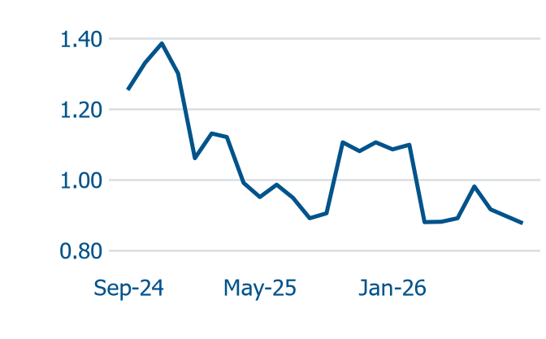  Source: Bahrain Bourse. Month-end closes to 26 Aug 2026, BHD  Performance  Source: Al Ramz Research, Bahrain Bourse  Summary Financial and Ratios  Source: Al Ramz Research, company financials
  Current Rating | OVER-WEIGHT
  Fair Value (BHD) | 1.150
  Former Rating | Not rated
  Previous FV (BHD) | n/a
  Target Upside | +31.0%
  Listing Location | Bahrain
  Sector | Aluminium
  Local Exchange | Bahrain Bourse
  Bloomberg | ALBH BI
  Reuters | ALBH.BH
  Last Close, BHD | 0.878
  Market Cap (BHD m) | 1,243
  Avg. Daily Vol 3m (m) | 0.16
  Shares Out. (m) | 1,416.0
  Free Float (%) | 10.0
  YTD Change (%) | (20.5)
  52w High (BHD) | 1.150
  52w Low (BHD) | 0.715
  Performance | 1m | 3m | 6m | 12m | 24m
  Absolute (%) | (4.9) | (1.3) | (20.0) | (1.3) | (20.9)
  Rel. to LME (%) | (5.9) | 12.8 | (23.4) | (24.5) | (51.9)
  Financial metrics | FY2026E
  EBITDA margin | 29.0%
  Net margin | 16.0%
  ROE | 10.9%
  EV/EBITDA (x) | 4.49
  P/E (x) | 5.29
  P/BV (x) | 0.58
  Net debt/EBITDA (x) | 1.56
  Dividend yield | 6.16%

Aluminium: capped supply, contested sea lanes
Primary aluminium is a 74 million tonne, roughly US$194bn market whose marginal producer has been capped by decree and whose principal Gulf export corridor has been closed by force. We believe both are structural rather than cyclical, and Alba sits at their intersection.

Three physical facts
Three characteristics of the Hall-Heroult electrolytic process determine everything else. First, electricity intensity of roughly 13 to 15 MWh per tonne forces smelters to locate where power is cheap and stranded, not where customers are. Second, potlines cannot be economically cycled: stopping a line risks freezing the cryolite bath and destroying the cathode lining, so producers run flat out and absorb cycles through margin, not volume.
The consequence is a set of price-taking, high-fixed-cost, high-operating-leverage assets. No volume lever, no pricing lever, only cost and mix.
LME cash averaged US$1,604/t in 2016 and US$1,704/t as recently as 2020, then US$2,705/t in 2022, US$2,419/t in 2024, US$2,630/t in 2025, and US$3,335.91/t in 2026 to 27 August. Unit margin swings by a multiple across that series without a single operational decision changing.
Chart 1: LME cash price, annual averages | Chart 2: LME cash price, last 24 months
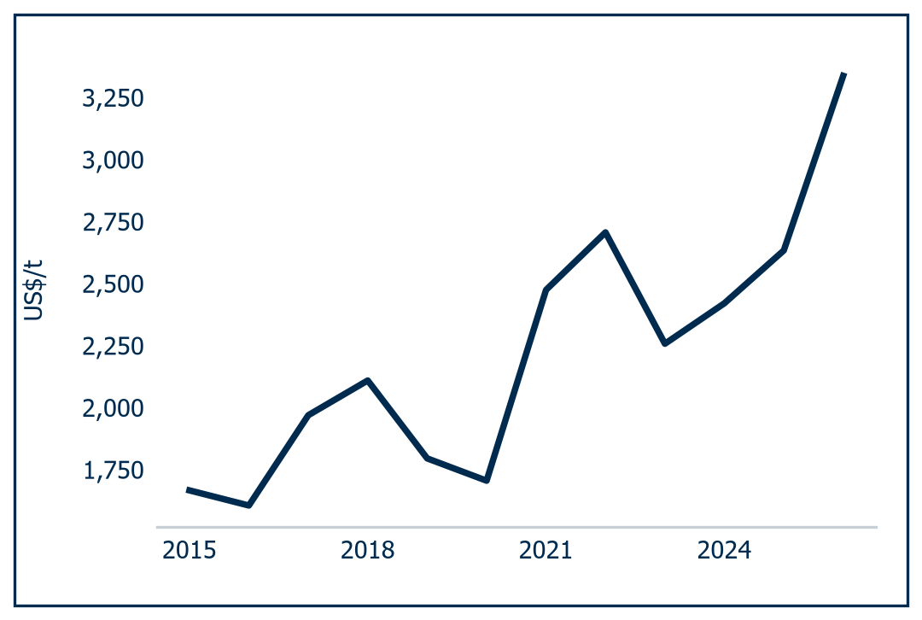 | 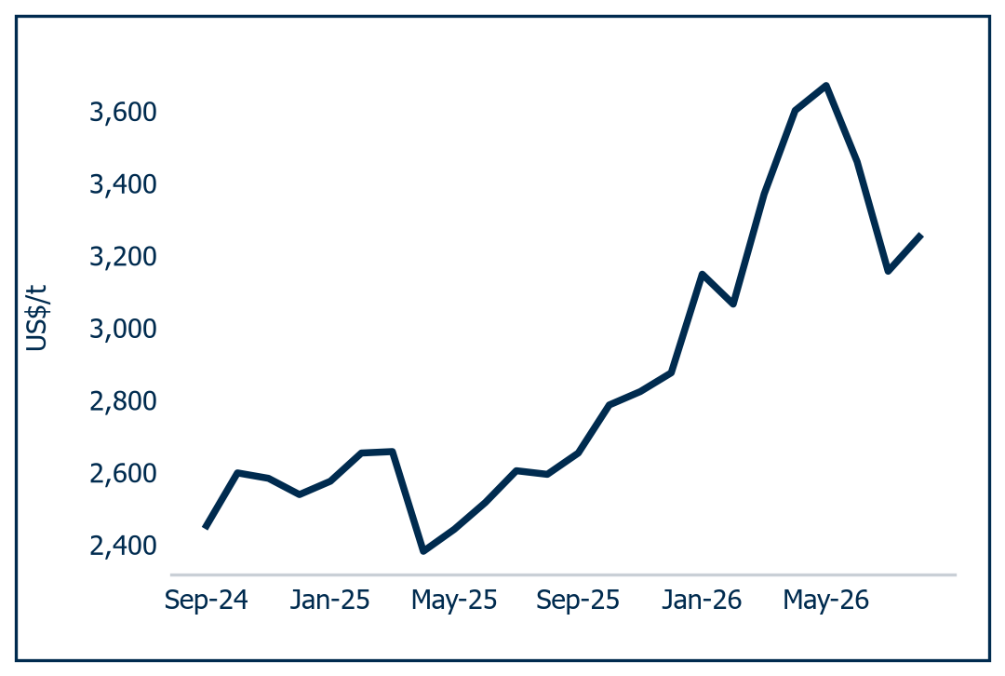
Source: Al Ramz Investment Research, LME cash settlements | Source: Al Ramz Investment Research, LME cash settlements

A market capped by decree
At the 2025 average LME of US$2,630/t, 73.8 million tonnes is roughly US$194bn at exchange price alone, or approximately US$219bn adding an average realised physical premium near Alba's US$332/t. At the Q2 2026 average LME of US$3,576/t the same tonnage is worth approximately US$264bn. A 36% increase in the size of the "market" with no extra metal produced is the clearest statement of what this industry sells.
Including secondary and recycled units, total global aluminium supply was 105.34 million tonnes in 2025 and is forecast to reach 122.40 million tonnes by 2030, roughly 17 million tonnes of incremental supply over five years.
Chart 3: Global supply, primary and secondary | Chart 4: Primary production by region, 2025
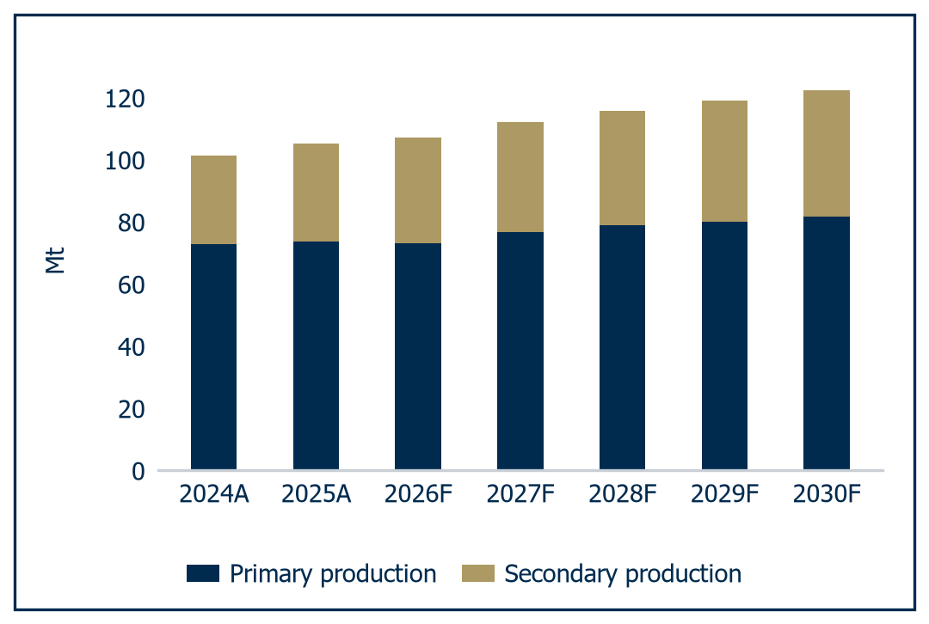 | 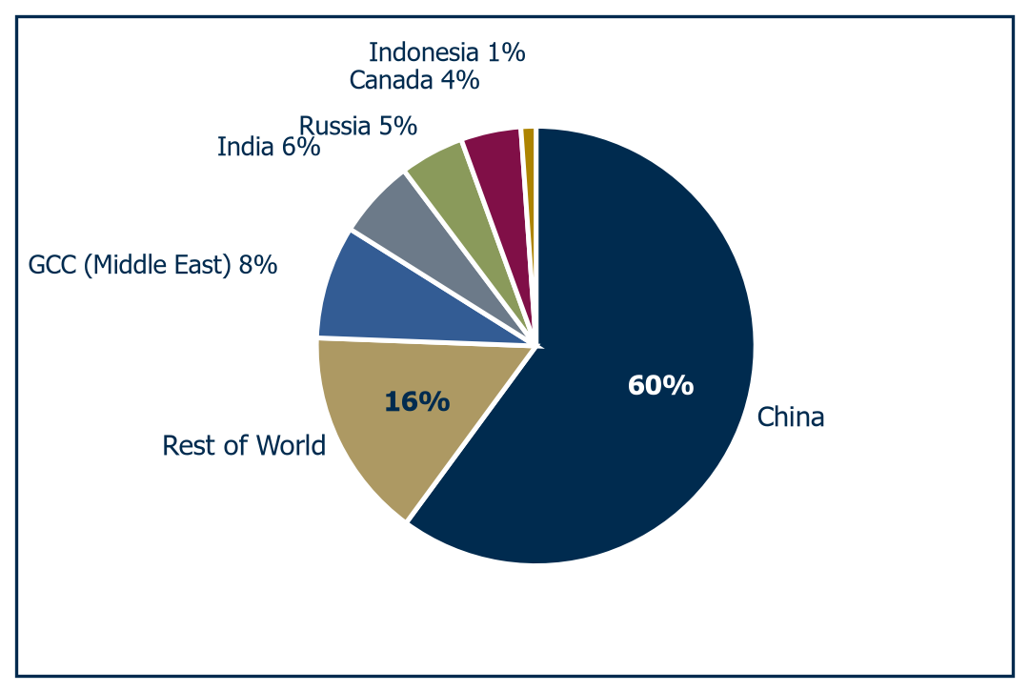
Source: Al Ramz Investment Research, Axis Securities Research | Source: Al Ramz Investment Research, Axis Securities Research

It cannot come from China, and that is the structural fact of the decade. Beijing has capped domestic smelting capacity at 45 million tonnes a year and Chinese operating capacity is close to that ceiling. China supplies roughly 60% of world output, so capping the marginal producer means incremental global demand must be met from the roughly 29 million tonnes produced outside China. Alba's 1,613,360 tonnes sold in 2025 are approximately 2.2% of global primary production but 5.6% of the serviceable ex-China market.
On the demand side we see no drama, and in our view that is the point. CRU put both 2025 global demand growth and supply growth at 2%, with the regional split doing the work: China +3%, Europe +1%, the Middle East flat and North America -3%. The end markets are unglamorous and durable, which is why they trend rather than cycle: billets into window frames, curtain walling and structural profiles, slabs into can stock, foil and automotive body sheet, foundry alloys into castings and wheels. Construction and transport set the trend, not any single technology.
So the marginal tonne has to be built. Roughly 17 million tonnes of incremental supply to 2030 is about 3% a year and leans heavily on secondary units. Of the primary additions, EGA's planned 750,000 tonne US smelter would be the first new American smelter since 1980, and Alcoa's 2026 guidance of 2.4 to 2.6 million tonnes rests on restarts, which are cheap and finite. Greenfield at a historical US$5,000 to US$6,000 per annual tonne needs a price the forward curve does not offer.

A fractured premium map
Physical premiums are the second half of realised price, and the three benchmark indices have moved in three different directions over five quarters: not normal for a fungible commodity, and evidence of a fragmenting trade map.
Table 1: Regional physical premiums, US$/t
Premium index | Q4 2024 | Q1 2025 | Q2 2025 | Q3 2025 | Q4 2025
US Midwest | 457 | 718 | 984 | 1,553 | 1,870
DDP Rotterdam | 351 | 294 | 194 | 213 | 313
Major Japanese Ports (CIF) | 175 | 228 | 182 | 108 | 86
Source: Al Ramz Investment Research, company reports
Realised price is now a function of where a producer can physically deliver, the variable 2026 has taken out of Gulf producers' hands. Inventories confirm the tightening. LME stocks stood at 246,825 tonnes on 27 August 2026, down 51.5% year to date and, on Shanghai Metals Market's framing, the lowest since November 1990: less than one day of global consumption.

The 2025 input-cost windfall
The ratio tells the real story: alumina fell from US$553/t, or 21% of LME, in Q4 2024 to US$366/t, or 13% of LME, in Q4 2025. We treat 2025 alumina as a windfall, not a run rate. Reversion of that ratio to its long-run zone is a cost headwind that arrives with a three to four month lag to profit and loss, per Alba's disclosure, and cannot be hedged.
The deeper structure is who buys alumina and who makes it. At 30% to 40% of cash cost it is the largest single input, and this industry splits cleanly into producers that refine their own and producers that do not. EGA refines 2.40 million tonnes at Al Taweelah and self-supplies 46% of its needs; Ma'aden, Alcoa and Rio Tinto are integrated all the way back to bauxite; Alba has neither bauxite nor a refinery and contracts up to 16.5 million tonnes from Alcoa's Western Australian system between 2026 and 2035. We read integration as a hedge rather than a margin enhancer, and in a falling market it is a drag: the index averaged US$503/t in 2025 vs US$444/t in 2024, yet had reached roughly US$310/t by February 2026 on Asian oversupply.
Power separates winners from losers, and for Gulf producers it is contracted rather than exposed. Alba signed a ten-year gas supply agreement with Bapco Upstream on 23 January 2024 at a fixed US$4.00/MMBTU for the first five years, with US$4.50/MMBTU effective through December 2026. Against European producers facing forecast gas of US$15.0/MMBTU in 2026, that contracted position is the whole of the Gulf cost advantage.
We would go further: power, not scale and not technology, is the only durable differentiator in primary aluminium. At 13 to 15 MWh per tonne, the distance between Norsk Hydro's hydropower and its 16th-percentile cost position, Rio Tinto's hydro-powered Canadian fleet, Indian coal and Gulf contracted gas is a permanent spread that no operating improvement closes and no producer can hedge its way out of. It also runs in two directions at once after 2026, because the same hydro position that sets the cost floor now also sets the carbon floor. Cost curve and carbon curve have started to rhyme, and the Gulf sits mid-table on both.

A supply shock, not a cycle
The defining industry event of 2026 is the disruption of the Strait of Hormuz. GCC producers account for approximately 8% to 9% of global aluminium supply and approximately 25% of non-Chinese supply. On 27 August 2026, day 179, the strait remained effectively closed to commercial shipping, with three transits recorded on 23 August against a pre-crisis baseline of 85 a day. The effect on the balance has been violent: the 2025 market was a surplus of 118 thousand tonnes including China, and by Q2 2026 Alba disclosed a deficit of approximately 934 thousand tonnes including China, a reversal of roughly 1.53 million tonnes in a single quarter on a 74 million tonne market.
The mechanism is routinely misread. This is not a demand-led cycle but a supply shock that has simultaneously raised the price Alba receives and cut the volume it can produce and ship, through physical conflict with a fat left tail. Buying Gulf aluminium exposure in 2026 is not buying an upcycle, it is a short volatility position on a shipping lane, with the payoff running one way on price and the other on tonnes.

Carbon policy and tariffs
Two regulatory vectors now matter more than cost curves. US Section 232 tariffs have lifted the domestic price and rewarded anyone with metal inside the wall, the entire explanation for a Midwest premium of US$1,870/t in Q4 2025 against US$457/t a year earlier. EU CBAM entered its definitive phase in 2026 and prices embedded emissions on imported aluminium. The consequence is decisive: a tonne produced inside the European Union is worth structurally more than an identical tonne imported into it, whatever the cost of making either. For a Gulf exporter with 26.7% of its 2025 tonnes sold into Europe, that is not a compliance question but a question about where the assets are.

The widest disagreement in the sector
The curve prices only about US$46/t between cash and the long-dated tenor, treating today's price as close to permanent. The sell side does not. Goldman Sachs cut its 2027 forecast to US$2,700/t on 6 July 2026 while raising its 2027 surplus estimate to roughly 1.5 million tonnes; Morgan Stanley cut 2027 by 13% to US$2,850/t; J.P. Morgan's published quarterly path falls US$1,050/t from Q3 2026 to Q4 2027. That is roughly US$1,000/t of disagreement on 2027 between the curve and the houses that cover this metal.
Chart 5: Aluminium price forecasts
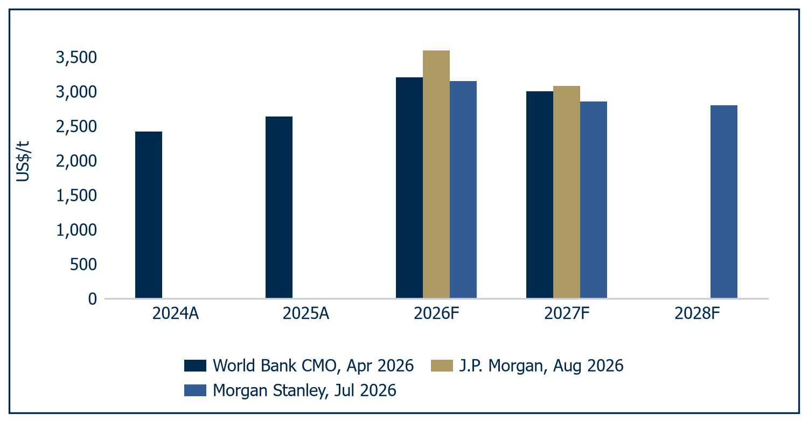
Source: Al Ramz Investment Research, World Bank, J.P. Morgan, Morgan Stanley
Independent sector work puts an equilibrium incentive price of US$2,800 to US$3,000/t on the 2028 to 2030 cost curve, since no smelting industry sustains a price below the level at which replacement capacity gets built. The strongest mid-cycle mark in the public record is not a forecast: on 1 July 2026 Alcoa and South32 negotiated a CY2030 aluminium threshold of US$2,942/t into the contingent consideration of their transaction, real money behind a mid-cycle number from two sophisticated counterparties. Al Ramz's terminal assumption of US$2,750/t sits US$192/t below that mark, deliberately.

The Alba read-through
A capped marginal producer, a fragmented premium map and a closed shipping lane have made realised price a function of where a tonne can be delivered rather than what it cost to make, in a business with no volume lever. For Alba, price leverage is extreme, cost is contracted on power and unhedged on alumina, and delivery rather than cost is now the binding constraint. That is why management has bought 300,000 tonnes of production inside the European carbon border.

Alba: the largest smelter in the world on one site
Alba is one asset, and almost everything about the equity follows from that.

Six potlines and 3,926 MW
Aluminium Bahrain B.S.C. is a single-site primary smelter at Askar on Bahrain's south-eastern coast, the largest in the world on one site and, on 2025 volumes, the largest outside China. Value is the spread between the LME price plus a regional physical premium and the cost of alumina, carbon and power. There is no other lever.
Alba produced a record 1,623,139 tonnes of net finished aluminium in 2025 and sold 1,613,360 tonnes, serving over 290 customers and exporting approximately 70% of output.
Outside readers most consistently underweight the power position. Alba runs 3,926 MW of captive generation under a Chief Power Officer, Amin Sultan, at C-suite level. Electricity is roughly a third of industry cash cost, and Alba does not buy power at a market price, it makes it: a cost-curve fact, not a line item.
Chart 6: Smelter scale, FY2025 output
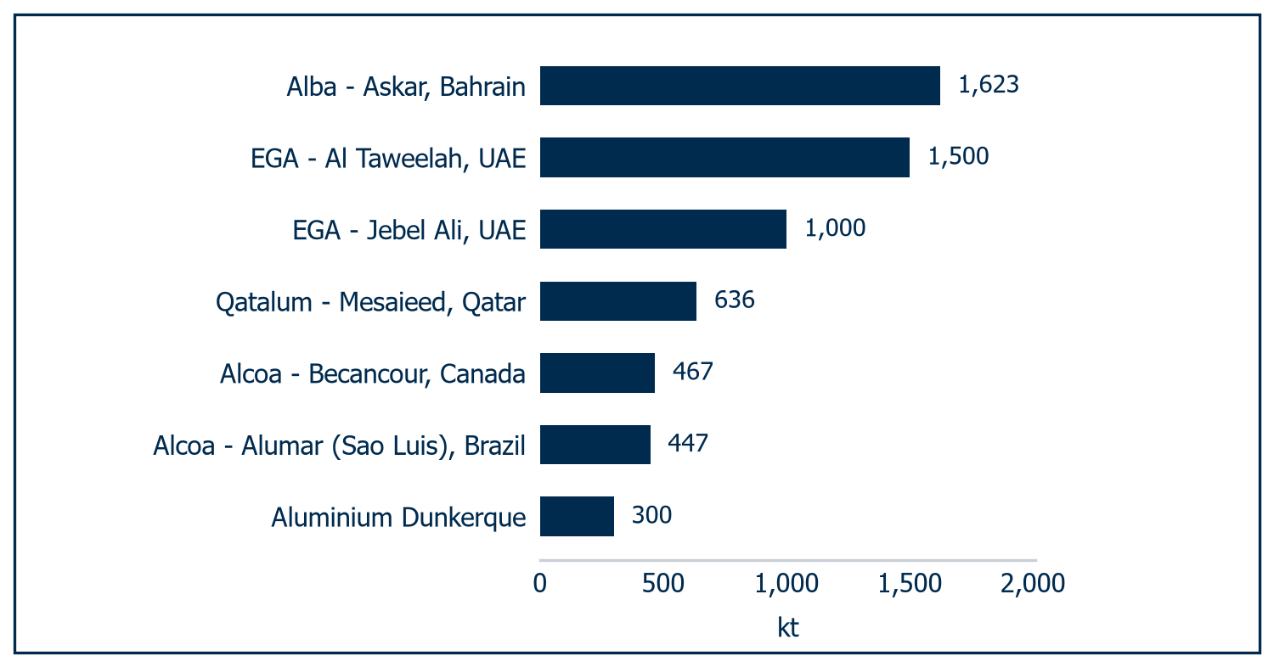
Source: Al Ramz Investment Research, company reports. Site nameplate on a 100% basis

Built on stranded gas
Bahrain has no bauxite, no alumina refining and, until the 1970s, no heavy industry: it had associated gas, a government wanting an industrial base, and a metal that migrates to cheap energy.
Expansion came as line additions, each with new captive generation: Line 3 in 1981, Line 4 and Power Station 3 in 1992, the coke calciner in 2002, and Line 5 in 2005, taking capacity above 830,000 tonnes per annum.
Line 6 is the defining project of the modern company, the source of its scale advantage and, for five years, its leverage. Engineered by Bechtel and financed with approximately US$3bn of debt that Ali Al Baqali was instrumental in securing, it took net debt to US$2,218m by 2021. Deleveraging to US$564m at end-2025 and 0.52x net debt to EBITDA made a US$2.2bn acquisition financeable: Alba spent five years paying for Line 6 to buy Dunkerque in the sixth.
Chart 7: Alba capacity build-out by potline | Chart 8: Product mix, value-added vs commodity
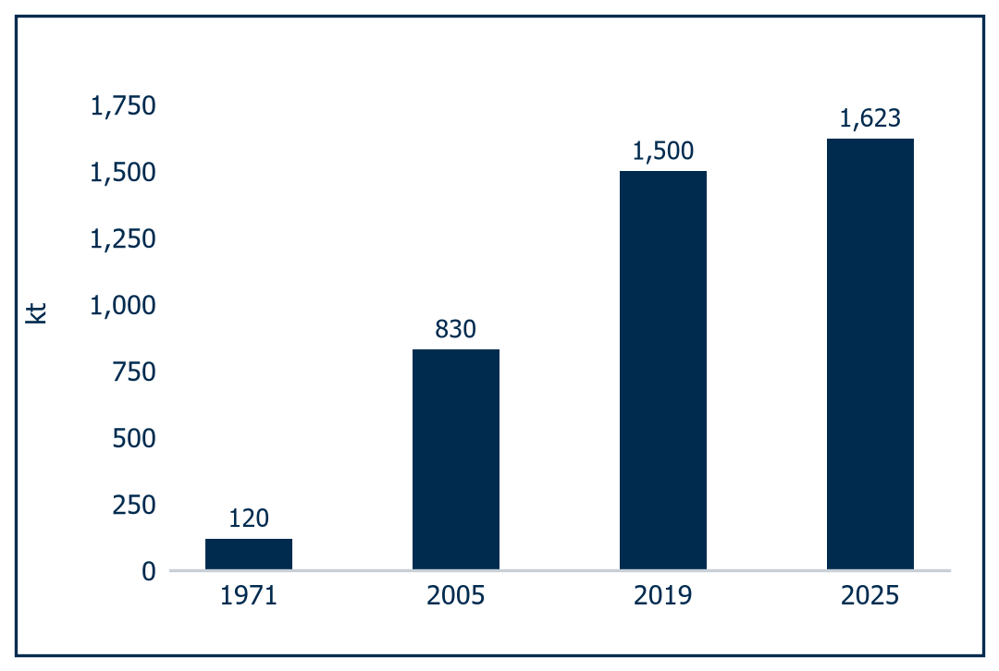 | 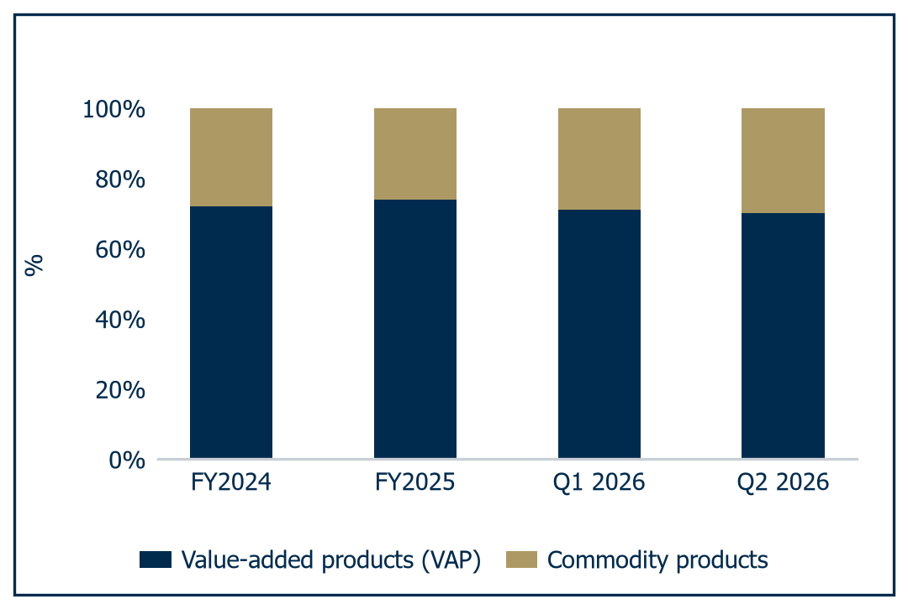
Source: Al Ramz Investment Research, company reports | Source: Al Ramz Investment Research, company reports

The 2025 revenue bridge
Value-added products were 74% of shipments in 2025 at 1,195,788 tonnes, up from 72% in 2024, and the realised premium above LME rose 24% from US$268/t to US$332/t.
That revenue bridge should govern how the equity is read. Metal sales rose from US$4,290m to US$4,731m in 2025, and the bridge splits the US$441m increase into LME price US$334m, premium US$95m, product mix US$8m and volume US$4m. Two-thirds was price, a fifth premium, and a low single-digit percentage anything management controlled. Alba is a competent operator of a price-taking asset: an excellent 2025 result is not an excellent commercial performance. That performance was the 39kt shift into value-added products against 62kt shed at the commodity end, and US$67.32m of e-Al Hassalah savings.

The downstream moat
The 2025 geographic mix by tonnes sold was Bahrain 30.0%, Europe 26.7%, MENA 16.8%, Americas 15.1% and Asia 11.4%. The domestic 30% is the least replicable part of the customer base. Midal Cables, in rod, cable and conductors, takes over 220,000 tonnes of liquid metal a year and is Alba's largest client.
Midal is not the whole cluster. Garmco rolls sheet, coil and circles, Balexco extrudes profiles, Bahrain Atomisers makes aluminium powders, and BAMCO, Bahrain Welding Wire Products and Aluwheel take the balance: an industrial base that exists because Alba exists. What that base buys is the top of the range. Alba sells one molecule in six commercial forms, and the value-added end is extrusion billet, including a proprietary 6060.HE alloy developed with the University of Bahrain, rolling slab feeding can stock and automotive sheet, Properzi foundry alloys for wheels and castings, and liquid metal. The commodity end, T-ingots and 10kg and 22.5kg standard ingots, is where the 62kt of shed tonnes came from.
Liquid metal is a genuine moat, and in our view the market does not price it. A customer built around molten aluminium delivered by road from a smelter three kilometres away cannot switch without rebuilding its melting capability. Alba's domestic share is effectively 100%, and the volumes prove it: liquid metal grew 24kt in 2025 while commodity export tonnes fell 62kt.
The export desks are the other two legs: Zug for Europe and MENA, Singapore for Asia, and the Atlanta subsidiary inside the US tariff wall.

A strategic register
Bahrain Mumtalakat Holding Company, the sovereign wealth fund of the Kingdom of Bahrain, holds 69.38%. Saudi Arabian Mining Company (Ma'aden) holds 20.62%, effective 19 February 2025. Free float is 10.00%.
The register changed in February 2025, when Ma'aden acquired SABIC's entire 20.62%, 292.8m shares, for BD363.08m, implying BHD 1.240 a share. Ma'aden and Alba had terminated merger discussions the month before, but a shareholder intending to grow its aluminium business tenfold by 2040 while owning a fifth of Alba is a permanent feature of the case. That is a governance fact, not a criticism, and it bears on the four questions minority investors care about: the float, a Saudi cross-listing, the 35% payout ratio, and whether a Ma'aden combination returns.
The float itself dates from the November 2010 IPO, floating 10% on the Bahrain Bourse and, through global depositary receipts, on the London Stock Exchange. It has never been increased. In our view that is the cheapest re-rating lever available.
Chart 9: Shareholder structure
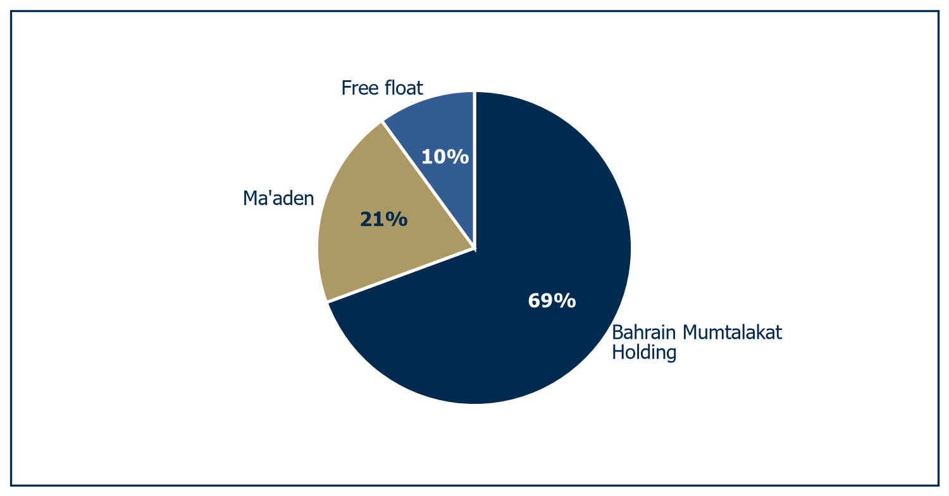
Source: Al Ramz Investment Research, company reports

Insider, outsider and chairman
Ali Al Baqali, Chief Executive Officer. Al Baqali has led Alba since 13 February 2020, having joined in 1998 as a Purchasing Officer. By 2026 that is 28 years inside one asset: unmatched knowledge of six reduction lines and five power stations, and no outside-in perspective at a company buying a smelter in northern France.
The ladder was procurement and finance, not engineering: Manager Procurement in 2010, Chief Financial Officer in 2013, Deputy Chief Executive Officer and Chief Supply Chain Officer in 2017. His market judgement has been tested and passed. In February 2026, against a CRU consensus of US$2,650 to US$2,750/t, he called the price above US$2,900/t into the third quarter; Q1 printed US$3,195 and Q2 US$3,576. A sourcing and cost operator is precisely what a restart needs. It is only half of what Dunkerque needs.
Ricardo Fontes Santana, Chief Financial Officer. Santana joined on 15 August 2024 as the counterweight to Al Baqali's institutional tenure, bringing over 25 years across metals, mining and energy: Sohar Aluminium, where he was CFO immediately before Alba, plus South32, BHP Billiton, Essilor and Shell.
Sohar is a 375,000 tonne gas-powered GCC smelter, so the operating economics are familiar, and South32 supplies listed-company capital allocation discipline and a marketing organisation. Santana has defended the 35% payout ratio against repeated pressure for a special dividend, framing the choice explicitly as deleveraging vs. distribution. On a US$2.2bn cross-border purchase we would rather have that instinct than the other one.
HE Khalid Al Rumaihi, Chairman. Al Rumaihi is the link to the 69.38% shareholder: Chief Executive Officer of Mumtalakat from September 2019 to 2023, still on its board. His Bapco Energies board seat sits on the other side of Alba's ten-year gas supply agreement: the terms are disclosed and we raise no concern, but it is a related-party consideration.
Before Mumtalakat he ran the Bahrain Economic Development Board, and before that spent over ten years at Investcorp as a Managing Director heading Gulf institutional placement, preceded by nine years at J.P. Morgan. A chairman drawn from placement and sovereign wealth rather than from metals fits a board whose 2026 question is capital allocation across an acquisition, a replacement line, deleveraging and dividends.

Exhausted organic growth
The advantages are real and they compound. Single-site scale means one set of overheads, one management team, one port and six lines, the origin of a 22.8% FY2025 EBITDA margin against Alcoa's 15.5%. Add contracted gas, the liquid metal moat, a 74% value-added mix at a US$332/t realised premium and 0.52x net debt to EBITDA, and Alba is the highest-margin listed pure-play smelter of scale in our peer set.
Table 2: Alba against its peer set, FY2025
Company | Output FY2025 (kt) | Revenue (US$bn) | EBITDA (US$bn) | EBITDA margin | Alumina | Power | Note
Aluminium Bahrain | 1,623 | 4.73 | 1.08 | 22.8% | None | Captive gas, 3,926 MW | Largest smelter in the world on one site
Emirates Global Aluminium | 2,840 | 8.71 | 2.53 | 29.0% | 46% | Captive gas | Unlisted; ADX listing prepared at US$10bn to US$15bn
Alcoa | 2,319 | 12.83 | 1.98 | 15.5% | Integrated | - | Alba's largest alumina supplier
Ma'aden | - | 10.29 | 4.30 | 41.7% | Integrated | - | Holds 20.62% of Alba
SABIC | - | 31.07 | 4.77 | 15.3% | - | - | Sold its 20.62% Alba stake, February 2025
Source: Al Ramz Investment Research, company financials
The vulnerabilities are the same facts read from the other side. Alba has zero upstream integration against EGA's 46% alumina self-sufficiency, and in 2026 that dependency cost it 19% of its capacity. Single-site concentration stopped being theoretical on 28 March 2026, and both inbound alumina and outbound metal transit the Strait of Hormuz. And the 10% float limits liquidity and leaves minority interests decisive on nothing.
Chart 10: Peer production and shipments, FY2025
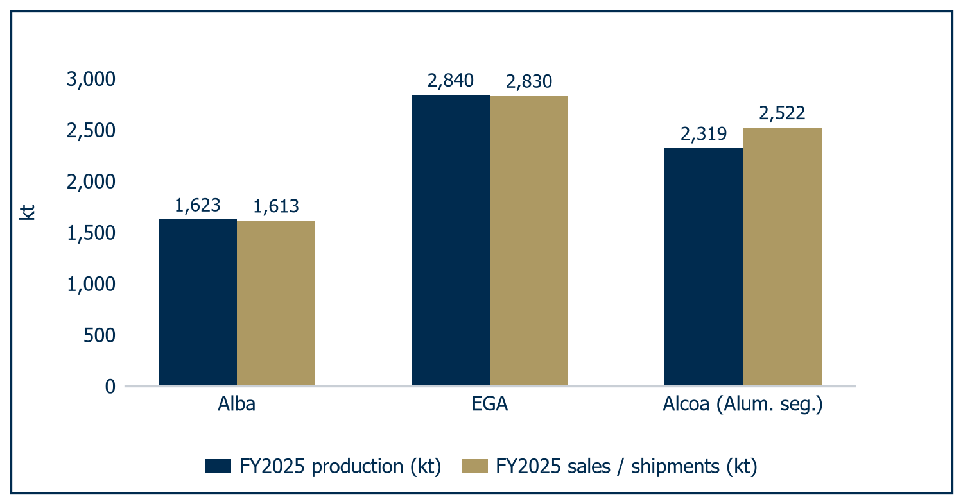
Source: Al Ramz Investment Research, company reports
Volume growth from the existing asset is exhausted: Lines 1 to 5 are old, Line 6 is full, and the New Replacement Line adds net capacity only by subtracting Lines 1 to 3. Its capacity is disputed, approximately 380kt per the CEO against 540kt in earlier reporting, and neither its capital cost nor a board decision has been disclosed. Growth therefore has to come from acquisition, and Alba has chosen it. A share purchase agreement for 100% of Aluminium Dunkerque was signed on 6 May 2026 at approximately US$2.2bn, for the European Union's largest primary smelter at roughly 300,000 tonnes per annum. What it is worth is the subject of the chapters that follow.
Put per-tonne numbers on that. Alba realised US$2,930.2/t in 2025 against a cash cost excluding depreciation of US$2,133.0/t, a spread of roughly US$797 on every tonne sold. The 730bp of EBITDA margin over Alcoa is worth approximately US$210/t at that realised price, and we attribute it to three things: one set of overheads across six lines and one port, captive gas at US$4.50/MMBtu on a load of 102 MMBtu per tonne, and a 74% value-added mix carrying a US$332/t realised premium, up US$64 on 2024. The curtailment inverts the same arithmetic. Roughly US$560m of fixed and semi-fixed cost spread across 44% fewer tonnes lifts FY2026E cash cost 12.1% to US$2,390.7/t. Scale is only an advantage when the lines run.
Read as a franchise, Alba is a low-cost single-asset price taker with a captive power position, a domestic customer base that cannot leave and the lowest leverage it has carried since Line 6. Read as an equity, none of that is the question. The question is what the asset earns through a cycle it does not control, how fast three curtailed potlines come back, and whether US$2.2bn for 300,000 tonnes in northern France buys enough diversification to be worth the cash. Those are earnings questions rather than franchise questions, and they are settled in the financial statements. We turn to them next, beginning with the four years of deleveraging that made the acquisition possible at all.

From war premium to mid-cycle earnings
Alba enters the most violent operating year in its history with the cleanest balance sheet it has carried since Line 6 was commissioned. That is not a coincidence.

Four years of deleveraging
Start with the balance sheet: it bought the company its options. Net debt fell from US$2,218m at the post-Line-6 peak in 2021 to US$1,424m in 2022, US$1,399m in 2023, US$1,103m in 2024 and US$564m at the end of 2025, with net debt to EBITDA at 1.36x, 0.95x, 1.74x, 1.17x and 0.52x; the 2023 rise is a denominator effect, not a borrowing decision. A company at 1.74x of leverage with 15 weeks of inventory does not get to choose whether to curtail three potlines when its alumina cannot reach the island. A company at 0.52x does.
One definitional point, because it recurs below: modelled EBITDA and EBIT both embed interest income inside other income, US$19.0m in FY2025A rising to US$54.3m in FY2027E on the post-acquisition cash pile.
The cash line is where the record year shows up. Net cash from operating activities reached US$1,030.4m in FY2025A on the model, against US$1,100m on Alba's own disclosure, with capital expenditure of US$286.0m. Working capital discipline did real work: receivable days fell from 54 to 46 and inventory days from 113 to 105, the 15-week buffer that made March 2026 an orderly curtailment rather than a crash stop.
Table 3: Operating and financial track record
Metric (US$m unless stated) | FY2023A | FY2024A | FY2025A
Revenue | 4,106.1 | 4,313.1 | 4,730.8
EBITDA | 803.5 | 939.1 | 1,078.4
EBITDA margin (%) | 19.6 | 21.8 | 22.8
EBIT | 447.4 | 572.5 | 670.0
Profit attributable to equity holders | 313.9 | 490.8 | 581.6
EPS (fils) | 83.00 | 130.33 | 154.49
Net finished production (kt) | 1,620.7 | 1,622.3 | 1,623.1
Sales volume (kt) | 1,603.0 | 1,612.0 | 1,613.4
LME cash average (US$/t) | 2,252 | 2,419 | 2,630
Realised premium above LME (US$/t) | 335 | 268 | 332
Realised price per tonne sold (US$/t) | 2,551.9 | 2,650.0 | 2,930.2
Cash cost of production ex D&A (US$/t) | 1,924.8 | 1,937.0 | 2,133.0
Net cash from operating activities | 874.1 | 789.0 | 1,030.4
Capital expenditure | (352.5) | (276.6) | (286.0)
Free cash flow, operating cash flow less capex | 521.7 | 512.4 | 744.5
Memo: free cash flow as disclosed by Alba | 652 | 569 | 765
Net debt | 1,399.5 | 1,103.3 | 564.0
Net debt / EBITDA (x) | 1.74 | 1.17 | 0.52
Total equity | 4,758.6 | 5,116.9 | 5,546.8
Book value per share (BHD) | 1.2583 | 1.3588 | 1.4727
Source: Al Ramz Investment Research, company financials

Lower volumes, higher EBITDA
FY2026E is a year of two halves. Sales fall much less than production, to 1,043.4kt or minus 35.3%, because 133.2kt is released from inventory: the only year in the forecast where sales exceed production, every other year absorbing 5kt to 10kt into stock. Consolidated revenue falls 17.6% to US$3,898.2m, a far shallower decline than the volume line implies.
And yet EBITDA rises 4.7% to US$1,129.2m at a 29.0% margin, up 610bp. EPS rises to 165.89 fils from 154.49 fils, per the model. This is extreme operating leverage in the producer's favour: a smelter that loses 44% of its output and still posts its best-ever earnings per share tells you where the marginal tonne is priced.
Chart 11: Revenue trajectory and growth | Chart 12: Revenue by product line
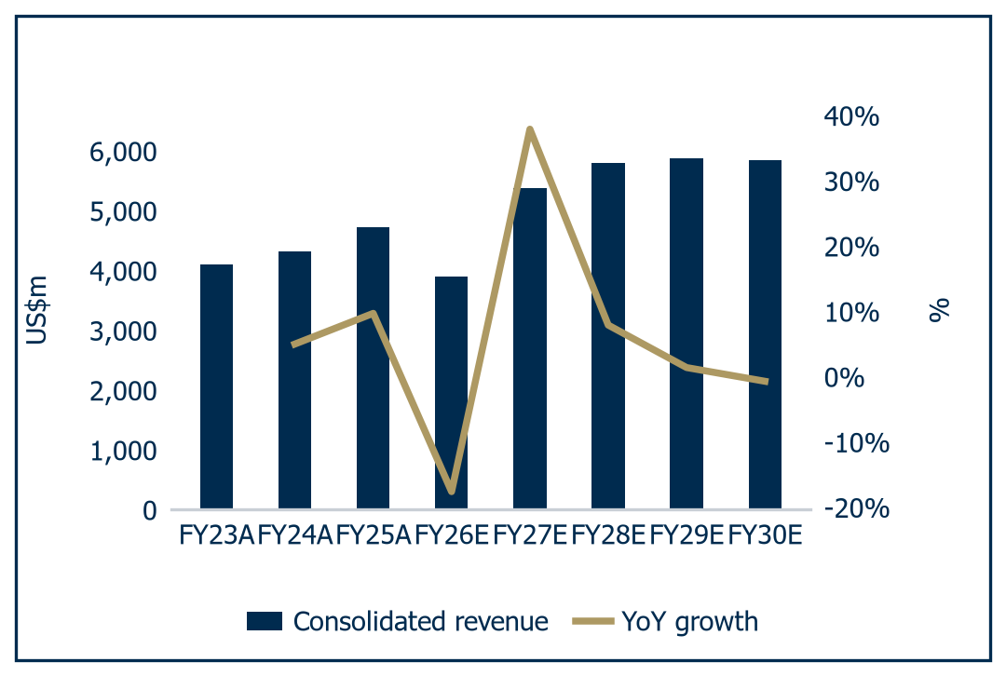 | 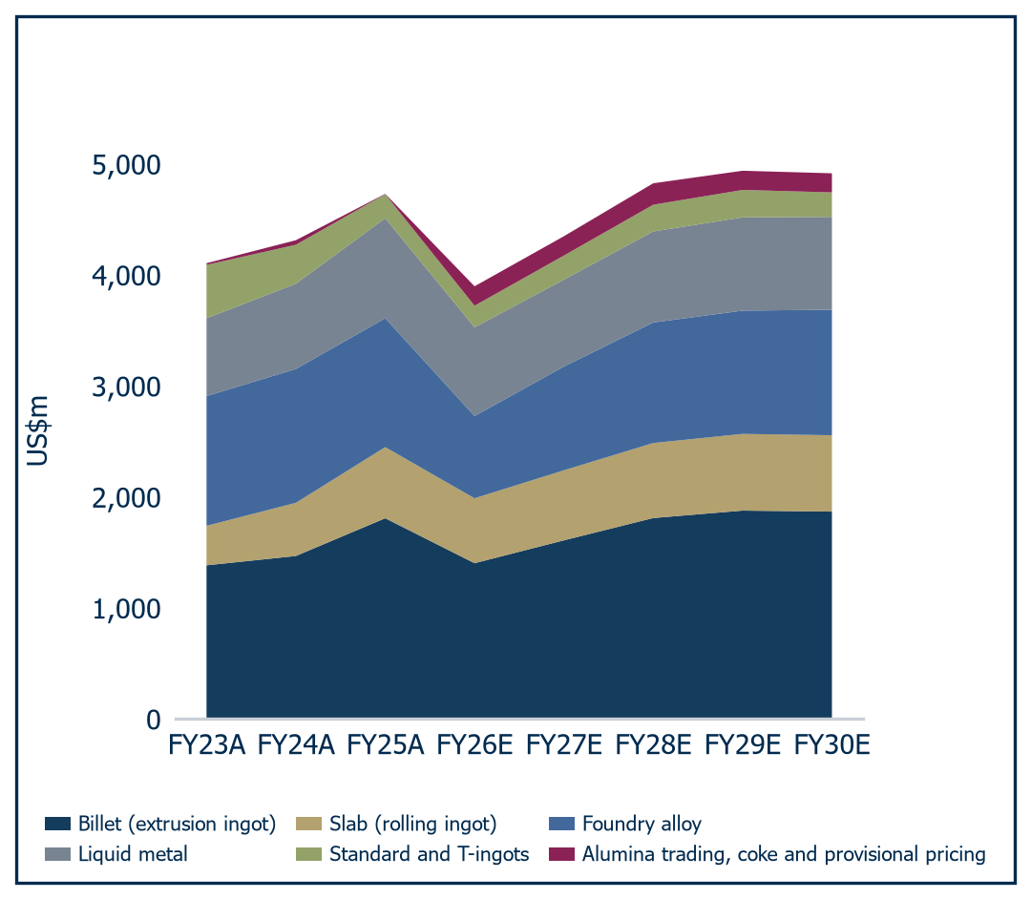
Source: Al Ramz Investment Research, company data and estimates | Source: Al Ramz Investment Research, company data and estimates

The offsetting cost move is real. Cash cost of production excluding depreciation rises 12.1% to US$2,390.7/t in FY2026E from US$2,133.0/t, because roughly US$560m of fixed and semi-fixed cost is spread across 44% fewer tonnes.

The recovery path
We phase the restart over four years, and it is our estimate. Production recovers to 1,300kt in FY2027E at 80.1% utilisation, then 1,510kt in FY2028E at 93.0%, 1,600kt in FY2029E at 98.6% and 1,620kt in FY2030E at 99.8%. Alba has published no restart schedule for Reduction Lines 1 to 3 in either its Q1 or its Q2 2026 release; nothing in the phasing above is company guidance.
We are cautious on the front of the ramp because the constraint is not an Alba decision. Q2 2026 net finished production of 155,469 tonnes annualises to roughly 622kt, approximately 38% of the 2025 run rate, far below what the announced 19% curtailment of Lines 1 to 3 would produce on its own: the binding constraint is inbound alumina logistics through Hormuz, not the potline decision.
The mix moves with the curtailment. Value-added products fall to 71% of shipments in FY2026E from 74%, then rebuild to 75% by FY2029E. Foundry alloy takes the deepest cut, down 36.2% to US$740.7m, because it is the most export-weighted line; liquid metal falls only 11.3% to US$799.1m, protected by the downstream cluster next door. Billet, at 36% to 38% of standalone revenue throughout, is the swing line: US$1,403.4m in FY2026E rebuilding to US$1,868.0m by FY2030E.
Unit cost does the work to FY2028E, then turns. Cash cost troughs at US$2,067.3/t in FY2028E as US$620m of fixed and semi-fixed cost is spread over 1,510kt and the curtailment and rerouting charge we carry falls from US$300m to US$220m. It then rises to US$2,147.8/t and US$2,169.8/t on the gas reset to US$5.25/MMBtu from US$4.50/MMBtu, which at 102 MMBtu per tonne adds roughly US$122m of energy cost in FY2029E, and on alumina consumed at 1.93 tonnes per tonne against an index climbing to US$410/t.
Meanwhile the metal price fades, and the two curves cross. Volume recovers into a falling price. That crossing is the argument of this chapter and its title: the war premium and the volume recovery do not arrive together, they hand off, and what is left is a mid-cycle earnings stream.
Table 4: Projection assumptions, FY2026E to FY2030E
Driver | FY2026E | FY2027E | FY2028E | FY2029E | FY2030E
LME cash average (US$/t) | 3,350 | 3,050 | 2,900 | 2,800 | 2,750
Realised premium above LME (US$/t) | 430 | 380 | 350 | 335 | 330
Mix and realisation adjustment (US$/t) | (200) | (120) | (100) | (95) | (95)
Realised price per tonne sold (US$/t) | 3,580 | 3,310 | 3,150 | 3,040 | 2,985
Alumina Price Index realised (US$/t) | 345 | 360 | 385 | 400 | 410
API as % of LME | 10.3 | 11.8 | 13.3 | 14.3 | 14.9
Natural gas price (US$/MMBtu) | 4.50 | 4.50 | 4.50 | 5.25 | 5.25
Carbon cost (US$/t Al) | 275 | 270 | 265 | 265 | 265
Net finished production, Alba (kt) | 910.2 | 1,300 | 1,510 | 1,600 | 1,620
Capacity utilisation (%) | 56.1 | 80.1 | 93.0 | 98.6 | 99.8
Sales volume, Alba (kt) | 1,043.4 | 1,290 | 1,505 | 1,595 | 1,615
Sales volume, Aluminium Dunkerque (kt) | - | 295 | 295 | 295 | 295
Sales volume, consolidated (kt) | 1,043.4 | 1,585 | 1,800 | 1,890 | 1,910
Cash cost of production ex D&A (US$/t) | 2,390.7 | 2,115.0 | 2,067.3 | 2,147.8 | 2,169.8
Effective tax rate (%) | 1.5 | 5.0 | 15.0 | 15.0 | 15.0
Capital expenditure, Alba (US$m) | 220 | 280 | 300 | 310 | 320
Capital expenditure, Dunkerque (US$m) | - | 60 | 60 | 60 | 60
Source: Al Ramz Investment Research, company financials and estimates

Dunkerque, behind a switch
The model carries Dunkerque behind an explicit consolidation switch. It is off through FY2026E and on from FY2027E, so no Dunkerque revenue, cost or EBITDA touches the income statement before FY2027E. The balance sheet consolidates a year earlier, at 31 December 2026, when the US$2,200m is paid and the acquisition facility drawn, consistent with the guided Q4 2026 closing.
What the estimate contains. Dunkerque contributes 300kt of production and 295kt of sales from FY2027E at a realised price of US$3,470/t, struck on an EU duty-paid premium of US$420/t over our LME assumption, giving revenue of US$1,023.7m and EBITDA of US$212.4m at a 20.7% margin on a US$2,750/t cash cost, with US$86.7m of depreciation on acquired property, plant and equipment and US$60m a year of sustaining capital expenditure.
Every Dunkerque line above is an analyst estimate. Neither Alba, nor American Industrial Partners, nor Bpifrance has ever disclosed Dunkerque revenue, EBITDA or a balance sheet. Everything else is ours. At 66% of Alba's current market capitalisation of US$3,306m, an unverified estimate of that size would be an unacceptable foundation for a valuation, which is why we test it against the target's own statutory accounts in the differentiator chapter rather than asserting it here.
Chart 13: Revenue by geography | Chart 14: Production, pricing and unit cost
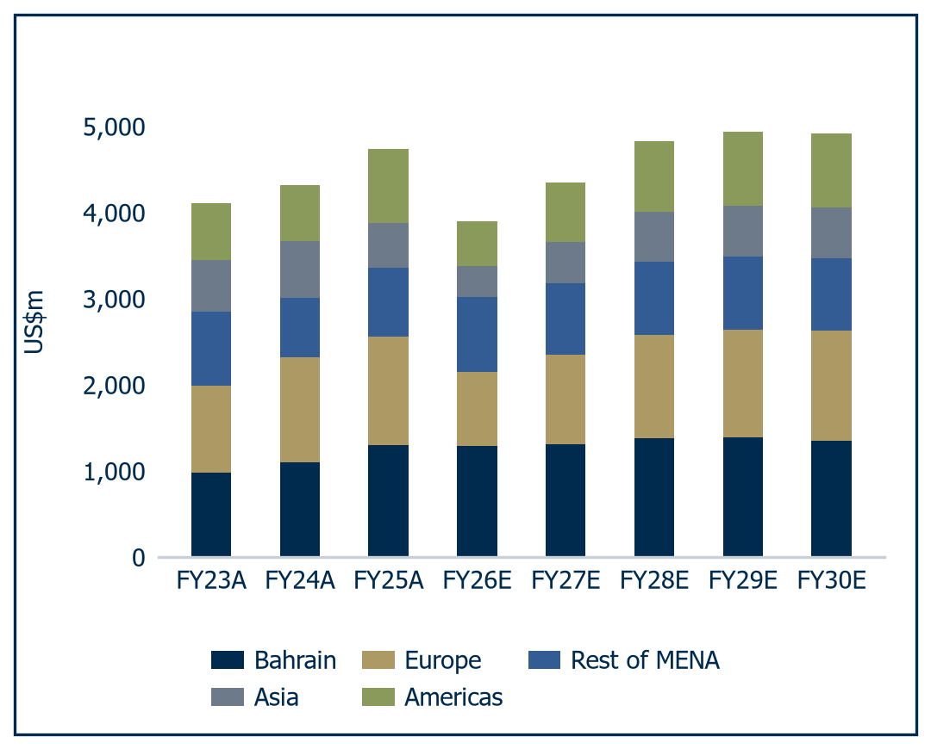 | 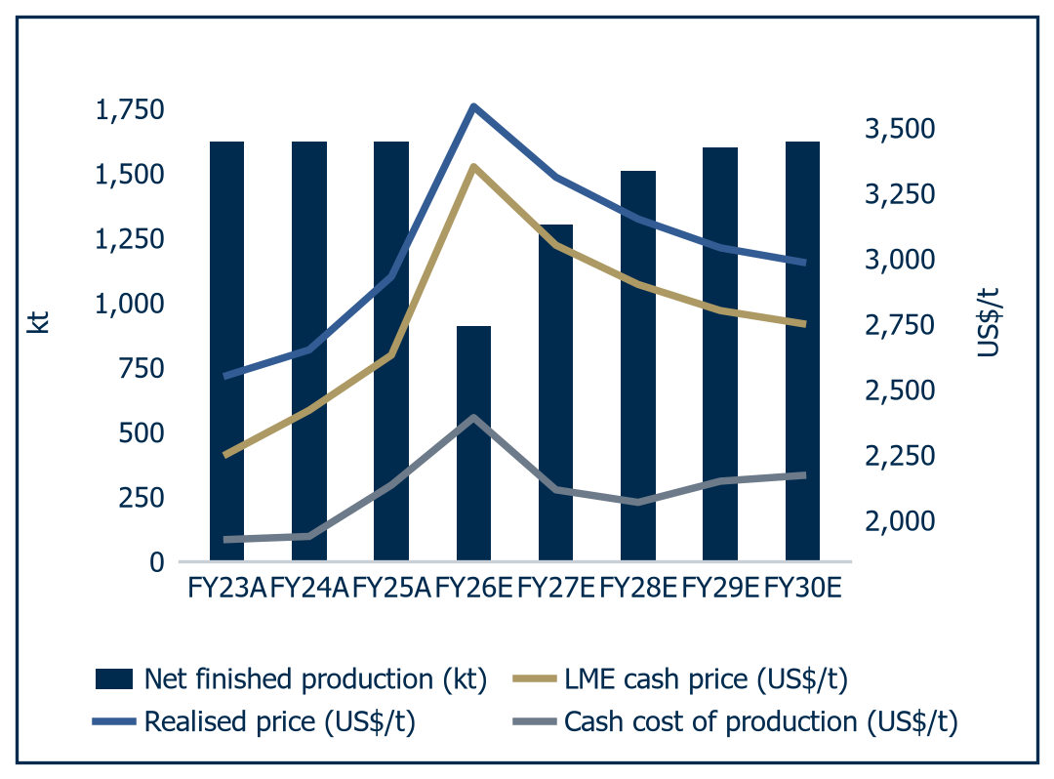
Source: Al Ramz Investment Research, company data and estimates | Source: Al Ramz Investment Research, company data and estimates

An early EPS peak
The earnings arc peaks early and in the wrong order, the most important structural feature of this forecast. Revenue peaks at US$5,879.9m in FY2029E, but EBITDA peaks a year earlier at US$1,640.8m in FY2028E, having already reached US$1,619.4m in FY2027E, then falls to US$1,393.4m and US$1,263.6m.
On a per-tonne basis the fade is starker, from US$1,082/t of EBITDA per tonne sold in FY2026E to US$662/t in FY2030E, the FY2026E figure being struck on a curtailed denominator. That US$662/t is the number to hold: what we think a fully utilised, fully consolidated Alba earns at US$2,750/t aluminium.
Chart 15: Gross profit and gross margin | Chart 16: EBITDA and EBITDA margin
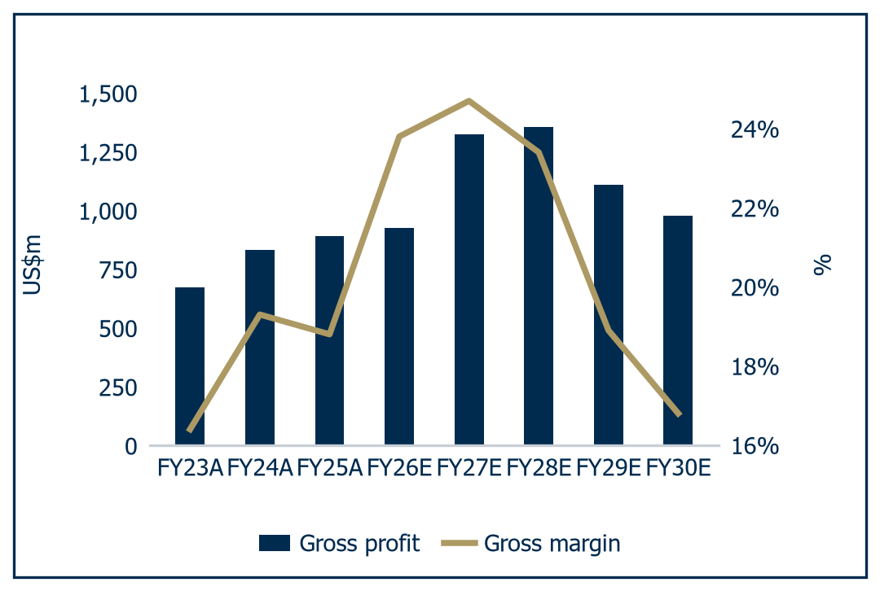 | 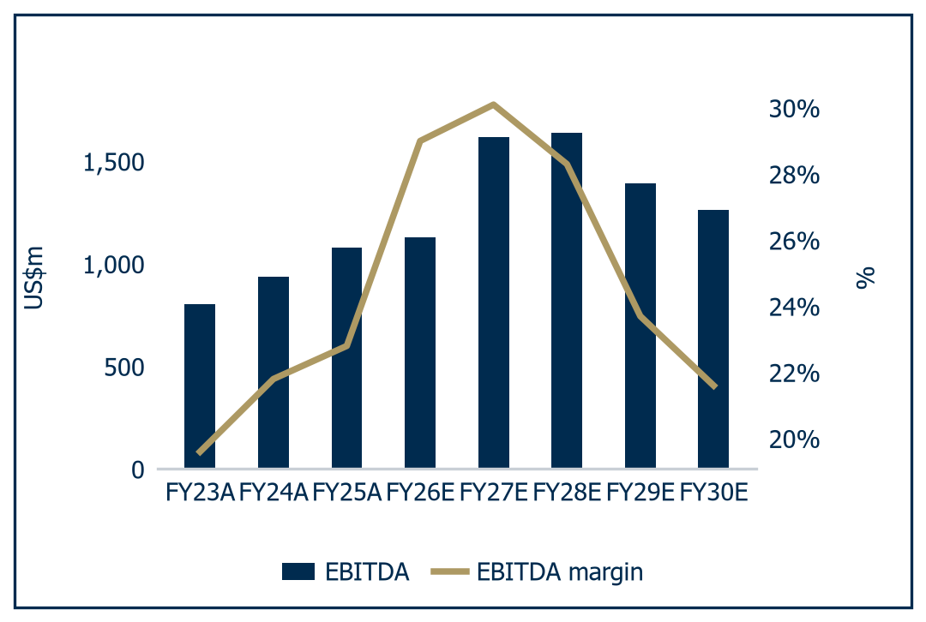
Source: Al Ramz Investment Research, company data and estimates | Source: Al Ramz Investment Research, company data and estimates

Attributable profit peaks a full year before EBITDA, at US$866.2m in FY2027E and 230.00 fils of EPS, then falls to 220.89, 171.71 and 147.83 fils. Both reasons sit below the operating line. First, tax: the modelled effective rate runs 1.5% in FY2026E, 5.0% in FY2027E and 15.0% from FY2028E onward under the Bahrain Domestic Minimum Top-up Tax, so the FY2028E charge is US$147.5m against US$46.0m in FY2027E, taking US$101m off net income in a year when EBITDA rises US$21m. Second, finance cost jumps to US$184.4m in FY2027E from US$78.0m in FY2026E on the acquisition facility, then falls to US$130.2m, US$90.3m and US$54.5m as the debt amortises.
The compound outcome is modest, the path violent, and the gap between them is the investment question. Revenue compounds at 4.31% and EBITDA at 3.22% from FY2025A to FY2030E on the model. What happens is a 44% output collapse, a 22% price spike, a US$2.2bn acquisition, a tenfold increase in the tax rate and a return to full utilisation, all netting out to roughly 4% compound revenue growth.
Table 5: Income statement summary, FY2024A to FY2030E
US$m unless stated | FY2024A historical | FY2025A historical | FY2026E | FY2027E | FY2028E | FY2029E | FY2030E
Revenue | 4,313.1 | 4,730.8 | 3,898.2 | 5,373.6 | 5,799.3 | 5,879.9 | 5,840.6
Revenue growth (%) | 5.0 | 9.7 | (17.6) | 37.8 | 7.9 | 1.4 | (0.7)
Cost of revenue | (3,480.6) | (3,840.9) | (2,970.2) | (4,048.0) | (4,444.5) | (4,771.0) | (4,862.0)
Gross profit | 832.5 | 889.8 | 928.0 | 1,325.5 | 1,354.8 | 1,108.9 | 978.6
Gross margin (%) | 19.3 | 18.8 | 23.8 | 24.7 | 23.4 | 18.9 | 16.8
Operating expenses | (276.5) | (269.4) | (309.1) | (291.1) | (303.1) | (314.1) | (319.1)
EBITDA | 939.1 | 1,078.4 | 1,129.2 | 1,619.4 | 1,640.8 | 1,393.4 | 1,263.6
EBITDA margin (%) | 21.8 | 22.8 | 29.0 | 30.1 | 28.3 | 23.7 | 21.6
Depreciation and amortisation | (366.7) | (408.4) | (421.9) | (518.7) | (530.4) | (542.8) | (555.5)
EBIT | 572.5 | 670.0 | 707.3 | 1,100.7 | 1,110.4 | 850.7 | 708.1
EBIT margin (%) | 13.3 | 14.2 | 18.1 | 20.5 | 19.1 | 14.5 | 12.1
Finance costs | (101.0) | (90.9) | (78.0) | (184.4) | (130.2) | (90.3) | (54.5)
Profit before tax | 491.9 | 588.0 | 634.3 | 919.3 | 983.2 | 763.4 | 656.6
Effective tax rate (%) | 0.2 | 1.1 | 1.5 | 5.0 | 15.0 | 15.0 | 15.0
Income tax expense | (1.1) | (6.4) | (9.5) | (46.0) | (147.5) | (114.5) | (98.5)
Profit for the year | 490.8 | 581.6 | 624.8 | 873.4 | 835.7 | 648.9 | 558.1
Attributable to non-controlling interest | 0.0 | 0.0 | 0.0 | 7.2 | 3.9 | 2.2 | 1.4
Profit attributable to equity holders | 490.8 | 581.6 | 624.8 | 866.2 | 831.9 | 646.7 | 556.7
EPS (fils) | 130.33 | 154.49 | 165.89 | 230.00 | 220.89 | 171.71 | 147.83
DPS paid in the year (fils) | 34.49 | 37.13 | 61.07 | 58.06 | 80.50 | 77.31 | 60.10
Return on average equity (%) | 9.9 | 10.9 | 10.9 | 13.8 | 12.1 | 8.9 | 7.3
Return on capital employed (%) | 9.2 | 10.7 | 10.0 | 13.4 | 12.1 | 9.3 | 7.9
Source: Al Ramz Investment Research, company financials and estimates

Cash generation
Working capital is a use of cash right through the recovery, the honest offset. Net working capital falls US$93m in FY2026E as the destocking releases cash, then absorbs US$195m in FY2027E and US$122m in FY2028E as tonnes come back.
On the cash flow statement definition, operating cash flow less both capital expenditure lines, free cash flow runs US$1,181.4m in FY2026E, US$987.3m, US$967.1m, US$807.1m and US$743.7m, cumulating to US$4,686.6m over the five years. Against a market capitalisation of US$3,306m at the BHD 0.878 close of 26 August 2026, Alba generates more free cash over the next five years than the entire equity is capitalised at today.
Chart 17: Working capital and cash conversion
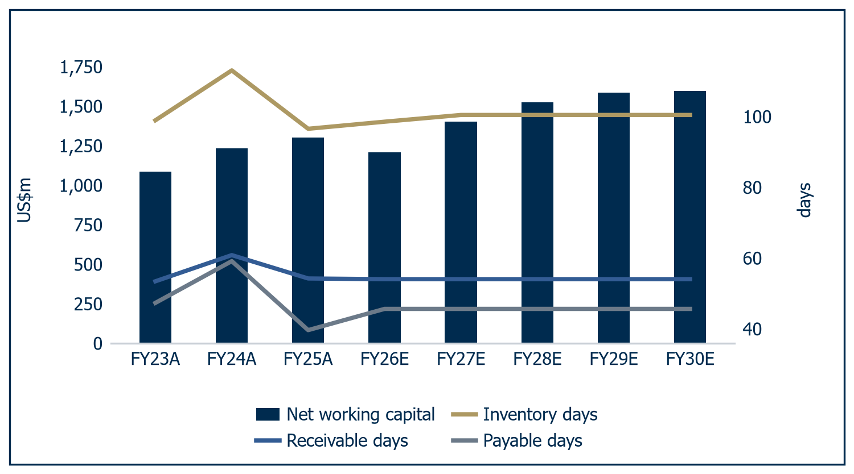
Source: Al Ramz Investment Research, company data and estimates
Capital expenditure is light against depreciation. We carry US$220m to US$320m a year on the Alba asset plus US$60m a year at Dunkerque from FY2027E, 52.1% of depreciation in FY2026E rising to 68.4% by FY2030E. It is not a perpetuity assumption: a smelter that reinvests two thirds of its depreciation forever liquidates itself slowly, which is why the valuation chapter sets terminal capital expenditure equal to depreciation and takes the hit to terminal free cash flow.
Chart 18: Free cash flow generation | Chart 19: Net debt and leverage
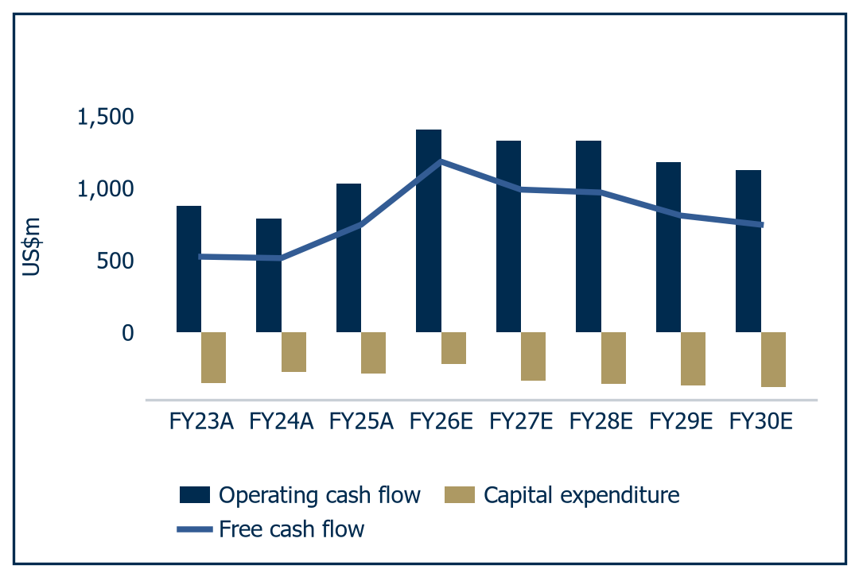 | 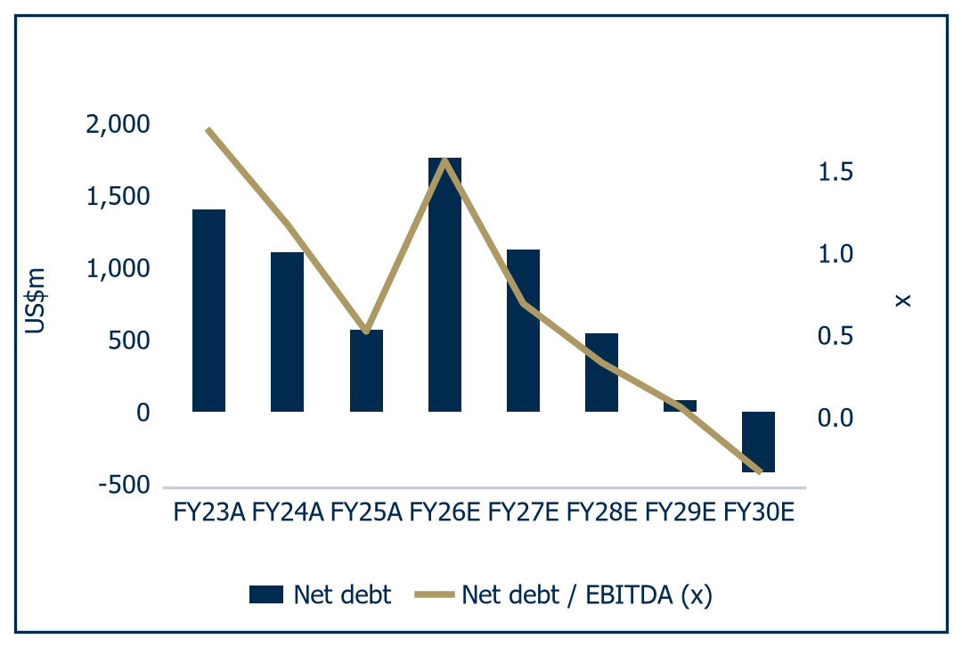
Source: Al Ramz Investment Research, company data and estimates | Source: Al Ramz Investment Research, company data and estimates

Balance sheet capacity
Leverage triples and then unwinds inside four years. Net debt goes from US$564.0m at FY2025A to US$1,759.2m at FY2026E, which is 1.56x EBITDA against 0.52x, then falls to US$1,122.8m, US$544.3m and US$76.7m before turning into a net cash position of US$420.8m by FY2030E. The peak of 1.56x is below where Alba sat in 2023 and nowhere near what a lender would consider stressed.
The mechanics of that peak are worth stating. We allocate the US$2,200m consideration as US$1,300m to property, plant and equipment, US$180m to inventories and US$150m to receivables, less US$130m of payables assumed, leaving US$700m of residual goodwill. Funding is US$2,083m of facility and US$117m from Bpifrance for 6%, so gross borrowings step from US$972.9m to US$3,115.9m and total assets to US$9,713.7m. The facility amortises US$400m in FY2027E and US$500m a year after, leaving US$183m outstanding at FY2030E.
Returns tell the truest story here, and it is a sobering one. Return on average equity peaks at 13.8% in FY2027E and fades to 12.1%, 8.9% and 7.3% by FY2030E, with return on capital employed tracing the same arc from 13.4% down to 7.9%. Against a 16.05% cost of equity and a 13.27% WACC, a business earning 7% to 8% on capital at mid-cycle is not creating value. The dividend reinforces it: the policy is 35% of the prior year's attributable profit, so payments of 61.07, 58.06, 80.50, 77.31 and 60.10 fils across FY2026E to FY2030E lag the earnings arc by a year, the FY2030E dividend struck on FY2029E earnings.

A bimodal outcome
The distribution is wide enough that the base case alone would mislead. We run three fully specified scenarios through the same 13.27% WACC, applying a 5.0x exit multiple to FY2030E EBITDA rather than a perpetuity, because a perpetuity struck on a trough NOPAT is not an equilibrium: no smelting industry runs below the incentive price forever, supply exits.
Table 6: Bull, base and bear scenarios
Metric | Bull | Base | Bear
Narrative | The disruption holds | Orderly normalisation | Hormuz reopens, volumes do not
FY2027E LME (US$/t) | 3,500 | 3,050 | 2,700
FY2030E LME (US$/t) | 3,100 | 2,750 | 2,500
FY2027E Alba production (kt) | 1,420 | 1,300 | 1,150
FY2030E Alba production (kt) | 1,620 | 1,620 | 1,550
FY2027E EBITDA (US$m) | 2,579 | 1,619 | 579
FY2030E EBITDA (US$m) | 2,024 | 1,264 | 648
FY2030E net debt / EBITDA (x) | (1.39) | (0.18) | 2.66
Implied EV per tonne (US$/t) | 5,995 | 3,338 | 1,255
Fair value (BHD) | 2.602 | 1.195 | 0.145
Probability | 20% | 55% | 25%
Contribution to weighted FV (BHD) | 0.520 | 0.657 | 0.036
Weighted fair value (BHD) | 1.214 | 1.214 | 1.214
Source: Al Ramz Investment Research, company financials and estimates
The roughly eighteen-fold spread between the wings is not a modelling artefact. The gap is what a single-asset, price-taking, fully operationally levered smelter looks like when price and volume move at once, which is what 2026 has done.
Four levers separate the cases, not one. Realised premium peaks at US$460/t in the bull case against US$380/t in the base and US$275/t in the bear. Dunkerque contributes US$255m, US$212.4m or US$75m of FY2027E EBITDA. Tax is the quiet lever: the bull case assumes relief from the Domestic Minimum Top-up Tax, the base phases it in, the bear applies the full 15% from FY2027E. Payout follows at 40%, 35% and 25%, and the bear peaks at 3.60x net debt to EBITDA in FY2028E.
Chart 20: Bull, base and bear scenario outcomes
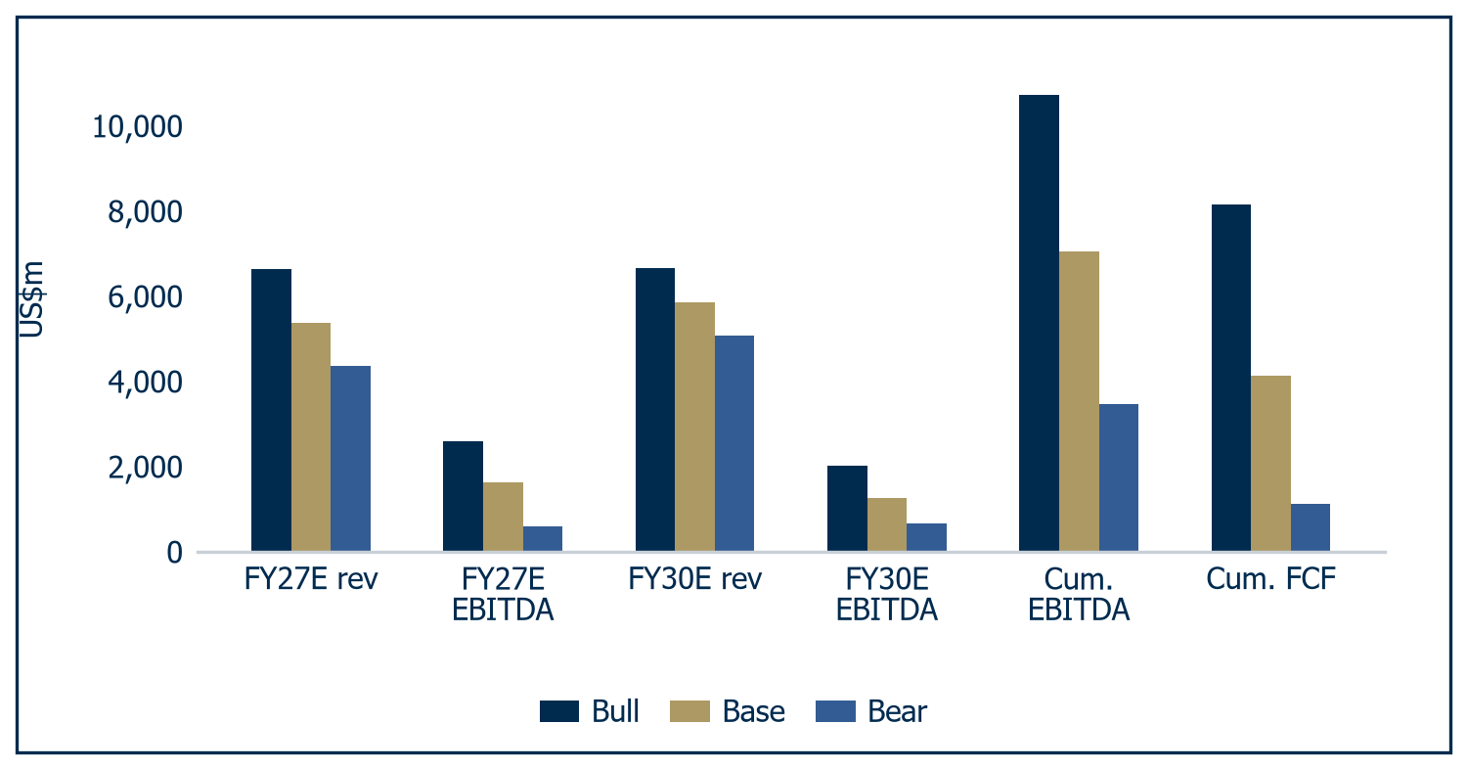
Source: Al Ramz Investment Research, company data and estimates
The bear case is severe and we have deliberately not softened it. At BHD 0.145 it implies an enterprise value of US$1,255 per annual tonne, a distress mark below the price Rio Tinto accepted for Dunkerque in 2018. It gets there by running LME at US$2,500/t in perpetuity, below the industry's incentive price and not an equilibrium we would underwrite. But a 25% weight is the discipline the current price deserves, and recent evidence has strengthened it: Axis Securities models GCC production recovering from 3.40 Mt in 2026 to 5.50 Mt in 2027, 2.10 Mt returning to a market in a single year. The evidence points both ways with unusual force, hence a 20/55/25 weighting rather than something more comfortable.
Which frames the valuation question properly. On the numbers in this chapter Alba generates US$4,686.6m of free cash flow over five years on the cash flow statement definition against a US$3,306m market capitalisation, trades at US$2,634 per tonne of consolidated capacity and earns 7.3% on equity at mid-cycle. Cheapness is not in dispute. What is in dispute is the multiple that earnings this volatile, this concentrated in one asset and this dependent on a shipping lane deserve. That is the valuation chapter's problem, and it is the right one.
Step back from the line items and the five-year path has one shape. Volume troughs at 910.2kt in FY2026E and returns to 1,620kt by FY2030E, but EBITDA peaks at US$1,640.8m in FY2028E and attributable profit a year earlier still, at 230.00 fils of EPS on a plant only 80.1% utilised. Cash is the part that does not fade: US$4,686.6m over five years against a US$3,306m market capitalisation. Leverage goes out to 1.56x and back to a US$420.8m net cash position by FY2030E. What that hands the valuation chapter is a company unambiguously cheap on cash and unambiguously short of its cost of capital on returns, at 7.3% on equity. Reconciling those two is the work.

The wrong kind of good year
Alba is earning the best profits in its history out of the worst operating conditions in its history, and the market is refusing to pay for them. We think the market is right to discount these earnings and wrong about the magnitude.

Record earnings, a third of a plant
Alba's H1 2026 profit attributable to shareholders rose 228% to US$372.8m while Q2 net finished production fell 61% year on year to 155,469 tonnes. Alba is printing record profits from a smelter running at just over a third of capacity, for one reason: LME cash averaged US$3,576/t in Q2 2026, up 46% year on year, with realised premiums following.
The result is a trailing P/E of 3.94x and a P/B of 0.575x: the multiple has halved in eight months on a company delivering the best half-year it has ever reported. That admits only two readings. Either the market has made a mistake, or it is telling you the earnings are not real.
Chart 21: Net production against the LME price | Chart 22: Shares rebased against the LME price
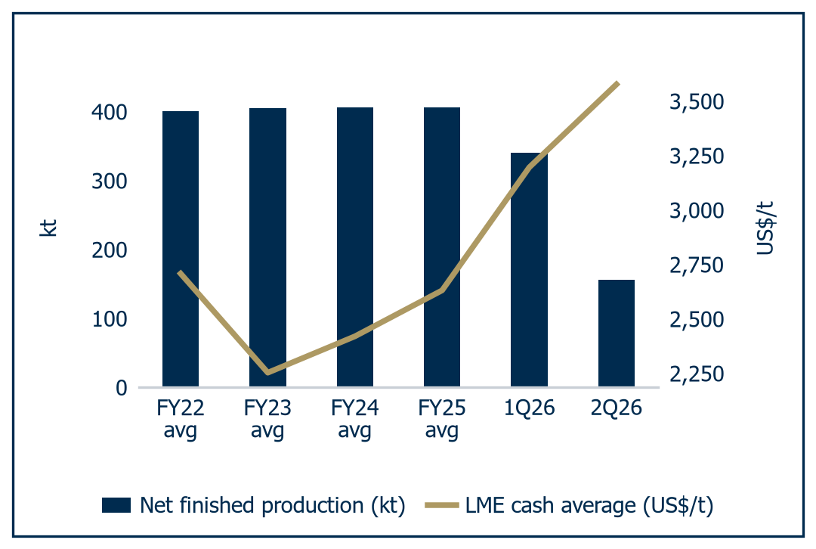 | 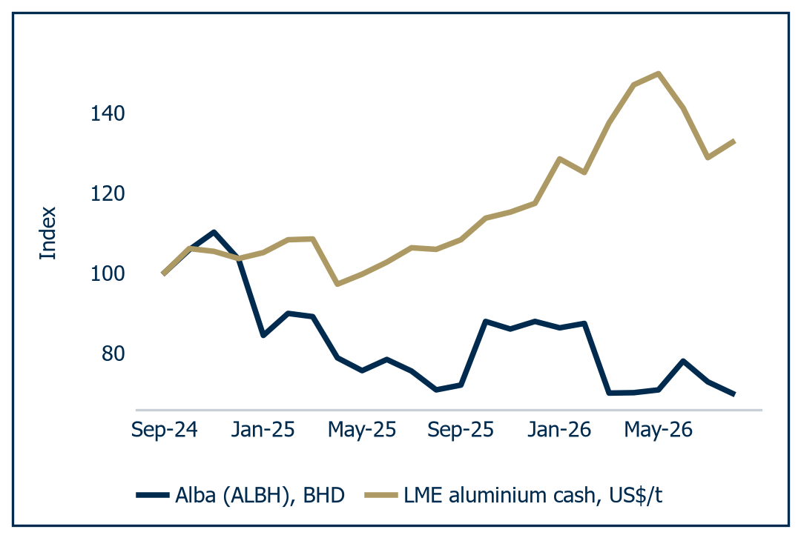
Source: Al Ramz Investment Research, company reports | Source: Al Ramz Investment Research, Bahrain Bourse, LME. Indexed to 100 at September 2024

Three earnings streams, one profit line
Alba's 2026 profit is three businesses stacked on top of each other, and applying one multiple to the total is a category error. We separate them.
First, the structural core, and it deserves a full multiple. The output is an FY2025 EBITDA margin of 22.8% against Alcoa at 15.5%, Norsk Hydro at 13.9%, Century Aluminum at 16.8% and Chalco at 16.3%. That is not a cyclical fact, and it does not reverse when Hormuz reopens.
Second, the cyclical component, and it deserves a mid-cycle multiple applied to mid-cycle earnings. The standard error in cyclical valuation is to apply a full-cycle multiple to an above-cycle earnings number, which counts the cycle twice. We do the opposite. Every multiple in this report is applied to FY2030E mid-cycle earnings, not to the FY2026E print distorted by a 44% collapse in production or the FY2027E print still carrying a disruption premium.
Third, the war premium, and it deserves essentially no multiple at all. This is the portion of the realised price attributable to Hormuz, and it capitalises to nothing because it reverses on normalisation.
The arithmetic is blunt. FY2030E consolidated EBITDA of US$1,264m at US$2,750/t and 1,620kt is the structural core, and it is the only layer we capitalise in full. FY2027E EBITDA of US$1,619m sits US$355m above it, and that US$355m, about 22% of the FY2027E line, is the cycle: a US$300/t gap to mid-cycle that exists in 2027 and not in perpetuity. The bull case sizes the third layer at US$2,579m, a further US$960m, or 37% of that print, earned on metal at US$3,500/t that survives only while Hormuz stays shut.

What the close discounts
Running the base-case model backwards at our 13.27% WACC and 2.0% terminal growth, the BHD 0.878 close discounts a perpetual mid-cycle LME of approximately US$2,644/t on a full volume recovery to 1,620kt. That is below the bottom of the US$2,650 to US$2,750/t band Alba discloses from CRU, and below the US$2,800 to US$3,000/t incentive-price floor in independent sector work. Read the other way, on the unchanged base-case model the market is applying a 15.02% WACC and an implied cost of equity of roughly 18.4%.
The market is not pricing Alba at mid-cycle, it is pricing Alba below the bottom of mid-cycle, on full volumes, in perpetuity, with no credit at all for the structural core. That is too harsh but not absurd, which is why our BHD 1.150 fair value sits closer to the market than to consensus.
Layer by layer, that is what the close is paying. It capitalises mid-cycle EBITDA of US$1,264m at an enterprise value of 3.85x against a core smelter median of 6.59x, which values the structural core at a 42% discount and hands the buyer the cycle and the war premium for nothing.

Dunkerque on two metrics
Alba announced US$2.2bn for the EU's largest primary smelter on 2 June 2026 and disclosed no revenue, no EBITDA and no balance sheet. Those figures are now known. The holding company being sold, Aluminium Dunkerque Industries France files consolidated statutory accounts with the French registry, and the FY2025 comptes consolidés were filed on 23 April 2026.
Table 7: Aluminium Dunkerque statutory accounts, EUR m
ADIF consolidated (EUR m) | FY2022 | FY2023 | FY2024 | FY2025
Revenue | 931 | 836 | 834 | 895
EBITDA (EBE) | 104 | 169 | 317 | 292
EBIT | 52 | 127 | 259 | 227
Net income | - | - | 154 | 152
Equity | 197 | 266 | 414 | 533
Net debt | 438 | 217 | 220 | 201
EBITDA margin | 11.1% | 20.2% | 38.0% | 32.6%
Net debt / EBITDA | 4.2x | 1.3x | 0.7x | 0.7x
Source: Al Ramz Investment Research, INPI and RNE statutory filings
At the ECB fixing of EUR/USD 1.1641 on 27 August 2026, FY2025 EBITDA of EUR 292m is US$340m, which puts the US$2.2bn price at 6.47x trailing EBITDA, and FY2024's EUR 317m at 5.96x. The per-tonne optic is rich at US$7,333/t on 300kt. The cash-flow optic is not.

The undisclosed power contract
The ARENH regulated price of EUR 42/MWh expired on 31 December 2025. A ten-year EDF supply contract signed on 22 July 2025 runs from 1 January 2026 and covers "une part substantielle des besoins", with an undisclosed significant upfront advance to EDF, and its price is not disclosed. Both the FY2024 and the FY2025 EBITDA figures in Table 7 were earned under ARENH. That is the whole point, and it is why we do not mark Dunkerque up to its accounts.
Table 8: Aluminium Dunkerque, the power reset after ARENH
EDF price (EUR/MWh) | Delta vs ARENH | Cost delta (EUR m) | EBITDA rebased (EUR m) | US$m | US$/t
42 (ARENH, expired) | 0 | 0 | 292 | 340 | 1,133
55 | 13 | 51 | 241 | 280 | 934
65 | 23 | 91 | 201 | 234 | 781
75 | 33 | 130 | 162 | 188 | 628
85 | 43 | 170 | 122 | 143 | 475
95 | 53 | 209 | 83 | 97 | 322
Source: Al Ramz Investment Research, company reports and estimates
At a EUR 65 to 75/MWh reset applied to the full load, rebased EBITDA of US$188m to US$234m brackets the US$212m our model already assumed for FY2027E with no disclosure at all. We therefore adopt US$220m as the steady-state case, which values Dunkerque at roughly US$1.0bn against the US$2.2bn paid.
Read correctly, this is geographic diversification bought at a premium by a company that has just learned what single-site concentration costs: a defensible strategic decision and an expensive financial one. Consolidated fair value moves by roughly BHD 0.20 a share for every US$100m of steady-state Dunkerque EBITDA, the largest unforced band in our valuation, and the single number that would close it, the EDF contract price, has not been disclosed.

What would break the decomposition
Mapped onto the scenarios, the bull case, "The disruption holds", capitalises the structural core, the cycle and a persistent war premium, and gives BHD 2.602 on a 20% weight. The base case, "Orderly normalisation", capitalises the core at a mid-cycle price and gives BHD 1.195 on 55%. The bear case, "Hormuz reopens, volumes do not", strips out the war premium and the cycle together and gives BHD 0.145 on 25%. The probability-weighted outcome is BHD 1.214.
That leaves the crux. The forward curve and the sell-side consensus are roughly US$1,000/t apart on where aluminium goes from here, so a valuation anchored on the curve and one anchored on J.P. Morgan differ by about a third of Alba's revenue line. We sit between them, closer to the sell side, and we would rather say so than bury the choice in a discount rate.
Chart 23: Scenario fair value per share
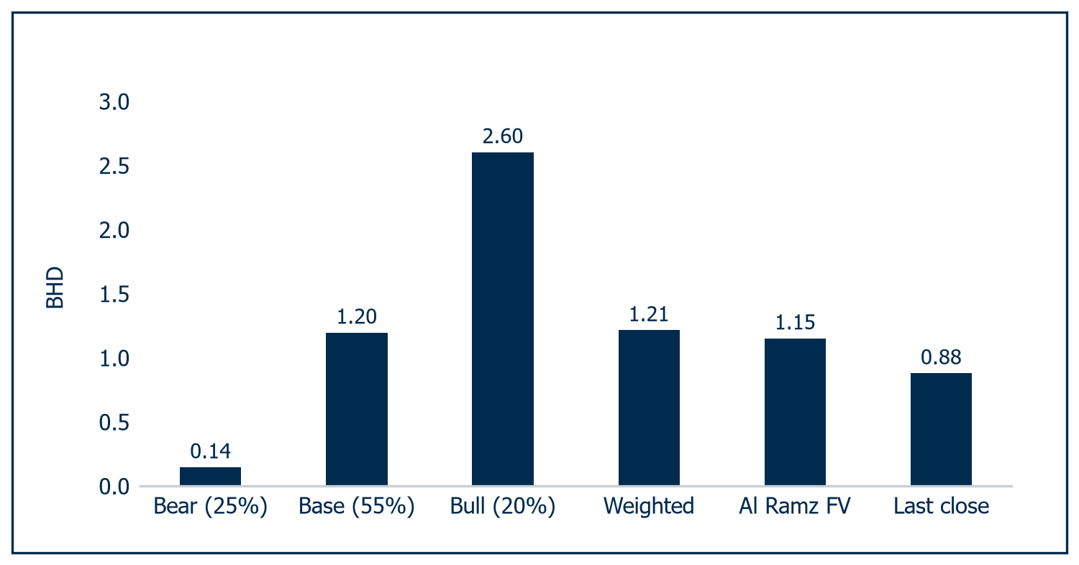
Source: Al Ramz Investment Research, company financials and estimates
The decomposition breaks in one place, and it is not the war premium. It breaks if the structural core is not structural: the 22.8% margin rests on gas at US$4.50/MMBtu and a 74% value-added mix, and if either resets, the layer we capitalise in full is one we should have discounted.
So what is the decomposition worth in practice? At the close the market pays 3.85x for the structural core against a 6.59x core smelter median, a 42% discount, and takes the cycle and the war premium for nothing. In our view that asymmetry, not the 2026 earnings print, is the reason to own the shares. Two disclosures would confirm or refute the read: the EDF contract price, worth roughly BHD 0.20 a share for every US$100m of Dunkerque EBITDA, and a restart schedule for Reduction Lines 1 to 3.

Priced at the bottom of mid-cycle
Six methods, a base-case spread of only 25%, and a rating that survives a 13.68% cost of capital but not a 14.27% one. We set out why our fair value sits 21% below consensus.

Over-Weight, below the street
We initiate coverage of Aluminium Bahrain at Over-Weight with a fair value of BHD 1.150, 31.0% above the close of BHD 0.878 on 26 August 2026. The house rule sets Over-Weight above +15% and Under-Weight below -15%, which at the last close means above BHD 1.010 or below BHD 0.746.
Our fair value is deliberately 21% below the consensus mean of BHD 1.450, a Strong Buy from four analysts ranging BHD 1.30 to BHD 1.75. We are constructive, and less constructive than the street.
The rating is not a comfortable one. Three of our six methods sit within 5% of the BHD 1.010 threshold. It survives a weighted average cost of capital of 13.68% against the 13.27% we carry and fails above it, and it survives a mid-cycle London Metal Exchange price of US$2,700/t at restored volumes and fails much below.
Two methods rest on the preceding chapter. The Dunkerque statutory accounts against the ARENH expiry of 31 December 2025 give a US$220m steady-state EBITDA case, carrying the discounted cash flow to BHD 1.229; the scenarios weighted 20% bull, 55% base and 25% bear give BHD 1.214. Each takes 15% of the blend.

A market-built cost of capital
Table 9: Cost of capital
Component | Value | Basis
Risk-free rate, Bahrain sovereign 10-year USD | 7.125% | Reoffer on the Kingdom of Bahrain US$1.0bn issue maturing 10 June 2036, priced 10 June 2026 into a book above US$3.2bn
Equity risk premium, mature market | 5.50% | Al Ramz house assumption; Damodaran carries 4.23% at the 5 January 2026 vintage
Levered beta | 1.35x | Peer unlevered median 0.58x on vendor betas and 1.09x on five-year weekly regressions; relevered at 25% gearing that is a 0.75x to 1.40x range
Single-asset concentration and liquidity premium | 1.50% | Cut from the 2.00% initial placeholder because the sourced sovereign yield carries the country component
Cost of equity | 16.05%
Pre-tax cost of debt | 5.80% | Weighted average of the facilities in audited note 13
Marginal tax rate | 15.00% | Bahrain Domestic Minimum Top-up Tax, Decree Law 11 of 2024
Target debt / total capital | 25.0% | Current market gearing of 34.7% would give a 12.19% WACC and a higher fair value
Weighted average cost of capital | 13.27%
Terminal growth | 2.00% | Below long-run global aluminium demand growth of roughly 2.2%
Source: Al Ramz Investment Research, Bloomberg, company financials
The discount rate is the largest single swing factor, so three points on the build.
First, we use the observed Bahrain sovereign yield, not a ratings-implied spread. A Damodaran-style construction takes a 4.67% adjusted default spread over a 4.65% US Treasury to 9.32%, roughly 220bp wider than the 7.125% Bahrain itself paid on 10 June 2026.
Second, we disclose what the alternative gives. Built the Damodaran way, on a 7.12% Bahrain country risk premium over a US risk-free rate, the discount rate is 14.34% and the discounted cash flow value BHD 0.94, which would be Equal-Weight.
Third, our beta is the conservative choice, because Alba's own regression is unusable. We build from peers and take 1.35x, the top of the relevered 0.75x to 1.40x range.
Alba's own five-year weekly regression against MSCI ACWI returns 0.053 on an R-squared of 0.001, the signature of a 10% free float on a frontier exchange, and the only published alternative is 2.81 with no disclosed benchmark. Relevering at the 0.75x floor rather than 1.35x would cut the cost of capital by roughly 250bp, six times the 41bp that decides the rating.

Discounted cash flow: BHD 1.056/share
We value Alba as at 31 December 2026, a twelve-month forward fair value from the 26 August 2026 close, over FY2027E to FY2030E.
Table 10: Discounted cash flow and the equity bridge
US$m unless stated | FY2027E | FY2028E | FY2029E | FY2030E | Total
Unlevered free cash flow
EBIT | 1,101 | 1,110 | 851 | 708
NOPAT | 1,046 | 944 | 723 | 602
Add: depreciation and amortisation | 519 | 530 | 543 | 556
Less: capital expenditure | (340) | (360) | (370) | (380)
Less: increase in net working capital | (195) | (122) | (61) | (8)
Unlevered free cash flow | 1,029 | 992 | 835 | 770
Discount factor at 13.27% | 0.883 | 0.779 | 0.688 | 0.607
Present value | 909 | 773 | 574 | 468 | 2,724
Terminal value build
Terminal year NOPAT, FY2030E |  |  |  |  | 602
Add: depreciation and amortisation |  |  |  |  | 556
Less: normalised capital expenditure |  |  |  |  | (556)
Less: terminal working capital investment |  |  |  |  | (32)
Normalised terminal free cash flow |  |  |  |  | 570
Terminal value at 31 December 2030 |  |  |  |  | 5,159
Present value of terminal value |  |  |  |  | 3,134
Enterprise to equity bridge
Present value of explicit-period free cash flow |  |  |  |  | 2,724
Present value of terminal value |  |  |  |  | 3,134
Enterprise value |  |  |  |  | 5,858
Less: net debt at 31 December 2026E |  |  |  |  | (1,759)
Less: non-controlling interest, Bpifrance |  |  |  |  | (120)
Equity value |  |  |  |  | 3,979
Shares outstanding, net of treasury (m) |  |  |  |  | 1,416.0
Fair value per share (BHD) |  |  |  |  | 1.056
Source: Al Ramz Investment Research, company financials and estimates
We make one analyst adjustment and it costs us BHD 0.26 a share. The model of record carries FY2030E capital expenditure at 0.68x depreciation, defensible after a curtailment but not in perpetuity, so we normalise it to depreciation in the terminal year, taking normalised terminal free cash flow to US$570m from US$770m.
FY2030E is a deliberately mid-cycle terminal year, not a peak: LME at US$2,750/t, Alba production back at 1,620kt and 1,910kt of consolidated sales.
Two tests on that terminal year. US$2,750/t is US$192/t below the CY2030 threshold of US$2,942/t that Alcoa and South32 negotiated into contingent consideration on 1 July 2026, so two counterparties structuring a live deal put mid-cycle 2030 metal above where we put it. And terminal value is 53.5% of enterprise value, inside the 70% at which an explicit forecast is judged too short.
Chart 24: DCF enterprise-to-equity bridge
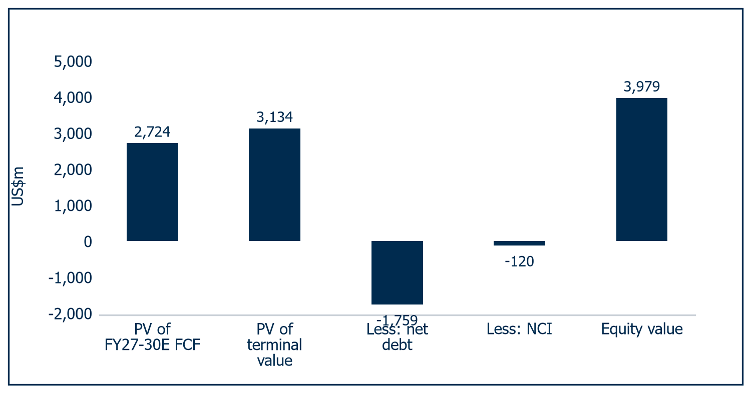
Source: Al Ramz Investment Research, company financials and estimates. Valuation date 31 December 2026, WACC 13.27%
At BHD 1.056 the implied enterprise value is 4.64x FY2030E mid-cycle EBITDA against a core smelter peer median of 6.59x, the terminal exit multiple 4.08x, enterprise value per annual tonne US$3,046 against a peer median of US$6,201, and enterprise value 54.8% of the Line 6 whole-scope build cost. The discounted cash flow is not stretching.

Sensitivity: rate and metal price
Over-Weight survives every combination at or below a 13.27% cost of capital and fails at 14.27% and above at any growth rate below 3.0%. The break-even is 13.68%, 41bp above where we carry it; Under-Weight is not reached until an implausible 16.68%.
Chart 25: DCF sensitivity, WACC vs growth
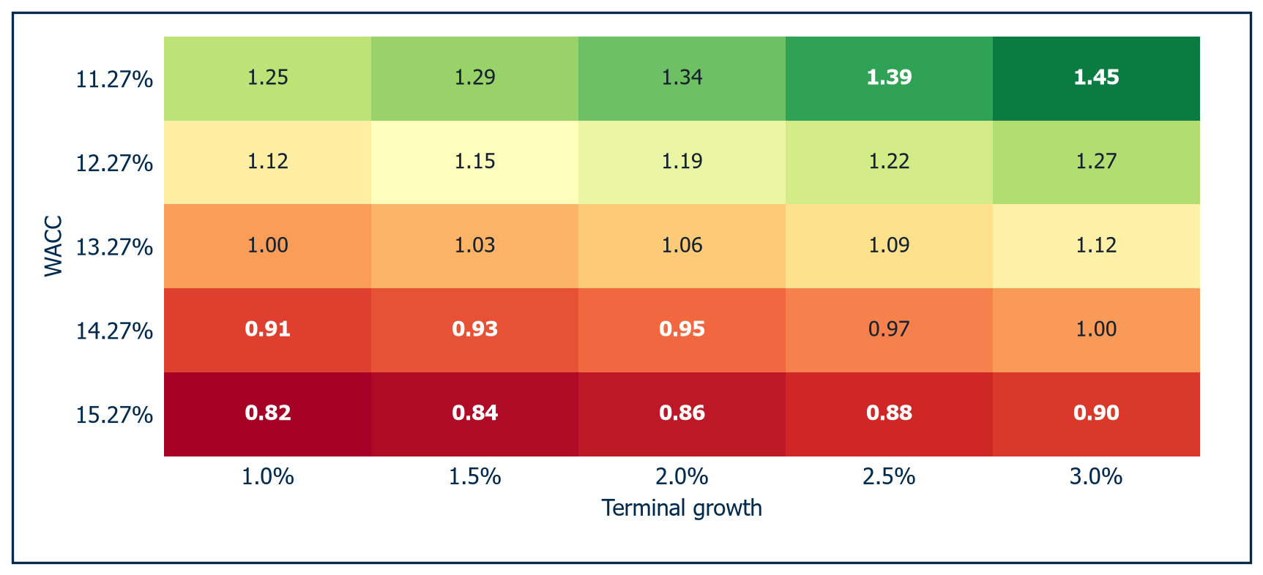
Source: Al Ramz Investment Research, company financials and estimates. Base case WACC 13.27%, terminal growth 2.0%
Table 11: DCF sensitivity, LME against restored production
LME (US$/t) vs production (kt) | 1,450 | 1,550 | 1,620 | 1,720 | 1,820
2,400 | 0.275 | 0.330 | 0.368 | 0.423 | 0.478
2,550 | 0.545 | 0.616 | 0.665 | 0.736 | 0.806
2,700 | 0.816 | 0.902 | 0.962 | 1.048 | 1.134
2,750, base case | 0.906 | 0.997 | 1.061 | 1.152 | 1.243
2,900 | 1.177 | 1.283 | 1.358 | 1.465 | 1.571
3,050 | 1.447 | 1.568 | 1.655 | 1.778 | 1.900
Source: Al Ramz Investment Research, LME, company financials
The sensitivity grid is where the equity is decided. For a producer whose cash cost is roughly 80% of its realised price, a 170kt shortfall against the 1,620kt base costs roughly BHD 0.09, a US$150/t shortfall in the metal price roughly BHD 0.28.
At US$2,750/t and 1,620kt the fair value is BHD 1.061; at US$2,650/t, the bottom of the CRU band Alba discloses, it is roughly BHD 0.98, which is Equal-Weight. The rating is a call on a US$100/t range in a metal price.

Trading comparables: BHD 1.051/share
Alcoa is the only listed pure-play of size, but 45% of its FY2025 segment EBITDA came from alumina, so its enterprise value per tonne overstates a smelting-only multiple. We extend the set to thirteen names, seven of them core smelters, and those seven are the reference set.
Table 12: Comparable companies and statistical summary
Company | Net debt (US$bn) | EV (US$bn) | Revenue (US$bn) | EBITDA (US$bn) | EBITDA margin | EV/EBITDA FY | EV/EBITDA LTM | P/E trailing | P/E forward
Core smelters
Alcoa | 0.87 | 14.38 | 12.83 | 1.98 | 15.5% | 7.25x | 6.22x | 10.61x | 8.76x
Emirates Global Aluminium | 3.41 | 15.91 | 8.71 | 2.53 | 29.0% | 6.29x | - | - | -
Norsk Hydro | 1.04 | 20.43 | 22.30 | 3.10 | 13.9% | 6.59x | 3.92x | 18.53x | 9.59x
Century Aluminum | 0.14 | 4.68 | 2.53 | 0.43 | 16.8% | 11.01x | 9.77x | 7.62x | 3.39x
Vedanta | 5.57 | 17.08 | 18.22 | 5.86 | 32.2% | 2.91x | 4.59x | 16.26x | 8.55x
Chalco | 5.28 | 28.50 | 35.88 | 5.83 | 16.3% | 4.89x | 4.13x | 7.18x | 6.04x
China Hongqiao | 3.18 | 32.16 | 24.16 | 7.05 | 29.0% | 4.56x | 4.59x | 7.45x | 5.94x
Press Metal | 0.42 | 16.80 | 4.02 | 0.84 | 20.9% | 20.00x | 15.45x | 25.59x | 26.12x
Wider complex, not core
Hindalco | 7.30 | 31.05 | 28.78 | 3.99 | 13.9% | 7.78x | 7.34x | 13.86x | 9.03x
Rio Tinto | 14.36 | 193.19 | 57.64 | 25.36 | 44.0% | 7.62x | 8.68x | 14.78x | 12.89x
South32 | (0.28) | 16.51 | 5.82 | 2.46 | 31.0% | 6.71x | 12.90x | 15.34x | 17.02x
Ma'aden | 5.59 | 77.74 | 10.29 | 4.30 | 41.7% | 18.08x | 20.59x | 35.20x | 27.04x
SABIC | (0.96) | 39.12 | 31.07 | 4.77 | 15.3% | 8.20x | 11.84x | - | 37.93x
Aluminium Bahrain
Aluminium Bahrain | 0.56 | 3.87 | 4.73 | 1.08 | 22.8% | 3.59x | 3.59x | 3.94x | 3.82x
Statistical summary, core smelters (7)
Maximum |  |  |  |  |  | 20.00x | 15.45x | 25.59x | 26.12x
75th percentile |  |  |  |  |  | 9.13x | 7.99x | 17.40x | 9.18x
Median, core smelters |  |  |  |  |  | 6.59x | 4.59x | 10.61x | 8.55x
25th percentile |  |  |  |  |  | 4.72x | 4.36x | 7.54x | 5.99x
Minimum |  |  |  |  |  | 2.91x | 3.92x | 7.18x | 3.39x
Median, all 12 peers |  |  |  |  |  | 7.44x | 8.01x | 14.78x | 9.31x
Memo: Alcoa/South32 through-the-cycle |  |  |  |  |  | 6.80x
Memo: EGA at ADX listing range |  |  |  |  |  | 5.30x to 7.30x
Source: Al Ramz Investment Research, Bloomberg, company financials. EGA valuation is an indication, not a traded price
The strongest evidence here is not a trading multiple at all. On 1 July 2026 South32 disclosed that an implied enterprise value of up to US$5.6bn for the sale of its bauxite, alumina and aluminium interests to Alcoa "implies a through-the-cycle EBITDA multiple of ~6.8x", footnoted to average consolidated underlying EBITDA of about US$0.8bn over FY21 to FY25.
We apply ours to mid-cycle earnings power, FY2030E consolidated EBITDA of US$1,264m.
We also read the FY column and not the LTM. With LME cash at US$3,212.50/t on 27 August 2026 against a 2025 average of US$2,632/t, every peer's trailing EBITDA is struck on a cyclical peak, and the whole of the gap from the 6.59x FY median to the 4.59x LTM median is that timing effect.
The discount is itemised rather than asserted. We start from a 6.60x reference multiple, between the core smelter median of 6.59x and the Alcoa and South32 negotiated 6.80x. We deduct 15% for single-asset concentration on one site struck on 28 March 2026; 10% for Strait of Hormuz dependence on inbound alumina and outbound metal; 10% for the sovereign, at B2 negative and B stable after S&P and Fitch downgrades; and 10% for liquidity, a 10% free float on about US$0.4m of average daily traded value. We add back 10% for the cost position (gas at US$4.50/MMBtu, a 74% value-added mix, single-site scale) and 5% for an FY2025 EBITDA margin of 22.8% against Alcoa 15.5%, Norsk Hydro 13.9%, Century 16.8% and Chalco 16.3%. The net discount is 30%, the applied multiple 4.62x, and the result an enterprise value of US$5,838m, equity of US$3,959m and BHD 1.051.
Chart 26: Peer EV/EBITDA against Alba
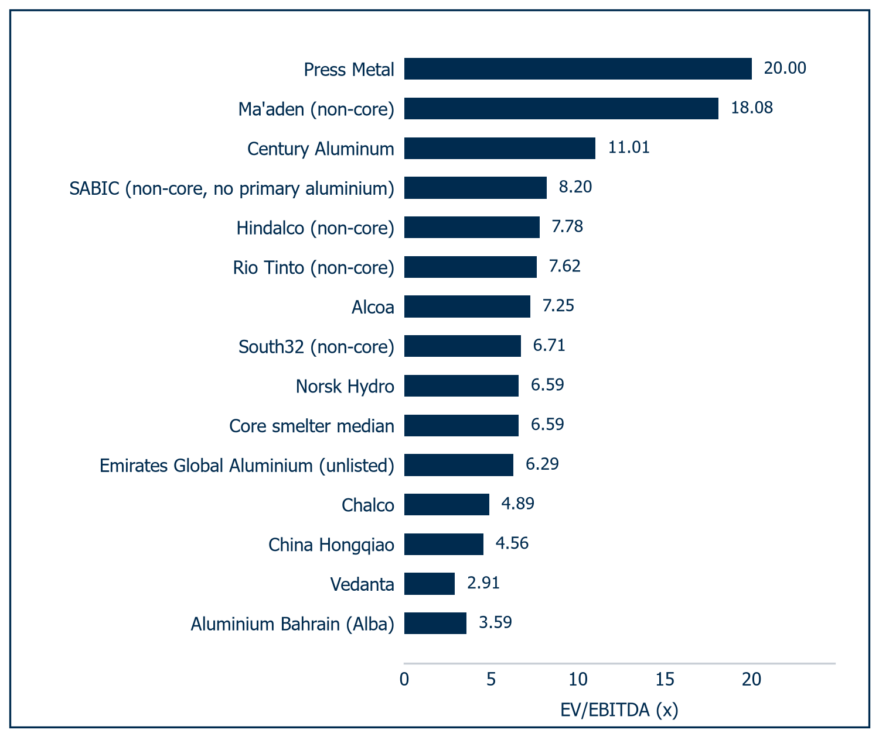
Source: Al Ramz Investment Research, Bloomberg, company financials. Market data 27 to 28 August 2026
Chart 27: Peer multiples, core smelters
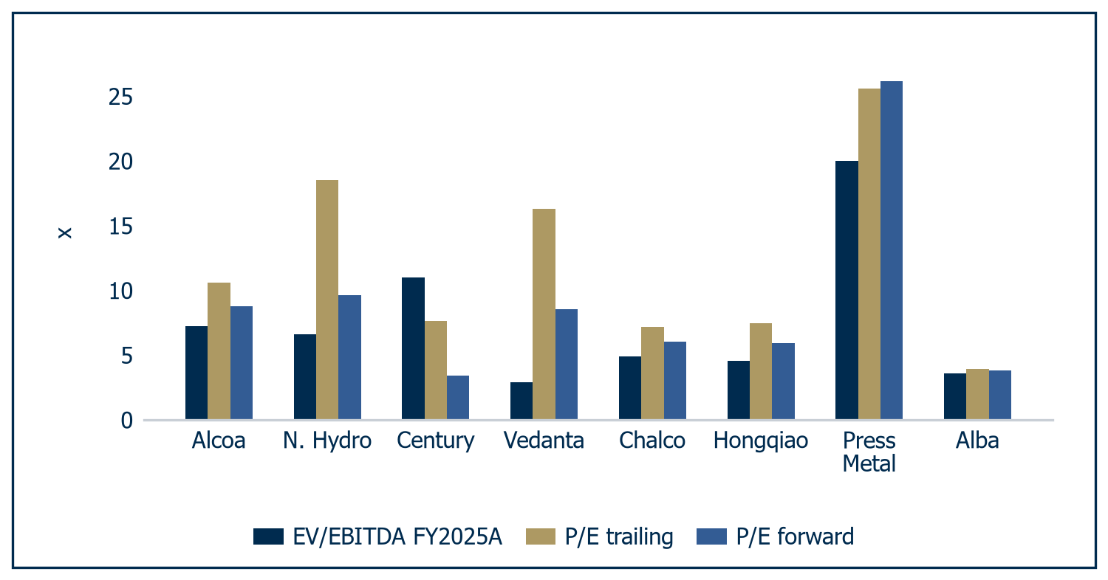
Source: Al Ramz Investment Research, Bloomberg, company financials
The discount is about risk and liquidity, not about asset quality. Nothing in the 30% is a statement about the plant.

Historical multiples: BHD 1.206/share
The price to earnings series is a cyclical inversion and should not be averaged naively. Alba traded at 2.51x in 2021 and 3.71x in 2022 on peak earnings and 13.80x in 2023 on trough earnings. This market refuses to capitalise peak aluminium earnings above about 4x, and today's 3.94x is no exception.
The price to book series is more stable and more informative. It ranges 0.750x to 0.957x across 2021 to 2025 on a 0.843x mean, below book in every year, and today's 0.575x is 32% below that mean and the lowest reading in the series.
Three applications follow. Price to book at the five-year mean of 0.843x on FY2026E book value of BHD 1.5765 gives BHD 1.329; price to earnings at the five-year median of 7.18x on FY2030E mid-cycle earnings of 147.8 fils gives BHD 1.061; dividend yield at the five-year median of 4.89% on FY2030E dividends of 60.1 fils gives BHD 1.228. The average is BHD 1.206.
Chart 28: Own historical multiples, 2021 to 2026 | Chart 29: Share price against price to book
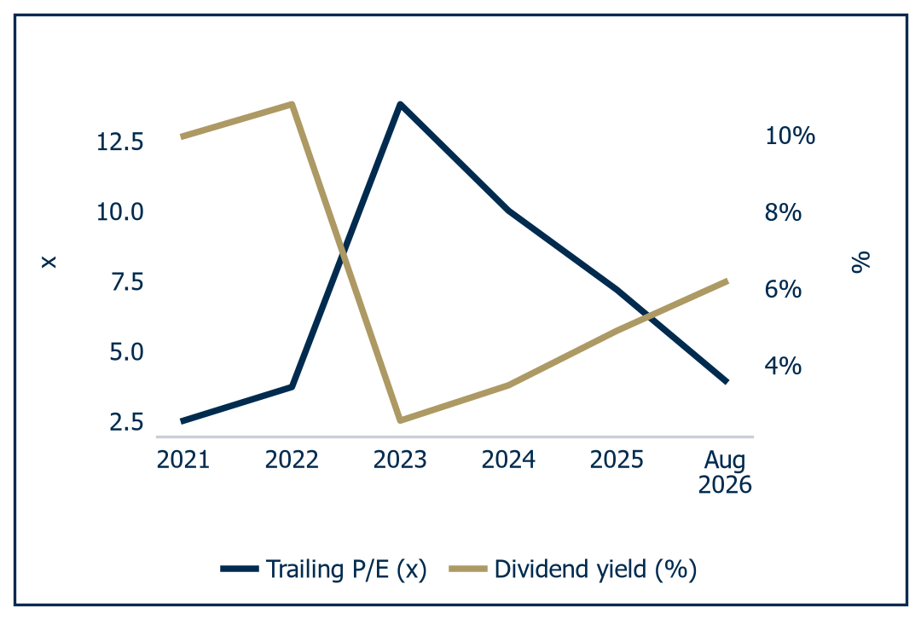 | 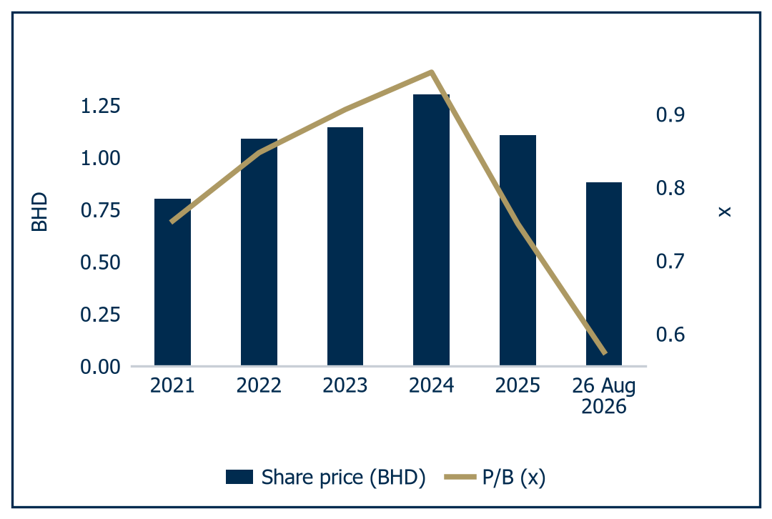
Source: Al Ramz Investment Research, Bahrain Bourse, company financials | Source: Al Ramz Investment Research, Bahrain Bourse, company financials

Transactions and asset value: BHD 1.318/share
Table 13: Precedent transactions in primary aluminium, 2016 to 2026
Announced | Target | Acquirer | Consideration | Capacity | EV or equity per tonne | Implied EV/EBITDA | LME at announcement
Jun 2026 | Aluminium Dunkerque (100%) | Alba (Bpifrance 6%) | US$2,200m | 300kt | US$7,333/t | 6.47x FY2025 | US$3,855/t
Jun 2026 | South32 aluminium chain | Alcoa | US$4.1-5.6bn | bundled | - | 6.8x cycle | US$3,439/t
Jan 2026 | CBA, Brazil (68.6%) | Chalco and Rio Tinto | US$903m | ~400kt | US$3,290/t eq | - | US$3,142/t
Jul 2025 | Ma'aden Aluminium and MBAC (25.1%) | Ma'aden, from Alcoa | US$1,350m | 202kt attrib. | US$6,690/t eq | - | US$2,450/t
Feb 2025 | Alba (20.62% block) | Ma'aden, from SABIC | US$966m | 1,623kt | US$3,557/t | 6.15x FY2024 | US$2,660/t
Oct 2021 | Aluminium Dunkerque (control) | American Industrial Ptnrs | - | 300kt | - | - | US$2,934/t
Feb 2018 | Rio Tinto ISAL, Iceland | Norsk Hydro (aborted) | US$345m | 205kt | US$1,683/t | - | US$2,182/t
Jan 2018 | Dunkerque smelter | Liberty House (GFG) | US$500m | 282kt | US$1,773/t | - | US$2,210/t
Nov 2016 | Rio Tinto Lochaber | SIMEC / Liberty House | US$410m | 47kt | US$8,723/t | - | US$1,737/t
2016 | New Madrid, Chapter 11 | Magnitude 7 Metals | US$14m | 263kt | US$52/t | - | US$1,604/t
Statistical summary, the three clean EV-basis deals
Median |  |  |  |  | US$3,557/t
75th percentile |  |  |  |  | US$5,445/t
25th percentile |  |  |  |  | US$2,665/t
Mean |  |  |  |  | US$4,221/t
Source: Al Ramz Investment Research, company announcements, SEC EDGAR, HKEXnews, LME
The Ma'aden mark is the most useful external evidence on Alba equity. On 17 February 2025 Ma'aden completed the purchase of SABIC's 20.62% holding, 292.8m shares, for BHD 363.08m: BHD 1.240 a share, US$4,670m of equity, US$5,773m of enterprise value, 6.15x FY2024 EBITDA, US$3,559 per annual tonne, 9.54x earnings, 0.91x book and a 41.2% premium to today's close. Applying the transaction median of US$3,559/t to 1,923kt of consolidated capacity gives US$6,844m and BHD 1.318.

The blend: BHD 1.150/share
Table 14: Blended fair value by method
Method | Low | Base | High | Weight | Contribution | Upside at base
DCF, model as built | 0.884 | 1.056 | 1.397 | 30% | 0.317 | +20.3%
DCF, Dunkerque at statutory accounts | 1.040 | 1.229 | 1.458 | 15% | 0.184 | +40.0%
Scenario probability-weighted DCF | 1.010 | 1.214 | 1.407 | 15% | 0.182 | +38.3%
Trading comparables on mid-cycle EBITDA | 0.843 | 1.051 | 1.383 | 20% | 0.210 | +19.7%
Alba's own historical multiples | 1.061 | 1.206 | 1.335 | 10% | 0.121 | +37.4%
Precedent transactions and asset value | 0.931 | 1.318 | 1.799 | 10% | 0.132 | +50.1%
Blended fair value | 0.941 | 1.146 | 1.439 | 100% | 1.146 | +30.5%
Rounded fair value |  | 1.150 |  |  |  | +31.0%
Source: Al Ramz Investment Research, company financials. Upside against the BHD 0.878 close of 26 August 2026
The weighting is a judgement. The discounted cash flow carries 45% across its two variants, because it alone prices the four-year volume recovery rather than assuming it away. Trading comparables take 20%: only four of thirteen names are structurally comparable and none shares Alba's single-site or Hormuz exposure. The scenario-weighted discounted cash flow takes 15%, the outcome being genuinely bimodal. Historical multiples and precedent transactions take 10% each, both resting on samples too thin or too cycle-dependent to bear more.
Note the direction the weighting pushes in. Equal-weighting the six methods would give BHD 1.179, 33 fils above the BHD 1.146 we carry, so our scheme taxes the bull case rather than funding it.
The base-case range across the six methods is BHD 1.051 to BHD 1.318, a spread of only 25%, unusually tight for a single-asset cyclical producer struck five months ago. It is tight because every method is anchored on the same two facts: 0.575x book, and the BHD 1.240 a share Ma'aden paid in February 2025.
The entire sell-side consensus range of BHD 1.30 to BHD 1.75 sits above the top of our discounted cash flow base case and above five of our six method midpoints. We are not disputing that Alba is cheap. We are disputing how cheap.
Chart 30: Valuation football field | Chart 31: Consensus targets vs our fair value
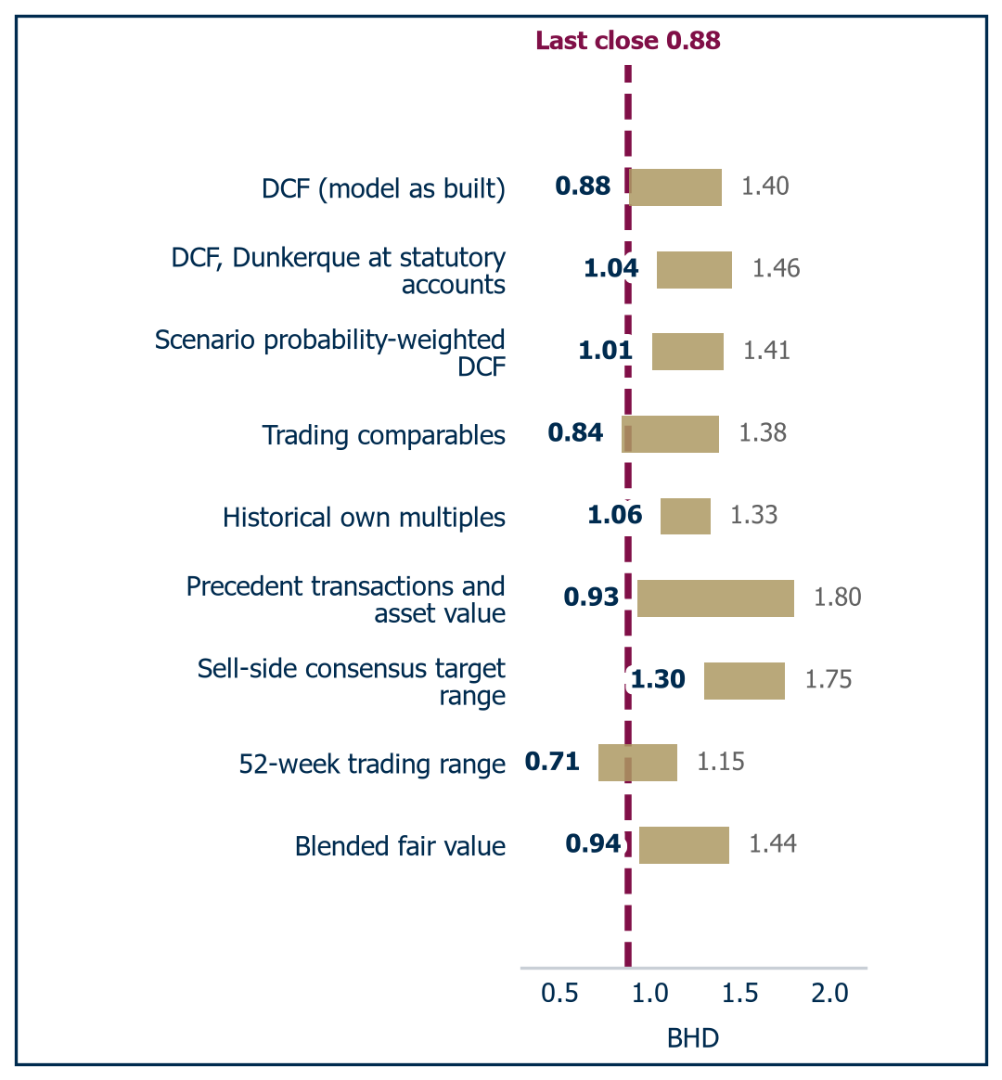 | 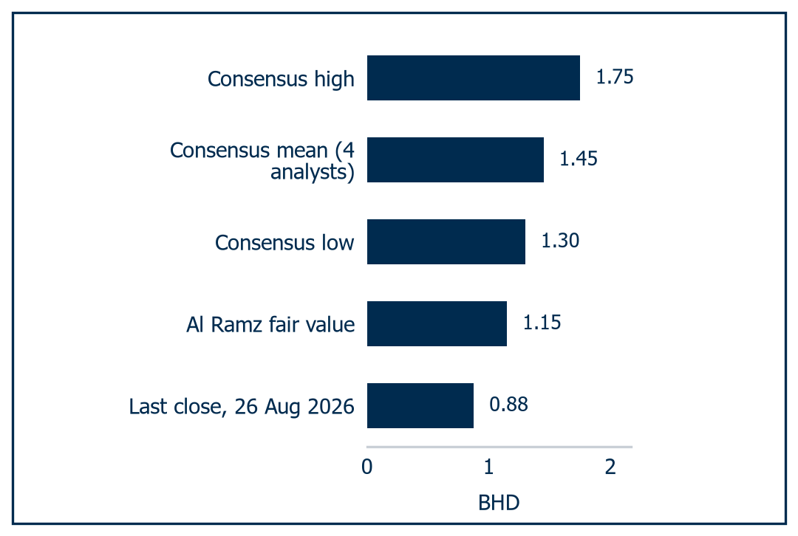
Source: Al Ramz Investment Research, Bloomberg, company financials. Fair value per share, BHD | Source: Al Ramz Investment Research, Investing.com and TradingView consensus, 28 August 2026

Six things would move the number.
- First, disclosure of the Dunkerque EDF contract price, or of Dunkerque earnings on completion in Q4 2026. This is the highest-value catalyst, because roughly BHD 0.20 of fair value rides on every US$100m of steady-state Dunkerque EBITDA.
- Second, a restart schedule for Reduction Lines 1 to 3, on which Alba gave no guidance in either 2026 quarterly release, against EGA's guidance of pre-war capacity at Al Taweelah by Q1 2027 with 25% of reduction cells restarted at 26 August 2026.
- Third, normalisation of the Strait of Hormuz, after Oman's and Iran's foreign ministers met on 25 August 2026 on a phased joint navigation corridor and mine clearing. This one is two-sided: it restores volumes and removes the price premium at once.
- Fourth, a New Replacement Line decision, to which we ascribe zero value because Alba has disclosed neither capacity (the 380kt and 540kt readings conflict) nor capital cost. Any credit is upside.
- Fifth, a larger free float or a Saudi cross-listing, on which Ali Al Baqali said on 18 February 2026 "this is a shareholders' matter, actually. But what we are doing, it's already in our radar". That attacks the 10% liquidity discount, worth roughly BHD 0.11 a share on comparables alone.
- Sixth, insurance recoveries, with the December 2025 rectifier fire fully insured and recoveries expected during 2026, and nothing disclosed on the 28 March 2026 attack, for which we model none.
Two of the six are dated and four are not, the honest weakness of the list. Dunkerque completes in Q4 2026, so the BHD 0.20 riding on every US$100m of steady-state EBITDA resolves within two reporting periods. Hormuz needs more care: a reopening that restores 1,620kt at US$2,750/t is worth BHD 1.195 on our grid, one that restores the price and not the volume BHD 0.145. We would add on the first quarter of restarted output, not on the headline.
We are buying the largest single-site smelter in the world at 0.58x book, 0.73x the price a strategic buyer paid eighteen months ago, and 4.8x mid-cycle earnings, and we are paid a 6.2% yield to wait for the volume. That is the trade, and we would take it.

Key risks to our investment theme
Our BHD 1.150 fair value rests on three propositions: that Alba restores production to 1,620kt, that mid-cycle aluminium settles near US$2,750/t, and that Aluminium Dunkerque earns roughly US$220m of steady-state EBITDA. We set out the six risks capable of breaking the rating and the level at which each does so.
Table 15: Key risks to our investment theme
Key Risk | Description
Single-asset concentration at Askar | One site produced all 1,623kt of 2025 output and was struck on 28 March 2026. Lines 1 to 3 curtailed, Q2 2026 at roughly 38% of nameplate, no restart guidance. A 170kt shortfall against the 1,620kt base costs roughly BHD 0.09 a share
Mid-cycle aluminium price | Over-Weight fails much below a mid-cycle LME of US$2,650/t at restored volumes, where fair value is roughly BHD 0.98. A US$150/t shortfall costs roughly BHD 0.28 a share. Axis Securities models 2.10 Mt of GCC supply returning in 2027
Aluminium Dunkerque power reset and completion | ARENH at EUR 42/MWh expired 31 December 2025 and the EDF replacement price is undisclosed. Rating fails below roughly US$100m of steady-state EBITDA vs the US$220m we carry. French FDI and EU Foreign Subsidies clearance still outstanding
Cost of capital and gearing | Over-Weight fails above a 13.68% WACC vs the 13.27% we carry. A Damodaran country-premium build gives 14.34% and BHD 0.94. A fully debt-financed US$2.2bn takes gearing to roughly 2.6x on static 2025 EBITDA
Alumina cost and the Hormuz corridor | No bauxite or refining; up to 16.5 Mt of Alcoa alumina from 2026 to 2035 transits Hormuz. Alumina at 13% of LME in Q4 2025 is a historic low, with a three to four month lag into the profit and loss account and no operational hedge
Free float, control and taxation | Mumtalakat 69.38% and Ma'aden 20.62% leave a 10% float on roughly US$0.4m of daily turnover, worth an explicit 10% discount. The 15% Domestic Minimum Top-up Tax is roughly US$87m on 2025 earnings once applied
Source: Al Ramz Investment Research, Company financials

Single-asset concentration
Alba's entire production base, 1,623,139 tonnes in 2025, sits on one site at Askar, which was struck directly in an Iranian attack on 28 March 2026. This threatens the volume recovery carrying 45% of our blended value. Table 11 puts a 170kt shortfall against the 1,620kt base at roughly BHD 0.09 a share. Lines 1 to 3 date from 1971 to 1981, and a prolonged cold outage risks converting a restart into a full cathode relining.

The mid-cycle metal price
We expect the rating to fail much below a mid-cycle London Metal Exchange price of US$2,650/t at restored volumes. A US$150/t shortfall costs roughly BHD 0.28 a share against BHD 0.09 for a 170kt volume miss, because Alba is a price taker whose cash cost is roughly 80% of realised price. The reversal channel is credible: Axis Securities models 2.10 Mt of GCC production returning in 2027 alone.

Aluminium Dunkerque execution
The ARENH price of EUR 42/MWh, under which both FY2024 and FY2025 Dunkerque EBITDA was earned, expired on 31 December 2025, and the ten-year EDF replacement contract price has not been disclosed by any party. We carry US$220m; the rating fails if the asset completes and earns less than roughly US$100m. Completion still requires French foreign direct investment clearance and EU Foreign Subsidies Regulation approval, neither obtained at the H1 2026 disclosure, with antitrust cleared in May 2026.

Cost of capital and leverage
Over-Weight survives a 13.68% weighted average cost of capital and fails above it, 41bp above the 13.27% we carry. Alba took net debt from US$2,218m to US$564m over four years; a fully debt-financed US$2.2bn takes gearing to roughly 2.6x on static 2025 EBITDA of US$1,078m, above the 2021 post-Line-6 peak.

Input costs through one chokepoint
Alba owns no bauxite and refines no alumina. Its largest third-party supply, up to 16.5 Mt from Alcoa between 2026 and 2035, ships through the Strait of Hormuz, and alumina constraint rather than demand is the stated cause of the Lines 1 to 3 curtailment. This threatens the 22.8% FY2025 EBITDA margin and the 10% cost-position add-back in our comparables build.

Free float, control and taxation
Mumtalakat holds 69.38% and Ma'aden 20.62%, leaving a 10% free float unchanged since the 2010 initial public offering and average daily traded value of roughly US$0.4m. That is a permanent feature, not an event, and is why we deduct 10% explicitly for liquidity. Bahrain's Domestic Minimum Top-up Tax, Decree Law 11 of 2024, applies from fiscal years beginning on or after 1 January 2025 to groups above EUR 750m of revenue, which Alba exceeds at US$4,731m.
Not all six risks are one-directional. The metal price, the alumina cost and the pace of the restart are two-sided: a US$150/t shortfall costs roughly BHD 0.28 a share, and US$150/t the other way adds about as much. Dunkerque is two-sided around the EDF reset, at roughly BHD 0.20 a share for every US$100m of steady-state EBITDA against the US$220m we carry. The 10% float, the control structure and the 15% top-up tax are one-directional and permanent, and we have already deducted for them.
Observability splits the six differently. Production, mix, realised premium, cash cost and net debt arrive quarterly, and we will mark the model to each release. The two that matter most are disclosed by nobody: the EDF contract price and any restart schedule for Lines 1 to 3. Until they are, the desk tracks LME and the regional premiums, the alumina index as a percentage of LME, the Hormuz corridor, and the two clearances still outstanding.

Summary financials
Table 16: Summary income statement, FY2023A to FY2030E
US$m unless stated | 2023A | 2024A | 2025A | 2026E | 2027E | 2028E | 2029E | 2030E
Revenue from contracts with customers | 4,106.1 | 4,313.1 | 4,730.8 | 3,898.2 | 5,373.6 | 5,799.3 | 5,879.9 | 5,840.6
Cost of revenue | (3,432.0) | (3,480.6) | (3,840.9) | (2,970.2) | (4,048.0) | (4,444.5) | (4,771.0) | (4,862.0)
Gross profit | 674.2 | 832.5 | 889.8 | 928.0 | 1,325.5 | 1,354.8 | 1,108.9 | 978.6
Total operating expenses | (253.4) | (276.5) | (269.4) | (309.1) | (291.1) | (303.1) | (314.1) | (319.1)
EBITDA | 803.5 | 939.1 | 1,078.4 | 1,129.2 | 1,619.4 | 1,640.8 | 1,393.4 | 1,263.6
Depreciation and amortisation | (356.1) | (366.7) | (408.4) | (421.9) | (518.7) | (530.4) | (542.8) | (555.5)
EBIT | 447.4 | 572.5 | 670.0 | 707.3 | 1,100.7 | 1,110.4 | 850.7 | 708.1
Finance costs | (165.5) | (101.0) | (90.9) | (78.0) | (184.4) | (130.2) | (90.3) | (54.5)
Profit before tax | 314.3 | 491.9 | 588.0 | 634.3 | 919.3 | 983.2 | 763.4 | 656.6
Income tax expense | (0.4) | (1.1) | (6.4) | (9.5) | (46.0) | (147.5) | (114.5) | (98.5)
Attributable to non-controlling interest | 0.0 | 0.0 | 0.0 | 0.0 | 7.2 | 3.9 | 2.2 | 1.4
Profit attributable to equity holders | 313.9 | 490.8 | 581.6 | 624.8 | 866.2 | 831.9 | 646.7 | 556.7
Source: Al Ramz Investment Research, company financials. FY2023A to FY2025A are audited; FY2026E to FY2030E are Al Ramz estimates.
Table 17: Summary balance sheet, FY2023A to FY2030E
US$m unless stated | 2023A | 2024A | 2025A | 2026E | 2027E | 2028E | 2029E | 2030E
Property, plant and equipment | 5,050.6 | 4,962.3 | 4,820.7 | 5,918.9 | 5,740.2 | 5,569.8 | 5,397.1 | 5,221.6
Total non-current assets | 5,087.9 | 4,999.0 | 4,843.1 | 6,641.2 | 6,462.6 | 6,292.2 | 6,119.4 | 5,943.9
Inventories | 930.3 | 1,077.8 | 1,015.0 | 982.0 | 1,113.2 | 1,222.2 | 1,312.0 | 1,337.0
Trade and other receivables | 600.2 | 718.9 | 702.9 | 726.9 | 795.3 | 858.3 | 870.2 | 864.4
Bank balances and cash | 158.6 | 302.7 | 408.9 | 1,356.7 | 1,168.2 | 1,096.7 | 914.2 | 761.7
Total current assets | 1,703.4 | 2,111.0 | 2,133.7 | 3,072.5 | 3,083.6 | 3,184.1 | 3,103.4 | 2,970.0
TOTAL ASSETS | 6,791.4 | 7,110.0 | 6,976.8 | 9,713.7 | 9,546.1 | 9,476.2 | 9,222.8 | 8,913.9
TOTAL EQUITY | 4,758.6 | 5,116.9 | 5,546.8 | 6,058.5 | 6,713.2 | 7,245.8 | 7,603.5 | 7,935.3
TOTAL LIABILITIES | 2,032.8 | 1,993.1 | 1,430.0 | 3,655.2 | 2,832.9 | 2,230.4 | 1,619.3 | 978.6
Total loans and borrowings | 1,558.1 | 1,406.0 | 972.9 | 3,115.9 | 2,290.9 | 1,640.9 | 990.9 | 340.9
Net debt | 1,399.5 | 1,103.3 | 564.0 | 1,759.2 | 1,122.8 | 544.3 | 76.7 | (420.8)
Source: Al Ramz Investment Research, company financials. FY2023A to FY2025A are audited; FY2026E to FY2030E are Al Ramz estimates.
Table 18: Key margins and ratios, FY2023A to FY2030E
Ratio | 2023A | 2024A | 2025A | 2026E | 2027E | 2028E | 2029E | 2030E
Revenue growth, % | - | 5.0 | 9.7 | (17.6) | 37.8 | 7.9 | 1.4 | (0.7)
Gross margin, % | 16.4 | 19.3 | 18.8 | 23.8 | 24.7 | 23.4 | 18.9 | 16.8
EBITDA margin, % | 19.6 | 21.8 | 22.8 | 29.0 | 30.1 | 28.3 | 23.7 | 21.6
Return on average equity, % | - | 9.9 | 10.9 | 10.9 | 13.8 | 12.1 | 8.9 | 7.3
Return on capital employed, % | - | 9.2 | 10.7 | 10.0 | 13.4 | 12.1 | 9.3 | 7.9
Net debt / EBITDA, x | 1.74 | 1.17 | 0.52 | 1.56 | 0.69 | 0.33 | 0.06 | (0.33)
Net debt / total equity, % | 29.4 | 21.6 | 10.2 | 29.0 | 16.7 | 7.5 | 1.0 | (5.3)
Basic and diluted EPS, fils | 83.00 | 130.33 | 154.49 | 165.89 | 230.00 | 220.89 | 171.71 | 147.83
Dividend per share paid, fils | 98.56 | 34.49 | 37.13 | 61.07 | 58.06 | 80.50 | 77.31 | 60.10
Book value per share, BHD | 1.2583 | 1.3588 | 1.4727 | 1.5770 | 1.7489 | 1.8893 | 1.9837 | 2.0714
Source: Al Ramz Investment Research, company financials. FY2023A to FY2025A are audited; FY2026E to FY2030E are Al Ramz estimates.

Disclaimer and disclosures

Disclaimer
The information provided in this report has been prepared without taking account of your objectives, financial situation and/or needs. You should therefore, before acting upon this report, consider the appropriateness of the report having regards to these matters and, if appropriate, seek professional financial and investment advice. All observations, conclusions and opinions expressed in this report reflect the personal views of the Al Ramz Capital analyst or analysts and are subject to change without notice. The information in this report has been obtained from sources that Al Ramz Capital believes to be reliable. However, Al Ramz Capital does not warrant the accuracy, or completeness of the information included herein, and will not be liable for any inaccuracies, omissions, or errors in the information, or of any loss or damage (including any consequential loss) arising from reliance on the information in this report. Al Ramz Capital does not guarantee the performance of any investment discussed or recommended in this report. Any information in this report relating to the distribution history or performance history of any investment should not be taken as an indication of the future performance of the relevant investment. In this report, Al Ramz Capital may express an expectation or belief as to future events, results or returns generally, or in respect of specific investments. Al Ramz Capital makes such statements in good faith and believes those statements to have a reasonable basis. However, such forward-looking statements are subject to risks, uncertainties, and other factors, which could cause actual results to differ materially from such forward-looking statements. No guarantee of future returns is given or implied by Al Ramz Capital.

Analyst disclosure
Analysts involved in the production of this report hereby certify that their views about the companies and/or securities discussed in this report are accurately expressed and that they have not received and will not receive any direct or indirect compensation in exchange for expressing specific recommendations or views. This report is a draft and is not approved for distribution until a certifying analyst has reviewed and signed it.

Ratings definitions
OVER-WEIGHT
A stock is rated over-weight when Al Ramz Investment Research believes that its fair value lies 15% above the current market price and the stock is likely to reach such fair value within the next 12 months.
EQUAL-WEIGHT
A stock is rated equal-weight when Al Ramz Investment Research believes that its fair value lies between -15% and +15% of the current market price and the stock is likely to remain within this range during the next 12 months.
UNDER-WEIGHT
A stock is rated under-weight when Al Ramz Investment Research believes that its fair value lies 15% below its current market price and the stock is likely to reach such fair value within the next 12 months.
NOT RATED
Al Ramz Capital may choose to classify a stock as Not Rated if it has not yet formally undertaken a detailed review of such stock but wishes to share some information about it with its clients. A stock may also be moved from any rating to Not Rated if Al Ramz Capital believes that there could be a conflict of interest in providing a rating and/or valuation on such a stock.

Basis of preparation
Historical figures are audited; forecasts are Al Ramz Investment Research estimates and market data is at the close of 26 August 2026. Relative price performance in the first-page sidebar is measured against the London Metal Exchange aluminium cash price, not a local equity index.
ALRAMZ Investment Research  Sky Tower, Level 22, Reem Island  PO Box 32000, Abu Dhabi, UAE  Tel: +971 2 626 26 26  Email: research@alramz.ae | Head of Research  Assignment pending, research@alramz.ae  Covering analyst  Assignment pending, research@alramz.ae  Certifying analyst  Assignment pending, research@alramz.ae  Draft for analyst review. Not approved for distribution.
Al Ramz Investment Research. Aluminium Bahrain B.S.C. (Alba), Bahrain Bourse: ALBH. Initiation of Coverage, 28 August 2026.

